UNITED STATES
SECURITIES AND EXCHANGE COMMISSION
Washington, D.C. 20549
Form 10-Q

(Mark one)
☒ QUARTERLY REPORT PURSUANT TO SECTION 13 OR 15(d) OF THE SECURITIES EXCHANGE ACT OF 1934
For the quarterly period ended June 27, 2026
Or
☐ TRANSITION REPORT PURSUANT TO SECTION 13 OR 15(d) OF THE SECURITIES EXCHANGE ACT OF 1934
For the transition period from to

Commission file number: 000-50307

FormFactor, Inc.
(Exact name of registrant as specified in its charter)
Delaware |  |  |  |  |  | 13-3711155
(State or other jurisdiction of  incorporation or organization) |  |  |  |  |  | (I.R.S. Employer  Identification No.)

7005 Southfront Road, Livermore, California 94551
(Address of principal executive offices, including zip code)

(925) 290-4000
(Registrant’s telephone number, including area code)

Securities registered pursuant to Section12(b) of the Act:
 |  |  | Title of each class |  |  |  |  |  |  |  |  | Trading Symbol(s) |  |  |  |  |  | Name of each exchange on which registered
 |  |  | Common stock, $0.001 par value |  |  |  |  |  |  |  |  | FORM |  |  |  |  |  | Nasdaq Global Select Market
______________________________________

Indicate by check mark whether the registrant (1) has filed all reports required to be filed by Section 13 or 15(d) of the Securities Exchange Act of 1934 during the preceding 12 months (or for such shorter period that the registrant was required to file such reports), and (2) has been subject to such filing requirements for the past 90 days. Yes ☒ No ☐

Indicate by check mark whether the registrant submitted electronically every Interactive Data File required to be submitted pursuant to Rule 405 of the Regulation S-T (§232.405 of this chapter) during the preceding 12 months (or for such shorter period that the registrant was required to submit such files). Yes ☒ No ☐

Indicate by check mark whether the registrant is a large accelerated filer, an accelerated filer, a non-accelerated filer, a smaller reporting company or an emerging growth company. See the definitions of “large accelerated filer”, “accelerated filer,” “smaller reporting company” and “emerging growth company” in Rule 12b-2 of the Exchange Act. (Check one):
Large Accelerated Filer |  |  | ☒ |  |  | Accelerated Filer |  |  | ☐ |  |  | Non-accelerated Filer |  |  | ☐
Smaller Reporting Company |  |  | ☐ |  |  | Emerging Growth Company |  |  | ☐
If an emerging growth company, indicate by check mark if the registrant has elected not to use the extended transition period for complying with any new or revised financial accounting standards provided pursuant to Section 13(a) of the Exchange Act. ☐

Indicate by check mark whether the registrant is a shell company (as defined in Rule 12b-2 of the Exchange Act). Yes ☐ No ☒

As of July 29, 2026, 78,120,725 shares of the registrant’s common stock, par value $0.001 per share, were outstanding.

FORMFACTOR, INC.
FORM 10-Q FOR THE QUARTERLY PERIOD ENDED JUNE 27, 2026
INDEX

Part I. |  |  | Financial Information
Item 1. |  |  | Financial Statements (Unaudited):
 |  |  | Condensed Consolidated Balance Sheets as of June 27, 2026 and December 27, 2025 |  |  | 3
 |  |  | Condensed Consolidated Statements of Income for the three and six months ended June 27, 2026 and June 28, 2025 |  |  | 4
 |  |  | Condensed Consolidated Statements of Comprehensive Income for the three and six months ended June 27, 2026 and June 28, 2025 |  |  | 5
 |  |  | Condensed Consolidated Statement of Stockholders' Equity for the three and six months ended June 27, 2026 and June 28, 2025 |  |  | 6
 |  |  | Condensed Consolidated Statements of Cash Flows for the six months ended June 27, 2026 and June 28, 2025 |  |  | 7
 |  |  | Notes to Condensed Consolidated Financial Statements |  |  | 9
Item 2. |  |  | Management’s Discussion and Analysis of Financial Condition and Results of Operations |  |  | 24
Item 3. |  |  | Quantitative and Qualitative Disclosures About Market Risk |  |  | 35
Item 4. |  |  | Controls and Procedures |  |  | 35
Part II. |  |  | Other Information |  |  | 36
Item 1A. |  |  | Risk Factors |  |  | 36
Item 2. |  |  | Unregistered Sales of Equity Securities and use of proceeds |  |  | 36
Item 5. |  |  | Other Information |  |  | 36
Item 6. |  |  | Exhibits |  |  | 37
Signatures |  |  |  |  |  | 38

2

PART I - FINANCIAL INFORMATION

Item 1. Financial Statements

FORMFACTOR, INC.
CONDENSED CONSOLIDATED BALANCE SHEETS
(In thousands, except share and per share amounts)
(Unaudited)
 |  |  | June 27,  2026 |  |  |  |  |  | December 27,  2025
ASSETS
Current assets:
Cash and cash equivalents |  |  | $ | 109,761 |  |  |  |  | $ | 103,330
Marketable securities |  |  | 235,879 |  |  |  |  |  | 171,842
Accounts receivable, net of allowance for credit losses of $6 and $29 |  |  | 155,777 |  |  |  |  |  | 125,416
Inventories, net |  |  | 121,409 |  |  |  |  |  | 110,884
Restricted cash |  |  | 765 |  |  |  |  |  | 1,063
Prepaid expenses and other current assets |  |  | 45,918 |  |  |  |  |  | 44,519
Total current assets |  |  | 669,509 |  |  |  |  |  | 557,054
Restricted cash |  |  | 2,621 |  |  |  |  |  | 2,654
Operating lease, right-of-use-assets |  |  | 15,089 |  |  |  |  |  | 17,202
Property, plant and equipment, net of accumulated depreciation |  |  | 265,402 |  |  |  |  |  | 259,068
Equity investment |  |  | 65,891 |  |  |  |  |  | 64,096
Goodwill |  |  | 212,557 |  |  |  |  |  | 216,029
Intangible assets, net |  |  | 17,961 |  |  |  |  |  | 16,302
Deferred tax assets |  |  | 90,916 |  |  |  |  |  | 89,524
Other assets |  |  | 2,534 |  |  |  |  |  | 2,433
Total assets |  |  | $ | 1,342,480 |  |  |  |  | $ | 1,224,362
LIABILITIES AND STOCKHOLDERS’ EQUITY
Current liabilities:
Accounts payable |  |  | $ | 77,427 |  |  |  |  | $ | 47,436
Accrued liabilities |  |  | 53,292 |  |  |  |  |  | 47,535
Current portion of long-term debt, net of unamortized issuance costs |  |  | 1,153 |  |  |  |  |  | 1,137
Deferred revenue |  |  | 23,976 |  |  |  |  |  | 20,091
Operating lease liabilities |  |  | 8,317 |  |  |  |  |  | 7,662
Total current liabilities |  |  | 164,165 |  |  |  |  |  | 123,861
Long-term debt, less current portion, net of unamortized issuance costs |  |  | 10,491 |  |  |  |  |  | 11,071
Deferred tax liabilities |  |  | 2,382 |  |  |  |  |  | 1,600
Long-term operating lease liabilities |  |  | 9,951 |  |  |  |  |  | 12,488
Deferred grant |  |  | 18,000 |  |  |  |  |  | 18,000
Other liabilities |  |  | 26,131 |  |  |  |  |  | 21,939
Total liabilities |  |  | 231,120 |  |  |  |  |  | 188,959
Stockholders’ equity:
Common stock, $0.001 par value:
250,000,000 shares authorized; 78,120,725 and 77,647,935 shares issued and outstanding |  |  | 78 |  |  |  |  |  | 78
Additional paid-in capital |  |  | 870,028 |  |  |  |  |  | 863,547
Accumulated other comprehensive loss |  |  | (10,643) |  |  |  |  |  | (3,528)
Accumulated income |  |  | 251,897 |  |  |  |  |  | 175,306
Total stockholders’ equity |  |  | 1,111,360 |  |  |  |  |  | 1,035,403
Total liabilities and stockholders’ equity |  |  | $ | 1,342,480 |  |  |  |  | $ | 1,224,362
The accompanying notes are an integral part of these condensed consolidated financial statements.

3

FORMFACTOR, INC.
CONDENSED CONSOLIDATED STATEMENTS OF INCOME
(In thousands, except per share amounts)
(Unaudited)
 |  |  | Three Months Ended |  |  |  |  |  |  |  |  |  |  |  | Six Months Ended
 |  |  | June 27,  2026 |  |  |  |  |  | June 28,  2025 |  |  |  |  |  | June 27,  2026 |  |  |  |  |  | June 28,  2025
Revenues |  |  | $ | 258,242 |  |  |  |  | $ | 195,798 |  |  |  |  | $ | 484,386 |  |  |  |  | $ | 367,154
Cost of revenues |  |  | 127,320 |  |  |  |  |  | 122,860 |  |  |  |  |  | 266,670 |  |  |  |  |  | 229,693
Gross profit |  |  | 130,922 |  |  |  |  |  | 72,938 |  |  |  |  |  | 217,716 |  |  |  |  |  | 137,461
Operating expenses:
Research and development |  |  | 31,099 |  |  |  |  |  | 28,793 |  |  |  |  |  | 61,879 |  |  |  |  |  | 56,593
Selling, general and administrative |  |  | 37,165 |  |  |  |  |  | 31,482 |  |  |  |  |  | 69,457 |  |  |  |  |  | 64,936
Factory start-up costs |  |  | 4,859 |  |  |  |  |  | 357 |  |  |  |  |  | 11,933 |  |  |  |  |  | 357
Total operating expenses |  |  | 73,123 |  |  |  |  |  | 60,632 |  |  |  |  |  | 143,269 |  |  |  |  |  | 121,886
Operating income |  |  | 57,799 |  |  |  |  |  | 12,306 |  |  |  |  |  | 74,447 |  |  |  |  |  | 15,575
Interest income, net |  |  | 2,683 |  |  |  |  |  | 2,642 |  |  |  |  |  | 4,857 |  |  |  |  |  | 5,959
Other income (expense), net |  |  | 212 |  |  |  |  |  | (6) |  |  |  |  |  | 653 |  |  |  |  |  | 884
Income before income taxes and equity investment |  |  | 60,694 |  |  |  |  |  | 14,942 |  |  |  |  |  | 79,957 |  |  |  |  |  | 22,418
Provision for income taxes |  |  | 6,729 |  |  |  |  |  | 2,372 |  |  |  |  |  | 7,125 |  |  |  |  |  | 3,447
Income (loss) from equity investment |  |  | 2,242 |  |  |  |  |  | (3,484) |  |  |  |  |  | 3,759 |  |  |  |  |  | (3,484)
Net income |  |  | $ | 56,207 |  |  |  |  | $ | 9,086 |  |  |  |  | $ | 76,591 |  |  |  |  | $ | 15,487
Net income per share:
Basic |  |  | $ | 0.72 |  |  |  |  | $ | 0.12 |  |  |  |  | $ | 0.98 |  |  |  |  | $ | 0.20
Diluted |  |  | $ | 0.71 |  |  |  |  | $ | 0.12 |  |  |  |  | $ | 0.96 |  |  |  |  | $ | 0.20
Weighted-average number of shares used in per share calculations:
Basic |  |  | 78,036 |  |  |  |  |  | 77,107 |  |  |  |  |  | 77,930 |  |  |  |  |  | 77,226
Diluted |  |  | 79,607 |  |  |  |  |  | 77,527 |  |  |  |  |  | 79,546 |  |  |  |  |  | 77,721
The accompanying notes are an integral part of these condensed consolidated financial statements.

4

FORMFACTOR, INC.
CONDENSED CONSOLIDATED STATEMENTS OF COMPREHENSIVE INCOME
(In thousands)
(Unaudited)
 |  |  | Three Months Ended |  |  |  |  |  |  |  |  |  |  |  | Six Months Ended
 |  |  | June 27,  2026 |  |  |  |  |  | June 28,  2025 |  |  |  |  |  | June 27,  2026 |  |  |  |  |  | June 28,  2025
Net income |  |  | $ | 56,207 |  |  |  |  | $ | 9,086 |  |  |  |  | $ | 76,591 |  |  |  |  | $ | 15,487
Other comprehensive income (loss), net of tax:
Foreign currency translation adjustments |  |  | (1,833) |  |  |  |  |  | 8,363 |  |  |  |  |  | (5,312) |  |  |  |  |  | 11,702
Unrealized gains (losses) on available-for-sale marketable securities |  |  | (340) |  |  |  |  |  | (110) |  |  |  |  |  | (1,039) |  |  |  |  |  | 260
Unrealized gains (losses) on derivative instruments |  |  | (812) |  |  |  |  |  | 1,234 |  |  |  |  |  | (764) |  |  |  |  |  | 2,328
Other comprehensive income (loss), net of tax: |  |  | (2,985) |  |  |  |  |  | 9,487 |  |  |  |  |  | (7,115) |  |  |  |  |  | 14,290
Comprehensive income |  |  | $ | 53,222 |  |  |  |  | $ | 18,573 |  |  |  |  | $ | 69,476 |  |  |  |  | $ | 29,777
The accompanying notes are an integral part of these condensed consolidated financial statements.

5

FORMFACTOR, INC.
CONDENSED CONSOLIDATED STATEMENTS OF STOCKHOLDERS' EQUITY
(In thousands, except shares)
(Unaudited)
 |  |  | Shares of  Common  Stock |  |  |  |  |  | Common  Stock |  |  |  |  |  | Additional  Paid-in Capital |  |  |  |  |  | Accumulated  Other  Comprehensive  Income (Loss) |  |  |  |  |  | Accumulated  Income |  |  |  |  |  | Total
 |  |  | Three Months Ended June 27, 2026
Balances, March 28, 2026 |  |  | 77,954,440 |  |  |  |  |  | $ | 78 |  |  |  |  | $ | 870,689 |  |  |  |  | $ | (7,658) |  |  |  |  | $ | 195,690 |  |  |  |  | $ | 1,058,799
Issuance of common stock pursuant to vesting of restricted stock units, net of stock withheld for tax |  |  | 166,285 |  |  |  |  |  | — |  |  |  |  |  | (9,243) |  |  |  |  |  | — |  |  |  |  |  | — |  |  |  |  |  | (9,243)
Stock-based compensation |  |  | — |  |  |  |  |  | — |  |  |  |  |  | 8,582 |  |  |  |  |  | — |  |  |  |  |  | — |  |  |  |  |  | 8,582
Other comprehensive loss |  |  | — |  |  |  |  |  | — |  |  |  |  |  | — |  |  |  |  |  | (2,985) |  |  |  |  |  | — |  |  |  |  |  | (2,985)
Net income |  |  | — |  |  |  |  |  | — |  |  |  |  |  | — |  |  |  |  |  | — |  |  |  |  |  | 56,207 |  |  |  |  |  | 56,207
Balances, June 27, 2026 |  |  | 78,120,725 |  |  |  |  |  | $ | 78 |  |  |  |  | $ | 870,028 |  |  |  |  | $ | (10,643) |  |  |  |  | $ | 251,897 |  |  |  |  | $ | 1,111,360
 |  |  | Six Months Ended June 27, 2026
Balances, December 27, 2025 |  |  | 77,647,935 |  |  |  |  |  | $ | 78 |  |  |  |  | $ | 863,547 |  |  |  |  | $ | (3,528) |  |  |  |  | $ | 175,306 |  |  |  |  | $ | 1,035,403
Issuance of common stock under the Employee Stock Purchase Plan |  |  | 176,570 |  |  |  |  |  | — |  |  |  |  |  | 5,836 |  |  |  |  |  | — |  |  |  |  |  | — |  |  |  |  |  | 5,836
Issuance of common stock pursuant to vesting of restricted stock units, net of stock withheld for tax |  |  | 296,220 |  |  |  |  |  | — |  |  |  |  |  | (15,994) |  |  |  |  |  | — |  |  |  |  |  | — |  |  |  |  |  | (15,994)
Stock-based compensation |  |  | — |  |  |  |  |  | — |  |  |  |  |  | 16,639 |  |  |  |  |  | — |  |  |  |  |  | — |  |  |  |  |  | 16,639
Other comprehensive loss |  |  | — |  |  |  |  |  | — |  |  |  |  |  | — |  |  |  |  |  | (7,115) |  |  |  |  |  | — |  |  |  |  |  | (7,115)
Net income |  |  | — |  |  |  |  |  | — |  |  |  |  |  | — |  |  |  |  |  | — |  |  |  |  |  | 76,591 |  |  |  |  |  | 76,591
Balances, June 27, 2026 |  |  | 78,120,725 |  |  |  |  |  | $ | 78 |  |  |  |  | $ | 870,028 |  |  |  |  | $ | (10,643) |  |  |  |  | $ | 251,897 |  |  |  |  | $ | 1,111,360
 |  |  | Three Months Ended June 28, 2025
Balances, March 29, 2025 |  |  | 77,075,636 |  |  |  |  |  | $ | 77 |  |  |  |  | $ | 844,488 |  |  |  |  | $ | (6,037) |  |  |  |  | $ | 127,346 |  |  |  |  | $ | 965,874
Issuance of common stock pursuant to vesting of restricted stock units, net of stock withheld for tax |  |  | 110,794 |  |  |  |  |  | — |  |  |  |  |  | (1,487) |  |  |  |  |  | — |  |  |  |  |  | — |  |  |  |  |  | (1,487)
Purchase and retirement of common stock through repurchase program |  |  | (75,000) |  |  |  |  |  | — |  |  |  |  |  | (2,402) |  |  |  |  |  | — |  |  |  |  |  | — |  |  |  |  |  | (2,402)
Stock-based compensation |  |  | — |  |  |  |  |  | — |  |  |  |  |  | 9,465 |  |  |  |  |  | — |  |  |  |  |  | — |  |  |  |  |  | 9,465
Other comprehensive income |  |  | — |  |  |  |  |  | — |  |  |  |  |  | — |  |  |  |  |  | 9,487 |  |  |  |  |  | — |  |  |  |  |  | 9,487
Net income |  |  | — |  |  |  |  |  | — |  |  |  |  |  | — |  |  |  |  |  | — |  |  |  |  |  | 9,086 |  |  |  |  |  | 9,086
Balances, June 28, 2025 |  |  | 77,111,430 |  |  |  |  |  | $ | 77 |  |  |  |  | $ | 850,064 |  |  |  |  | $ | 3,450 |  |  |  |  | $ | 136,432 |  |  |  |  | $ | 990,023
 |  |  | Six Months Ended June 28, 2025
Balances, December 28, 2024 |  |  | 77,114,633 |  |  |  |  |  | $ | 77 |  |  |  |  | $ | 837,586 |  |  |  |  | $ | (10,840) |  |  |  |  | $ | 120,945 |  |  |  |  | $ | 947,768
Issuance of common stock under the Employee Stock Purchase Plan |  |  | 197,051 |  |  |  |  |  | — |  |  |  |  |  | 6,576 |  |  |  |  |  | — |  |  |  |  |  | — |  |  |  |  |  | 6,576
Issuance of common stock pursuant to vesting of restricted stock units, net of stock withheld for tax |  |  | 204,775 |  |  |  |  |  | — |  |  |  |  |  | (3,619) |  |  |  |  |  | — |  |  |  |  |  | — |  |  |  |  |  | (3,619)
Issuance of common stock pursuant to private placement |  |  | 334,971 |  |  |  |  |  | — |  |  |  |  |  | 15,000 |  |  |  |  |  | — |  |  |  |  |  | — |  |  |  |  |  | 15,000
Purchase and retirement of common stock through repurchase program |  |  | (740,000) |  |  |  |  |  | — |  |  |  |  |  | (24,609) |  |  |  |  |  | — |  |  |  |  |  | — |  |  |  |  |  | (24,609)
Stock-based compensation |  |  | — |  |  |  |  |  | — |  |  |  |  |  | 19,130 |  |  |  |  |  | — |  |  |  |  |  | — |  |  |  |  |  | 19,130
Other comprehensive income |  |  | — |  |  |  |  |  | — |  |  |  |  |  | — |  |  |  |  |  | 14,290 |  |  |  |  |  | — |  |  |  |  |  | 14,290
Net income |  |  | — |  |  |  |  |  | — |  |  |  |  |  | — |  |  |  |  |  | — |  |  |  |  |  | 15,487 |  |  |  |  |  | 15,487
Balances, June 28, 2025 |  |  | 77,111,430 |  |  |  |  |  | $ | 77 |  |  |  |  | $ | 850,064 |  |  |  |  | $ | 3,450 |  |  |  |  | $ | 136,432 |  |  |  |  | $ | 990,023
The accompanying notes are an integral part of these condensed consolidated financial statements.

6

FORMFACTOR, INC.
CONDENSED CONSOLIDATED STATEMENTS OF CASH FLOWS
(In thousands)
(Unaudited)
 |  |  | Six Months Ended
 |  |  | June 27,  2026 |  |  |  |  |  | June 28,  2025
Cash flows from operating activities:
Net income |  |  | $ | 76,591 |  |  |  |  | $ | 15,487
Adjustments to reconcile net income to net cash provided by operating activities:
Depreciation and amortization |  |  | 18,143 |  |  |  |  |  | 18,390
Reduction in the carrying amount of right-of-use assets |  |  | 3,286 |  |  |  |  |  | 3,593
Stock-based compensation expense |  |  | 16,721 |  |  |  |  |  | 19,187
Deferred income tax benefit |  |  | (1,640) |  |  |  |  |  | (2,639)
Provision for excess and obsolete inventories |  |  | 7,938 |  |  |  |  |  | 6,695
Non-cash restructuring charges |  |  | 15,736 |  |  |  |  |  | 2,160
Loss (income) from equity investment |  |  | (3,759) |  |  |  |  |  | 3,484
Other adjustments to reconcile net income to net cash provided by operating activities |  |  | (320) |  |  |  |  |  | (1,559)
Changes in assets and liabilities:
Accounts receivable |  |  | (30,705) |  |  |  |  |  | (9,570)
Inventories |  |  | (19,617) |  |  |  |  |  | (12,367)
Prepaid expenses and other current assets |  |  | 461 |  |  |  |  |  | (5,717)
Other assets |  |  | (147) |  |  |  |  |  | 460
Accounts payable |  |  | 14,510 |  |  |  |  |  | 9,649
Accrued liabilities |  |  | 5,190 |  |  |  |  |  | (4,409)
Other liabilities |  |  | 4,843 |  |  |  |  |  | 2,487
Deferred revenues |  |  | 3,441 |  |  |  |  |  | 1,133
Operating lease liabilities |  |  | (3,908) |  |  |  |  |  | (4,032)
Net cash provided by operating activities |  |  | 106,764 |  |  |  |  |  | 42,432
Cash flows from investing activities:
Acquisition of property, plant and equipment |  |  | (24,791) |  |  |  |  |  | (84,840)
Proceeds from sale of assets |  |  | 576 |  |  |  |  |  | 103
Purchase of equity investment |  |  | — |  |  |  |  |  | (67,156)
Purchases of marketable securities |  |  | (128,665) |  |  |  |  |  | (73,823)
Proceeds from maturities and sales of marketable securities |  |  | 64,169 |  |  |  |  |  | 62,503
Net cash used in investing activities |  |  | (88,711) |  |  |  |  |  | (163,213)
Cash flows from financing activities:
Proceeds from issuances of common stock |  |  | 5,836 |  |  |  |  |  | 21,576
Purchase of common stock through stock repurchase program |  |  | — |  |  |  |  |  | (24,586)
Tax withholdings related to net share settlements of equity awards |  |  | (15,994) |  |  |  |  |  | (3,619)
Payments on term loan |  |  | (564) |  |  |  |  |  | (549)
Net cash used in financing activities |  |  | (10,722) |  |  |  |  |  | (7,178)
Effect of exchange rate changes on cash, cash equivalents and restricted cash |  |  | (1,231) |  |  |  |  |  | 1,658
Net increase (decrease) in cash, cash equivalents and restricted cash |  |  | 6,100 |  |  |  |  |  | (126,301)
Cash, cash equivalents and restricted cash, beginning of year |  |  | 107,047 |  |  |  |  |  | 197,206
Cash, cash equivalents and restricted cash, end of period |  |  | $ | 113,147 |  |  |  |  | $ | 70,905
The accompanying notes are an integral part of these condensed consolidated financial statements.
7

FORMFACTOR, INC.
CONDENSED CONSOLIDATED STATEMENTS OF CASH FLOWS
(In thousands)
(Unaudited)
 |  |  | Six Months Ended
 |  |  | June 27,  2026 |  |  |  |  |  | June 28,  2025
Non-cash investing and financing activities:
Increase (decrease) in accounts payable and accrued liabilities related to property, plant and equipment purchases |  |  | $ | 15,817 |  |  |  |  | $ | (13,010)
Operating lease, right-of-use assets obtained in exchange for lease obligations |  |  | 2,685 |  |  |  |  |  | 733
Supplemental disclosure of cash flow information:
Cash paid for income taxes, net |  |  | $ | 3,040 |  |  |  |  | $ | 5,443
Cash paid for interest |  |  | 168 |  |  |  |  |  | 187
Operating cash outflows from operating leases |  |  | 4,632 |  |  |  |  |  | 4,893
Reconciliation of cash, cash equivalents and restricted cash:
Cash and cash equivalents |  |  | $ | 109,761 |  |  |  |  | $ | 67,380
Restricted cash, current |  |  | 765 |  |  |  |  |  | 1,061
Restricted cash |  |  | 2,621 |  |  |  |  |  | 2,464
Total cash, cash equivalents and restricted cash |  |  | $ | 113,147 |  |  |  |  | $ | 70,905
The accompanying notes are an integral part of these condensed consolidated financial statements.

8

FORMFACTOR, INC.
NOTES TO CONDENSED CONSOLIDATED FINANCIAL STATEMENTS
(Unaudited)

Note 1 — Basis of Presentation and Significant Accounting Policies

Basis of Presentation
The accompanying condensed consolidated financial information of FormFactor, Inc. is unaudited and has been prepared in accordance with accounting principles generally accepted in the United States of America (“GAAP”) and pursuant to the rules and regulations of the Securities and Exchange Commission (“SEC”). However, such information reflects all adjustments, consisting only of normal recurring adjustments, which are, in the opinion of management, necessary for a fair presentation of the financial position, results of operations and cash flows for the interim periods. The condensed consolidated financial statements included herein should be read in conjunction with the consolidated financial statements and the notes thereto included in our 2025 Annual Report on Form 10-K filed with the SEC on February 20, 2026. The results of operations for the interim periods presented are not necessarily indicative of the results to be expected for the full year.

Fiscal Year
We operate on a 52/53 week fiscal year, whereby the fiscal year ends on the last Saturday of December. Fiscal 2026 and 2025 each contain 52 weeks and the six months ended June 27, 2026 and June 28, 2025 each contained 26 weeks. Fiscal 2026 will end on December 26, 2026.

Significant Accounting Policies
Our significant accounting policies have not changed during the six months ended June 27, 2026 from those disclosed in our Annual Report on Form 10-K for the year ended December 27, 2025.

New Accounting Pronouncements
ASU 2024-03
In November 2024, the Financial Accounting Standards Board (the “FASB”) issued Accounting Standards Update (“ASU”) No. 2024-03, “Income Statement - Reporting Comprehensive Income - Expense Disaggregation Disclosures (Subtopic 220-40): Disaggregation of Income Statement Expenses.” This ASU requires an entity to disclose, in tabular format in the notes to the financial statements, specific information about certain costs and expenses. Although the ASU does not change the expense captions an entity presents on the face of the income statement, it requires disaggregation of certain expense captions into specified categories. The amendments in the ASU are effective for annual reporting periods beginning after December 15, 2026 and interim reporting periods beginning after December 15, 2027, with early adoption permitted. An entity may apply the amendments prospectively for reporting periods after the effective date or retrospectively to any or all prior periods presented in the financial statements. This ASU will impact only our disclosures and not our financial condition and results of operations. We are currently evaluating the effect the adoption of this ASU may have on our disclosures.

Reclassifications
Certain immaterial reclassifications were made to prior-year amounts to conform to the current-year presentation. These reclassifications included presenting factory start-up costs separately from selling, general and administrative expenses in the Condensed Consolidated Statements of Income, combining depreciation and amortization into a single line item in the Condensed Consolidated Statements of Cash Flows, and presenting accrued restructuring charges separately from other accrued liabilities in Note 6, Accrued Liabilities. These reclassifications had no impact on previously reported results of operations, financial position, or cash flows.

Note 2 — Concentration of Credit and Other Risks

Each of the following customers accounted for 10% or more of our revenues for the periods indicated:
 |  |  | Three Months Ended |  |  |  |  |  |  |  |  |  |  |  | Six Months Ended
 |  |  | June 27,  2026 |  |  |  |  |  | June 28,  2025 |  |  |  |  |  | June 27,  2026 |  |  |  |  |  | June 28,  2025
SK hynix Inc. |  |  | 24.3 |  | % |  |  |  | 25.0 |  | % |  |  |  | 26.8 |  | % |  |  |  | 24.2 |  | %
Intel Corporation |  |  | * |  |  |  |  |  | 12.4 |  | % |  |  |  | * |  |  |  |  |  | 12.2 |  | %
Taiwan Semiconductor Manufacturing Company Ltd. |  |  | 11.0 |  | % |  |  |  | 10.4 |  | % |  |  |  | 10.3 |  | % |  |  |  | *
 |  |  | 35.3 |  | % |  |  |  | 47.8 |  | % |  |  |  | 37.1 |  | % |  |  |  | 36.4 |  | %
* Less than 10% of revenues.
9

At June 27, 2026, three customers accounted for 17.1%, 16.9%, and 12.9% of gross accounts receivable, compared with two customers that accounted for 15.8% and 10.8% at December 27, 2025.

Note 3 — Inventories, net

Inventories are stated at the lower of cost (principally standard cost, which approximates actual cost on a first in, first out basis) or net realizable value.

Inventories, net, consisted of the following (in thousands):
 |  |  | June 27,  2026 |  |  |  |  |  | December 27,  2025
Raw materials |  |  | $ | 55,920 |  |  |  |  | $ | 47,969
Work-in-progress |  |  | 45,305 |  |  |  |  |  | 42,812
Finished goods |  |  | 20,184 |  |  |  |  |  | 20,103
 |  |  | $ | 121,409 |  |  |  |  | $ | 110,884

Note 4 — Acquisition

On December 15, 2025, we acquired 100% of the shares of Keystone Photonics for total consideration of $20.6 million, net of cash acquired of $1.7 million. Keystone Photonics provides optical probing technology used in the testing of silicon photonics (“SiPh”) and co-packaged optics (“CPO”) devices. The acquisition expands the Company’s testing capabilities in these areas and supports customers as SiPh and CPO technologies transition from development into high-volume manufacturing, including applications related to artificial intelligence data-center infrastructure.

The acquisition was accounted for under the acquisition method of accounting, which requires that assets acquired and liabilities assumed be recognized on the consolidated balance sheets at their fair values as of the acquisition date. The purchase price was initially allocated to the tangible and identifiable intangible assets acquired and liabilities assumed based on management's estimates of their fair values as of the acquisition date, including goodwill representing the excess of consideration transferred over the fair value of identifiable net assets acquired. During the measurement period, the Company finalized certain valuation analyses and recorded adjustments to the purchase price allocation. See Note 5, Goodwill and Intangible Assets, for information regarding changes to identifiable intangible assets and goodwill resulting from these adjustments. No portion of the goodwill is expected to be deductible for tax purposes.
10

The preliminary purchase price allocation, measurement period adjustments, and adjusted fair values of the assets acquired, including goodwill and intangibles, and liabilities assumed is as follows (in thousands):
 |  |  |  |  |  | Preliminary |  |  |  |  |  | Measurement  Period  Adjustments |  |  |  |  |  | As Adjusted
Cash and cash equivalents |  |  |  |  |  | $ | 1,674 |  |  |  |  | $ | — |  |  |  |  | $ | 1,674
Other current assets |  |  |  |  |  | 728 |  |  |  |  |  | — |  |  |  |  |  | 728
Property, plant and equipment |  |  |  |  |  | 518 |  |  |  |  |  | — |  |  |  |  |  | 518
Operating lease, right-of-use-assets |  |  |  |  |  | 888 |  |  |  |  |  | — |  |  |  |  |  | 888
Other non-current assets |  |  |  |  |  | 19 |  |  |  |  |  | — |  |  |  |  |  | 19
Tangible assets acquired |  |  |  |  |  | 3,827 |  |  |  |  |  | — |  |  |  |  |  | 3,827
Accounts payable and accrued liabilities |  |  |  |  |  | (1,650) |  |  |  |  |  | — |  |  |  |  |  | (1,650)
Operating lease liabilities |  |  |  |  |  | (888) |  |  |  |  |  | — |  |  |  |  |  | (888)
Deferred tax liabilities |  |  |  |  |  | (2,471) |  |  |  |  |  | (1,068) |  |  |  |  |  | (3,539)
Total net tangible assets acquired and liabilities assumed |  |  |  |  |  | (1,182) |  |  |  |  |  | (1,068) |  |  |  |  |  | (2,250)
Intangible assets |  |  |  |  |  | 8,385 |  |  |  |  |  | 3,623 |  |  |  |  |  | 12,008
Goodwill |  |  |  |  |  | 15,050 |  |  |  |  |  | (2,555) |  |  |  |  |  | 12,495
Net assets acquired |  |  |  |  |  | $ | 22,253 |  |  |  |  | $ | — |  |  |  |  | $ | 22,253

The intangible assets as of the acquisition date included (in thousands, except years):
 |  |  |  |  |  | Amount |  |  |  |  |  | Weighted  Average Useful  Life (in years)
Developed technologies |  |  |  |  |  | $ | 10,447 |  |  |  |  | 10.0
Customer relationships |  |  |  |  |  | 1,526 |  |  |  |  |  | 4.0
Trade names |  |  |  |  |  | 35 |  |  |  |  |  | 2.0
Total intangible assets |  |  |  |  |  | $ | 12,008 |  |  |  |  | 9.2

Note 5 — Goodwill and Intangible Assets

Goodwill by reportable segment was as follows (in thousands):
 |  |  |  | Probe Cards |  |  |  |  |  | Systems |  |  |  |  |  | Total
Goodwill, as of December 28, 2024 |  |  |  | $ | 177,369 |  |  |  |  | $ | 21,802 |  |  |  |  | $ | 199,171
Acquisition - Keystone |  |  |  | — |  |  |  |  |  | 15,050 |  |  |  |  |  | 15,050
Foreign currency translation |  |  |  | — |  |  |  |  |  | 1,808 |  |  |  |  |  | 1,808
Goodwill, as of December 27, 2025 |  |  |  | 177,369 |  |  |  |  |  | 38,660 |  |  |  |  |  | 216,029
Acquisition - Keystone measurement period adjustment |  |  |  | — |  |  |  |  |  | (2,555) |  |  |  |  |  | (2,555)
Foreign currency translation |  |  |  | — |  |  |  |  |  | (917) |  |  |  |  |  | (917)
Goodwill, as of June 27, 2026 |  |  |  | $ | 177,369 |  |  |  |  | $ | 35,188 |  |  |  |  | $ | 212,557

We have not recorded goodwill impairments for the six months ended June 27, 2026.
11

Intangible assets were as follows (in thousands):
 |  |  |  |  |  | June 27, 2026 |  |  |  |  |  |  |  |  |  |  |  |  |  |  |  |  |  | December 27, 2025
Intangible Assets |  |  |  |  |  | Gross |  |  |  |  |  | Accumulated  Amortization |  |  |  |  |  | Net |  |  |  |  |  | Gross |  |  |  |  |  | Accumulated  Amortization |  |  |  |  |  | Net
Existing developed technologies |  |  |  |  |  | $ | 170,495 |  |  |  |  | $ | 153,855 |  |  |  |  | $ | 16,640 |  |  |  |  | $ | 169,165 |  |  |  |  | $ | 152,863 |  |  |  |  | $ | 16,302
Trade name |  |  |  |  |  | 7,883 |  |  |  |  |  | 7,858 |  |  |  |  |  | 25 |  |  |  |  |  | 7,894 |  |  |  |  |  | 7,894 |  |  |  |  |  | —
Customer relationships |  |  |  |  |  | 49,612 |  |  |  |  |  | 48,316 |  |  |  |  |  | 1,296 |  |  |  |  |  | 48,249 |  |  |  |  |  | 48,249 |  |  |  |  |  | —
 |  |  |  |  |  | $ | 227,990 |  |  |  |  | $ | 210,029 |  |  |  |  | $ | 17,961 |  |  |  |  | $ | 225,308 |  |  |  |  | $ | 209,006 |  |  |  |  | $ | 16,302

Amortization expense was included in our Condensed Consolidated Statements of Income as follows (in thousands):
 |  |  | Three Months Ended |  |  |  |  |  |  |  |  |  |  |  | Six Months Ended
 |  |  | June 27,  2026 |  |  |  |  |  | June 28,  2025 |  |  |  |  |  | June 27,  2026 |  |  |  |  |  | June 28,  2025
Cost of revenues |  |  | $ | 745 |  |  |  |  | $ | 474 |  |  |  |  | $ | 1,395 |  |  |  |  | $ | 957
Selling, general and administrative |  |  | 196 |  |  |  |  |  | 191 |  |  |  |  |  | 196 |  |  |  |  |  | 382
 |  |  | $ | 941 |  |  |  |  | $ | 665 |  |  |  |  | $ | 1,591 |  |  |  |  | $ | 1,339

The estimated future amortization of definite-lived intangible assets is as follows (in thousands):
Fiscal Year |  |  |  |  |  | Amount
Remainder of 2026 |  |  |  |  |  | $ | 1,582
2027 |  |  |  |  |  | 3,142
2028 |  |  |  |  |  | 3,014
2029 |  |  |  |  |  | 3,014
2030 |  |  |  |  |  | 2,056
Thereafter |  |  |  |  |  | 5,153
 |  |  |  |  |  | $ | 17,961

Note 6 — Accrued Liabilities

Accrued liabilities consisted of the following (in thousands):
 |  |  | June 27,  2026 |  |  |  |  |  | December 27,  2025
Accrued compensation and benefits |  |  | $ | 37,069 |  |  |  |  | $ | 31,495
Accrued employee stock purchase plan contributions withheld |  |  | 5,602 |  |  |  |  |  | 5,190
Accrued restructuring charges |  |  | 4,282 |  |  |  |  |  | 464
Accrued warranty |  |  | 2,422 |  |  |  |  |  | 2,503
Accrued income and other taxes |  |  | 881 |  |  |  |  |  | 3,098
Other accrued expenses |  |  | 3,036 |  |  |  |  |  | 4,785
 |  |  | $ | 53,292 |  |  |  |  | $ | 47,535

Note 7 — Restructuring Charges

On January 5, 2026, we adopted restructuring plans (the “2026 Restructuring Plans”) that are intended to better align our cost structure and support gross margin improvement to the Company’s target financial model, while also aligning manufacturing capabilities with current and anticipated business needs and the Company's strategic priorities. As part of this restructuring plan, the Company is consolidating the manufacturing facilities located in Carlsbad, California and Baldwin Park, California, to other manufacturing facilities.

The restructuring plans are expected to result in the Company recording restructuring charges in the aggregate amount of approximately $32.0 million to $40.0 million, estimated to be comprised primarily of $17.5 million to $20.0 million of cost related to the impairment and accelerated depreciation of property and equipment, $10.0 million to $12.5 million of costs relating to employee severance and benefits, $1.0 million to $2.0 million of impairment and accelerated amortization of right-
12

of-use assets, and $3.5 million to $5.5 million of other costs. These restructuring charges relate primarily to the Company’s Probe Cards segment, and the Company expects the majority of charges to be incurred in fiscal 2026.

Total restructuring charges included in our Condensed Consolidated Statements of Income for the three and six months ended June 27, 2026 were as follows (in thousands):
 |  |  | Three Months Ended |  |  |  |  |  | Six months ended
 |  |  | June 27, 2026 |  |  |  |  |  | June 27, 2026
Cost of revenues |  |  | $ | 4,292 |  |  |  |  | $ | 25,790
Research and development |  |  | (33) |  |  |  |  |  | $ | 1,341
Selling, general and administrative |  |  | 234 |  |  |  |  |  | 683
 |  |  | $ | 4,493 |  |  |  |  | $ | 27,814

Changes to the restructuring accrual in the six months ended June 27, 2026 were as follows (in thousands):
 |  |  | Employee  Severance  and Benefits |  |  |  |  |  | Stock-based  Compensation |  |  |  |  |  | Property and  Equipment |  |  |  |  |  | Leases |  |  |  |  |  | Other Costs |  |  |  |  |  | Total
December 27, 2025 |  |  | $ | 464 |  |  |  |  | $ | — |  |  |  |  | $ | — |  |  |  |  | $ | — |  |  |  |  | $ | — |  |  |  |  | $ | 464
Restructuring charges |  |  | 7,964 |  |  |  |  |  | 128 |  |  |  |  |  | 16,251 |  |  |  |  |  | 1,206 |  |  |  |  |  | 2,265 |  |  |  |  |  | 27,814
Cash payments |  |  | (4,146) |  |  |  |  |  | — |  |  |  |  |  | — |  |  |  |  |  | (37) |  |  |  |  |  | (2,265) |  |  |  |  |  | (6,448)
Non-cash settlement |  |  | — |  |  |  |  |  | (128) |  |  |  |  |  | (16,251) |  |  |  |  |  | (1,169) |  |  |  |  |  | — |  |  |  |  |  | (17,548)
June 27, 2026 |  |  | $ | 4,282 |  |  |  |  | $ | — |  |  |  |  | $ | — |  |  |  |  | $ | — |  |  |  |  | $ | — |  |  |  |  | $ | 4,282

Note 8 — Debt

Revolving Credit Agreement
On July 29, 2025, we entered into a Revolving Credit Agreement (the “Credit Agreement”) with Wells Fargo Bank, National Association, as Administrative Agent, and the lenders party thereto, providing us with a $150 million revolving credit facility (the “Facility”). The Facility has a maturity date of July 29, 2030. The Facility may be used for working capital and other general corporate purposes, subject to the terms and conditions set forth in the Credit Agreement. No amounts were outstanding under the Facility as of June 27, 2026.

Borrowings under the Facility will bear interest at a fluctuating rate per annum equal to, at our option, (i) the forward-looking secured overnight financing rate (“SOFR”) term, (ii) a base rate set forth in the Credit Agreement, or (iii) a combination thereof, plus, in each case, an applicable margin calculated based on our leverage ratio. Voluntary prepayments are permissible without penalty, subject to certain conditions pertaining to minimum notice and minimum prepayment and reduction amounts as described in the Credit Agreement.

The Facility also bears a quarterly commitment fee ranging from 0.15% to 0.25% on the daily amount by which the commitments under the Facility exceed the outstanding amount. The commitment fee as of June 27, 2026 was 0.15%.

The Credit Agreement contains customary representations and warranties, and affirmative and negative covenants and events of default, including limitations on subsidiary indebtedness and liens, and the requirement to maintain specified financial ratios including the requirement to maintain a consolidated total net leverage ratio not exceeding 3.50 to 1.00 as of the last day of each fiscal quarter with an increase to 4.00 to 1.00 for four quarters following a permitted acquisition.

Building Term Loan and Interest Rate Swap
On June 22, 2020, we entered into an $18.0 million 15-year credit facility loan agreement (the “Building Term Loan”). The proceeds of the Building Term Loan were used to purchase a building adjacent to our leased facilities in Livermore, California. On May 19, 2023, we amended the Building Term Loan, replacing the benchmark reference rate London Interbank Offered Rate (“LIBOR”) with the term SOFR, with no change to the amount or timing of contractual cash flows.

The Building Term Loan bears interest at a rate equal to the applicable SOFR rate plus 1.86% per annum. Interest payments are payable in monthly installments over a fifteen-year period. The interest rate at June 27, 2026, before consideration of interest rate swap discussed in the next paragraph, was 5.48%. As of June 27, 2026, the balance outstanding pursuant to the Building Term Loan was $11.7 million.

13

On March 17, 2020, we entered into an interest rate swap agreement to hedge the interest payment on the Building Term Loan for the notional amount of $18.0 million, and an amortization period that matches the debt. As future levels of LIBOR over the life of the loan were uncertain, we entered into this interest-rate swap agreement to hedge the exposure in interest rate risks associated with movement in LIBOR rates. This agreement was amended on May 19, 2023 to replace the benchmark reference rate LIBOR with SOFR to match the Building Term Loan agreement (as amended). After the amendment, the interest rate swap continues to convert our floating-rate interest into a fixed-rate at 2.75%. As of June 27, 2026, the notional amount of the loan that is subject to this interest rate swap is $11.7 million.

Note 9 — Fair Value and Derivative Instruments

Whenever possible, the fair values of our financial assets and liabilities are determined using quoted market prices of identical securities or quoted market prices of similar securities from active markets. The three levels of inputs that may be used to measure fair value are as follows:
•Level 1 valuations are obtained from real-time quotes for transactions in active exchange markets involving identical securities;
•Level 2 valuations utilize significant observable inputs, such as quoted prices for similar assets or liabilities, quoted prices near the reporting date in markets that are less active, or other inputs that are observable or can be corroborated by observable market data for substantially the full term of the assets or liabilities; and
•Level 3 valuations utilize unobservable inputs to the valuation methodology and include our own data about assumptions market participants would use in pricing the asset or liability based on the best information available under the circumstances.

We did not have any transfers of assets or liabilities measured at fair value on a recurring basis to or from Level 1, Level 2 or Level 3 during the six months ended June 27, 2026 or the year ended December 27, 2025.

The carrying values of Cash, Accounts receivable, net, Restricted cash, Prepaid expenses and other current assets, Accounts payable, and Accrued liabilities approximate fair value due to their short maturities. The carrying value of debt approximates fair value due to its variable interest rate.

No changes were made to our valuation techniques during the first six months of fiscal 2026.

Assets and Liabilities Measured at Fair Value on a Recurring Basis
Assets and liabilities measured at fair value on a recurring basis were as follows (in thousands):
June 27, 2026 |  |  |  |  |  | Level 1 |  |  |  |  |  | Level 2 |  |  |  |  |  | Level 3 |  |  |  |  |  | Total
Assets:
Cash equivalents:
Money market funds |  |  |  |  |  | $ | 63,613 |  |  |  |  | $ | — |  |  |  |  | $ | — |  |  |  |  | $ | 63,613
U.S. treasuries |  |  |  |  |  | 998 |  |  |  |  |  | — |  |  |  |  |  | — |  |  |  |  |  | 998
Commercial paper |  |  |  |  |  | — |  |  |  |  |  | 2,985 |  |  |  |  |  | — |  |  |  |  |  | 2,985
 |  |  |  |  |  | 64,611 |  |  |  |  |  | 2,985 |  |  |  |  |  | — |  |  |  |  |  | 67,596
Marketable securities:
U.S. treasuries |  |  |  |  |  | 107,080 |  |  |  |  |  | — |  |  |  |  |  | — |  |  |  |  |  | 107,080
U.S. agency securities |  |  |  |  |  | — |  |  |  |  |  | 15,572 |  |  |  |  |  | — |  |  |  |  |  | 15,572
Corporate bonds |  |  |  |  |  | — |  |  |  |  |  | 100,630 |  |  |  |  |  | — |  |  |  |  |  | 100,630
Commercial paper |  |  |  |  |  | — |  |  |  |  |  | 12,597 |  |  |  |  |  | — |  |  |  |  |  | 12,597
 |  |  |  |  |  | 107,080 |  |  |  |  |  | 128,799 |  |  |  |  |  | — |  |  |  |  |  | 235,879
Promissory note receivable |  |  |  |  |  | — |  |  |  |  |  | — |  |  |  |  |  | 1,526 |  |  |  |  |  | 1,526
Interest rate swap derivative contract |  |  |  |  |  | — |  |  |  |  |  | 1,434 |  |  |  |  |  | — |  |  |  |  |  | 1,434
Total assets |  |  |  |  |  | $ | 171,691 |  |  |  |  | $ | 133,218 |  |  |  |  | $ | 1,526 |  |  |  |  | $ | 306,435
Liabilities:
Foreign exchange derivative contracts |  |  |  |  |  | $ | — |  |  |  |  | $ | (776) |  |  |  |  | $ | — |  |  |  |  | $ | (776)
Total liabilities |  |  |  |  |  | $ | — |  |  |  |  | $ | (776) |  |  |  |  | $ | — |  |  |  |  | $ | (776)

14

December 27, 2025 |  |  |  |  |  | Level 1 |  |  |  |  |  | Level 2 |  |  |  |  |  | Level 3 |  |  |  |  |  | Total
Assets:
Cash equivalents:
Money market funds |  |  |  |  |  | $ | 62,017 |  |  |  |  | $ | — |  |  |  |  | $ | — |  |  |  |  | $ | 62,017
Commercial paper |  |  |  |  |  | — |  |  |  |  |  | 500 |  |  |  |  |  | — |  |  |  |  |  | 500
 |  |  |  |  |  | 62,017 |  |  |  |  |  | 500 |  |  |  |  |  | — |  |  |  |  |  | 62,517
Marketable securities:
U.S. treasuries |  |  |  |  |  | 76,626 |  |  |  |  |  | — |  |  |  |  |  | — |  |  |  |  |  | 76,626
U.S. agency securities |  |  |  |  |  | — |  |  |  |  |  | 12,905 |  |  |  |  |  | — |  |  |  |  |  | 12,905
Corporate bonds |  |  |  |  |  | — |  |  |  |  |  | 74,897 |  |  |  |  |  | — |  |  |  |  |  | 74,897
Commercial paper |  |  |  |  |  | — |  |  |  |  |  | 7,414 |  |  |  |  |  | — |  |  |  |  |  | 7,414
 |  |  |  |  |  | 76,626 |  |  |  |  |  | 95,216 |  |  |  |  |  | — |  |  |  |  |  | 171,842
Promissory note receivable |  |  |  |  |  | — |  |  |  |  |  | — |  |  |  |  |  | 1,522 |  |  |  |  |  | 1,522
Interest rate swap derivative contract |  |  |  |  |  | — |  |  |  |  |  | 1,422 |  |  |  |  |  | — |  |  |  |  |  | 1,422
Total assets |  |  |  |  |  | $ | 138,643 |  |  |  |  | $ | 97,138 |  |  |  |  | $ | 1,522 |  |  |  |  | $ | 237,303

Cash Equivalents
The fair value of our cash equivalents is determined based on quoted market prices for similar or identical securities.

Marketable Securities
We classify our marketable securities as available-for-sale and value them utilizing a market approach. Our investments are priced by pricing vendors who provide observable inputs for their pricing without applying significant judgment. Broker pricing is used mainly when a quoted price is not available, the investment is not priced by our pricing vendors or when a broker price is more reflective of fair value. Our broker-priced investments are categorized as Level 2 investments because fair value is based on similar assets without applying significant judgments. In addition, all investments have a sufficient trading volume to demonstrate that the fair value is appropriate.

Unrealized gains and losses were immaterial and were recorded as a component of Accumulated other comprehensive loss in our Condensed Consolidated Balance Sheets. We did not have any other-than-temporary unrealized gains or losses at either period end included in these financial statements.

Interest Rate Swap
The fair value of our interest rate swap contract is determined at the end of each reporting period based on valuation models that use interest rate yield curves as inputs. For accounting purposes, our interest rate swap contract qualifies for, and is designated as, a cash flow hedge. The hedged risk is the interest rate exposure to changes in interest payments attributable to changes in our variable-rate interest over the interest rate swap term. The changes in cash flows of the interest rate swap are expected to exactly offset changes in cash flows of the variable-rate debt. Cash settlements, in the form of cash payments or cash receipts, are recognized as a component of interest expense. The cash flows associated with the interest rate swaps are reported in Net cash provided by operating activities in our Condensed Consolidated Statements of Cash Flows and the fair value of the interest rate swap contracts are recorded within Prepaid expenses and other current assets and Other assets in our Condensed Consolidated Balance Sheets.

Foreign Exchange Derivative Contracts
We operate and sell our products in various global markets. As a result, we are exposed to changes in foreign currency exchange rates. We utilize foreign currency forward contracts to hedge against future movements in foreign exchange rates that affect certain existing foreign currency denominated assets and liabilities and forecasted foreign currency revenue and expense transactions. Under this program, our strategy is to have increases or decreases in our foreign currency exposures mitigated by gains or losses on the foreign currency forward contracts in order to mitigate the risks and volatility associated with foreign currency transaction gains or losses.
15

We do not use derivative financial instruments for speculative or trading purposes. For accounting purposes, certain of our foreign currency forward contracts are not designated as hedging instruments and, accordingly, we record the fair value of these contracts as of the end of our reporting period in our Condensed Consolidated Balance Sheets with changes in fair value recorded within Other income (expense), net in our Condensed Consolidated Statement of Income for both realized and unrealized gains and losses. Certain of our foreign currency forward contracts are designated as cash flow hedges, and, accordingly, we record the fair value of these contracts as of the end of our reporting period in our Condensed Consolidated Balance Sheets with changes in fair value recorded as a component of Accumulated other comprehensive loss and reclassified into earnings in the same period in which the hedged transaction affects earnings, and in the same line item on the Condensed Consolidated Statements of Income as the impact of the hedge transaction.

The fair value of our foreign exchange derivative contracts was determined based on current foreign currency exchange rates and forward points. All of our foreign exchange derivative contracts outstanding at June 27, 2026 will mature by the first quarter of fiscal 2027.

The following table provides information about our foreign currency forward contracts outstanding as of June 27, 2026 (in thousands):
Currency |  |  |  |  |  | Contract Position |  |  |  |  |  | Contract Amount  (Local Currency) |  |  |  |  |  | Contract Amount  (U.S. Dollars)
Euro |  |  |  |  |  | Sell |  |  |  |  |  | 28,070 |  |  |  |  |  | 32,940
Japanese Yen |  |  |  |  |  | Sell |  |  |  |  |  | 2,413,114 |  |  |  |  |  | 14,944
Taiwan Dollar |  |  |  |  |  | Sell |  |  |  |  |  | 124,401 |  |  |  |  |  | 3,892
Korean Won |  |  |  |  |  | Buy |  |  |  |  |  | 5,640,798 |  |  |  |  |  | 3,656

Our foreign currency contracts are classified within Level 2 of the fair value hierarchy as they are valued using pricing models that utilize observable market inputs.

Assets and Liabilities Measured at Fair Value on a Non-Recurring Basis
We measure and report our non-financial assets such as Property, plant and equipment, Equity investment, Goodwill and Intangible assets at fair value on a non-recurring basis if we determine these assets to be impaired or in the period when we make a business acquisition. Other than as discussed in Note 4, Acquisition, there were no assets or liabilities measured at fair value on a nonrecurring basis during the three and six months ended June 27, 2026 or June 28, 2025.

Note 10 — Warranty
We offer warranties on certain products and record a liability for the estimated future costs associated with warranty claims at the time revenue is recognized. The warranty liability is based upon historical experience and our estimate of the level of future costs. While we engage in product quality programs and processes, our warranty obligation is affected by product failure rates, material usage and service delivery costs. We regularly monitor product returns for warranty and maintain a reserve for the related expenses based upon our historical experience and any specifically identified failures. As we sell new products to our customers, we must exercise considerable judgment in estimating the expected failure rates. This estimating process is based on historical experience of similar products, as well as various other assumptions that we believe to be reasonable under the circumstances. We provide for the estimated cost of product warranties at the time revenue is recognized as a component of Cost of revenues in our Condensed Consolidated Statement of Income.

Changes in our warranty liability were as follows (in thousands):
 |  |  | Six Months Ended
 |  |  | June 27,  2026 |  |  |  |  |  | June 28,  2025
Balance at beginning of year |  |  | $ | 2,503 |  |  |  |  | $ | 3,558
Accruals |  |  | 2,296 |  |  |  |  |  | 3,076
Settlements |  |  | (2,377) |  |  |  |  |  | (3,362)
Balance at end of period |  |  | $ | 2,422 |  |  |  |  | $ | 3,272

16

Note 11 — Property, Plant and Equipment, net

Property, plant and equipment, net consisted of the following (in thousands):
 |  |  | June 27,  2026 |  |  |  |  |  | December 27,  2025
Land |  |  | $ | 35,274 |  |  |  |  | $ | 35,274
Building and building improvements |  |  | 46,508 |  |  |  |  |  | 46,502
Machinery and equipment |  |  | 313,516 |  |  |  |  |  | 317,024
Computer equipment and software |  |  | 45,308 |  |  |  |  |  | 45,135
Furniture and fixtures |  |  | 7,060 |  |  |  |  |  | 7,043
Leasehold improvements |  |  | 102,682 |  |  |  |  |  | 104,262
Sub-total |  |  | 550,348 |  |  |  |  |  | 555,240
Less: Accumulated depreciation and amortization |  |  | (400,567) |  |  |  |  |  | (390,323)
Net property, plant and equipment |  |  | 149,781 |  |  |  |  |  | 164,917
Construction-in-progress |  |  | 115,621 |  |  |  |  |  | 94,151
Total |  |  | $ | 265,402 |  |  |  |  | $ | 259,068

We incurred non-cash asset impairment and depreciation charges of $0.6 million and $16.3 million during the three and six months ended June 27, 2026, respectively, as a direct result of the 2026 Restructuring Plans (see Note 7, Restructuring Charges).

Note 12 — Equity Investment

On February 21, 2025, Frontier Investments Co., Ltd (“HoldCo”), a joint holding company in which we hold a 20% share of the equity and an affiliate of MBK Partners holds an 80% share of the equity, through HoldCo’s wholly-owned subsidiary, FM Holdings Co., Ltd., acquired 100% of the shares of FICT Limited (“FICT”) from Advantage Partners Inc. Our initial $67.2 million equity investment comprised of the funding of our share of the purchase price of $59.6 million, subject to changes in foreign currency fluctuations, and acquisition costs of $7.5 million.

During the three and six months ended June 27, 2026, we recorded income of $2.2 million and $3.8 million, respectively, from our equity share of the HoldCo using lag reporting. As of June 27, 2026, the carrying value of our investment was $65.9 million.

We engage in transactions with FICT, a related party and a supplier, in the normal course of business. Total related party purchases of inventory from FICT during the three and six months ended June 27, 2026 was $5.2 million and $8.2 million, respectively.

Note 13 — Stockholders’ Equity and Stock-Based Compensation

Common Stock Repurchase Programs
On October 30, 2023, our Board of Directors authorized a two-year program to repurchase up to $75.0 million of outstanding common stock, with the primary purpose of offsetting potential dilution from issuance of common stock under our stock-based compensation programs. On March 29, 2025, our Board of Directors approved an increase to the repurchase program, authorizing the repurchase of an additional $1.6 million in shares of common stock. During the first fiscal quarter of 2025, we repurchased and retired 665,000 shares of common stock for $22.1 million, utilizing the remaining shares available for repurchase under the program.

On April 24, 2025, our Board of Directors authorized a new two-year program to repurchase up to $75.0 million of outstanding common stock to offset potential dilution from issuance of common stock under our stock-based compensation programs. This share repurchase program will expire on April 24, 2027. During fiscal 2025, we repurchased and retired 135,000 shares of common stock for $4.1 million. During the six months ended June 27, 2026, we did not repurchase shares of common stock under this plan, and as of June 27, 2026, $70.9 million remained available for future repurchases.

Our policy related to repurchases of our common stock is to charge the excess of cost over par value to additional paid-in capital once the shares are retired. Share repurchases are subject to an excise tax enabled by the Inflation Reduction Act that is generally 1% of the fair market value of the shares repurchased at the time of the repurchase, net of the fair market value of
17

certain new stock issuances during the same taxable year. Certain exceptions apply to the excise tax. The excise tax incurred, if applicable, is included in the cost of shares repurchased in the Condensed Consolidated Statement of Stockholders Equity. All repurchases were made in compliance with Rule 10b-18 under the Securities Exchange Act of 1934, as amended.

Restricted Stock Units
Restricted stock unit (“RSU”) activity under our equity incentive plan was as follows:
 |  |  | Units |  |  |  |  |  | Weighted Average Grant Date Fair Value
RSUs at December 27, 2025 |  |  | 1,874,319 |  |  |  |  |  | $ | 35.10
Awards granted |  |  | 31,254 |  |  |  |  |  | 108.11
Awards vested |  |  | (437,002) |  |  |  |  |  | 32.85
Awards forfeited |  |  | (141,215) |  |  |  |  |  | 36.94
RSUs at June 27, 2026 |  |  | 1,327,356 |  |  |  |  |  | 37.37

Performance Restricted Stock Units
We may grant Performance RSUs (“PRSUs”) to certain executives, which vest based upon us achieving certain market performance criteria. There were no PRSUs granted during the six months ended June 27, 2026. PRSUs are included as part of the RSU activity above.

Employee Stock Purchase Plan
Information related to activity under our Employee Stock Purchase Plan (“ESPP”) was as follows:
 |  |  |  |  |  | Six Months Ended
 |  |  |  |  |  | June 27, 2026
Shares issued |  |  |  |  |  | 176,570
Weighted average per share purchase price |  |  |  |  |  | $ | 33.06
Weighted average per share discount from the fair value of our common stock on the date of issuance |  |  |  |  |  | $ | 37.49

Stock-Based Compensation
Stock-based compensation was included in our Condensed Consolidated Statements of Income as follows (in thousands):
 |  |  | Three Months Ended |  |  |  |  |  |  |  |  |  |  |  | Six Months Ended
 |  |  | June 27,  2026 |  |  |  |  |  | June 28,  2025 |  |  |  |  |  | June 27,  2026 |  |  |  |  |  | June 28,  2025
Cost of revenues |  |  | $ | 1,726 |  |  |  |  | $ | 1,690 |  |  |  |  | $ | 3,567 |  |  |  |  | $ | 3,695
Research and development |  |  | 1,966 |  |  |  |  |  | 2,536 |  |  |  |  |  | 4,370 |  |  |  |  |  | 5,182
Selling, general and administrative |  |  | 4,966 |  |  |  |  |  | 5,165 |  |  |  |  |  | 8,784 |  |  |  |  |  | 10,310
Total stock-based compensation |  |  | $ | 8,658 |  |  |  |  | $ | 9,391 |  |  |  |  | $ | 16,721 |  |  |  |  | $ | 19,187

Unrecognized Compensation Costs
At June 27, 2026, the unrecognized stock-based compensation was as follows (dollars in thousands):
 |  |  | Unrecognized  Expense |  |  |  |  |  | Average Expected  Recognition Period  (in years)
Restricted stock units |  |  | $ | 29,276 |  |  |  |  | 1.86
Performance restricted stock units |  |  | 6,419 |  |  |  |  |  | 1.74
Employee stock purchase plan |  |  | 353 |  |  |  |  |  | 0.09
Total unrecognized stock-based compensation expense |  |  | $ | 36,048 |  |  |  |  | 1.82

18

Note 14 — Net Income per Share

The following table reconciles the shares used in calculating basic net income per share and diluted net income per share (in thousands):
 |  |  | Three Months Ended |  |  |  |  |  |  |  |  |  |  |  | Six Months Ended
 |  |  | June 27,  2026 |  |  |  |  |  | June 28,  2025 |  |  |  |  |  | June 27,  2026 |  |  |  |  |  | June 28,  2025
Weighted-average shares used in computing basic net income per share |  |  | 78,036 |  |  |  |  |  | 77,107 |  |  |  |  |  | 77,930 |  |  |  |  |  | 77,226
Add potentially dilutive securities |  |  | 1,571 |  |  |  |  |  | 420 |  |  |  |  |  | 1,616 |  |  |  |  |  | 495
Weighted-average shares used in computing diluted net income per share |  |  | 79,607 |  |  |  |  |  | 77,527 |  |  |  |  |  | 79,546 |  |  |  |  |  | 77,721
Securities not included as they would have been antidilutive |  |  | 3 |  |  |  |  |  | 620 |  |  |  |  |  | 3 |  |  |  |  |  | 558

Note 15 — Commitments and Contingencies

Legal Matters
From time to time, we are subject to legal proceedings and claims in the ordinary course of business, the outcomes of which cannot be estimated with certainty. Our ability to estimate the outcomes may change in the near term and the effect of any such change could have a material adverse effect on our financial position, results of operations or cash flows.

Note 16 — Leases

We lease real estate space under non-cancelable operating lease agreements for commercial and industrial space, as well as for a portion of our corporate headquarters located in Livermore, California. Our leases have remaining terms of one to nine years, and some leases include options to extend up to 20 years. We also have operating leases for automobiles with remaining lease terms of one year. We did not include any of our renewal options in our lease terms for calculating our lease liability as the renewal options allow us to maintain operational flexibility and we are not reasonably certain we will exercise these options at this time. The weighted-average remaining lease term for our operating leases was three years as of June 27, 2026 and the weighted-average discount rate was 5.2%.

The components of lease expense were as follows (in thousands):
 |  |  | Three Months Ended |  |  |  |  |  |  |  |  |  |  |  | Six Months Ended
 |  |  | June 27,  2026 |  |  |  |  |  | June 28,  2025 |  |  |  |  |  | June 27,  2026 |  |  |  |  |  | June 28,  2025
Lease expense:
Operating lease expense |  |  | $ | 2,000 |  |  |  |  | $ | 2,186 |  |  |  |  | $ | 5,031 |  |  |  |  | $ | 4,337
Short-term lease expense |  |  | 131 |  |  |  |  |  | 132 |  |  |  |  |  | 299 |  |  |  |  |  | 236
Variable lease expense |  |  | 346 |  |  |  |  |  | 932 |  |  |  |  |  | 1,100 |  |  |  |  |  | 1,712
 |  |  | $ | 2,477 |  |  |  |  | $ | 3,250 |  |  |  |  | $ | 6,430 |  |  |  |  | $ | 6,285

19

Future minimum payments under our non-cancelable operating leases were as follows as of June 27, 2026 (in thousands):
Fiscal Year |  |  |  |  |  | Amount
Remainder of 2026 |  |  |  |  |  | $ | 4,658
2027 |  |  |  |  |  | 8,891
2028 |  |  |  |  |  | 5,212
2029 |  |  |  |  |  | 687
2030 |  |  |  |  |  | 452
Thereafter |  |  |  |  |  | 961
Total minimum lease payments |  |  |  |  |  | 20,861
Less: interest |  |  |  |  |  | (2,593)
Present value of net minimum lease payments |  |  |  |  |  | 18,268
Less: current portion |  |  |  |  |  | (8,317)
Total long-term operating lease liabilities |  |  |  |  |  | $ | 9,951

Note 17 — Revenue

Transaction price allocated to the remaining performance obligations: On June 27, 2026, we had $10.8 million of remaining performance obligations, which were comprised of deferred service contracts, extended warranty contracts, and contracts with overtime revenue recognition that are not yet delivered. We expect to recognize approximately 56.4% of our remaining performance obligations as revenue in the remainder of fiscal 2026, approximately 38.4% in fiscal 2027, and approximately 5.2% in fiscal 2028 and thereafter. The foregoing excludes the value of other remaining performance obligations as they have original durations of one year or less, and also excludes information about variable consideration allocated entirely to a wholly unsatisfied performance obligation.

Contract balances: The timing of revenue recognition may differ from the timing of invoicing to customers. Accounts receivable is recorded at the invoiced amount, net of an allowance for credit losses. A receivable is recognized in the period we deliver goods or provide services or when our right to consideration is unconditional. A contract asset is recorded when we have performed under the contract but our right to consideration is conditional on something other than the passage of time. Contract assets as of June 27, 2026 and December 27, 2025 were $5.2 million and $2.3 million, respectively, and are reported on the Condensed Consolidated Balance Sheets as a component of Prepaid expenses and other current assets.

Contract liabilities include payments received and payments due in advance of performance under a contract and are satisfied as the associated revenue is recognized. Contract liabilities are reported on the Condensed Consolidated Balance Sheets at the end of each reporting period as a component of Deferred revenue and Other liabilities. Contract liabilities as of June 27, 2026 and December 27, 2025 were $24.8 million and $21.4 million, respectively. During the six months ended June 27, 2026, we recognized $14.0 million of revenue that was included in contract liabilities as of December 27, 2025.

Costs to obtain a contract: We generally expense sales commissions when incurred as a component of Selling, general and administrative expense, as the amortization period is typically less than one year.

Revenue by category: Refer to Note 18, Operating Segments and Enterprise-Wide Information, for further details.

Note 18 — Operating Segments and Enterprise-Wide Information

We operate in two reportable segments consisting of the Probe Cards segment and the Systems segment.

Our chief operating decision maker (“CODM”) is our President and Chief Executive Officer, who assesses the reportable segments' performance by using each reportable segment's net contribution to make decisions about allocating resources and assessing performance for the entire company. The CODM uses net contribution for each reportable segment predominantly in the annual budget and forecasting process, as well as consideration of budget-to-actual variances on a quarterly basis when making decisions for assessment of our performance and results of operations. Certain components of net contribution are utilized to determine executive compensation along with other measures.

20

The following table provides net contribution by reportable segment and includes a reconciliation to net income before income taxes (dollars in thousands):
 |  |  | Three Months Ended
 |  |  | June 27, 2026 |  |  |  |  |  |  |  |  |  |  |  |  |  |  |  |  |  |  |  |  |  |  |  | June 28, 2025
 |  |  | Probe Cards |  |  |  |  |  | Systems |  |  |  |  |  | Corporate and Other |  |  |  |  |  | Total |  |  |  |  |  | Probe Cards |  |  |  |  |  | Systems |  |  |  |  |  | Corporate and Other |  |  |  |  |  | Total
Revenues |  |  | $ | 209,695 |  |  |  |  | $ | 48,547 |  |  |  |  | $ | — |  |  |  |  | $ | 258,242 |  |  |  |  | $ | 162,108 |  |  |  |  | $ | 33,690 |  |  |  |  | $ | — |  |  |  |  | $ | 195,798
Cost of revenues |  |  | 95,639 |  |  |  |  |  | 24,984 |  |  |  |  |  | 6,697 |  |  |  |  |  | 127,320 |  |  |  |  |  | 100,040 |  |  |  |  |  | 20,419 |  |  |  |  |  | 2,401 |  |  |  |  |  | 122,860
Gross profit |  |  | 114,056 |  |  |  |  |  | 23,563 |  |  |  |  |  | (6,697) |  |  |  |  |  | 130,922 |  |  |  |  |  | 62,068 |  |  |  |  |  | 13,271 |  |  |  |  |  | (2,401) |  |  |  |  |  | 72,938
Gross margin |  |  | 54.4 |  | % |  |  |  | 48.5 |  | % |  |  |  |  |  |  |  |  |  | 50.7 |  | % |  |  |  | 38.3 |  | % |  |  |  | 39.4 |  | % |  |  |  |  |  |  |  |  |  | 37.3 |  | %
Research and development |  |  | 22,961 |  |  |  |  |  | 6,205 |  |  |  |  |  | 1,933 |  |  |  |  |  | 31,099 |  |  |  |  |  | 20,974 |  |  |  |  |  | 5,261 |  |  |  |  |  | 2,558 |  |  |  |  |  | 28,793
Selling |  |  | 8,601 |  |  |  |  |  | 4,910 |  |  |  |  |  | 1,431 |  |  |  |  |  | 14,942 |  |  |  |  |  | 7,181 |  |  |  |  |  | 3,424 |  |  |  |  |  | 1,369 |  |  |  |  |  | 11,974
Marketing |  |  | 1,869 |  |  |  |  |  | 1,924 |  |  |  |  |  | 1,357 |  |  |  |  |  | 5,150 |  |  |  |  |  | 1,598 |  |  |  |  |  | 1,882 |  |  |  |  |  | 1,327 |  |  |  |  |  | 4,807
Net contribution |  |  | $ | 80,625 |  |  |  |  | $ | 10,524 |  |  |  |  | $ | (11,418) |  |  |  |  | 79,731 |  |  |  |  |  | $ | 32,315 |  |  |  |  | $ | 2,704 |  |  |  |  | $ | (7,655) |  |  |  |  | 27,364
General and administrative |  |  |  |  |  |  |  |  |  |  |  |  |  |  |  |  |  |  |  |  | 17,073 |  |  |  |  |  |  |  |  |  |  |  |  |  |  |  |  |  |  |  |  |  |  |  | 14,701
Factory start-up costs |  |  |  |  |  |  |  |  |  |  |  |  |  |  |  |  |  |  |  |  | 4,859 |  |  |  |  |  |  |  |  |  |  |  |  |  |  |  |  |  |  |  |  |  |  |  | 357
Operating income |  |  |  |  |  |  |  |  |  |  |  |  |  |  |  |  |  |  |  |  | 57,799 |  |  |  |  |  |  |  |  |  |  |  |  |  |  |  |  |  |  |  |  |  |  |  | 12,306
Interest income, net |  |  |  |  |  |  |  |  |  |  |  |  |  |  |  |  |  |  |  |  | 2,683 |  |  |  |  |  |  |  |  |  |  |  |  |  |  |  |  |  |  |  |  |  |  |  | 2,642
Other income (expense), net |  |  |  |  |  |  |  |  |  |  |  |  |  |  |  |  |  |  |  |  | 212 |  |  |  |  |  |  |  |  |  |  |  |  |  |  |  |  |  |  |  |  |  |  |  | (6)
Income before income taxes and equity investment |  |  |  |  |  |  |  |  |  |  |  |  |  |  |  |  |  |  |  |  | $ | 60,694 |  |  |  |  |  |  |  |  |  |  |  |  |  |  |  |  |  |  |  |  |  |  | $ | 14,942
 |  |  | Six Months Ended
 |  |  | June 27, 2026 |  |  |  |  |  |  |  |  |  |  |  |  |  |  |  |  |  |  |  |  |  |  |  | June 28, 2025
 |  |  | Probe Cards |  |  |  |  |  | Systems |  |  |  |  |  | Corporate and Other |  |  |  |  |  | Total |  |  |  |  |  | Probe Cards |  |  |  |  |  | Systems |  |  |  |  |  | Corporate and Other |  |  |  |  |  | Total
Revenues |  |  | $ | 407,952 |  |  |  |  | $ | 76,434 |  |  |  |  | $ | — |  |  |  |  | $ | 484,386 |  |  |  |  | $ | 298,628 |  |  |  |  | $ | 68,526 |  |  |  |  | $ | — |  |  |  |  | $ | 367,154
Cost of revenues |  |  | 193,765 |  |  |  |  |  | 42,269 |  |  |  |  |  | 30,636 |  |  |  |  |  | 266,670 |  |  |  |  |  | 184,945 |  |  |  |  |  | 39,740 |  |  |  |  |  | 5,008 |  |  |  |  |  | 229,693
Gross profit |  |  | 214,187 |  |  |  |  |  | 34,165 |  |  |  |  |  | (30,636) |  |  |  |  |  | 217,716 |  |  |  |  |  | 113,683 |  |  |  |  |  | 28,786 |  |  |  |  |  | (5,008) |  |  |  |  |  | 137,461
Gross margin |  |  | 52.5 |  | % |  |  |  | 44.7 |  | % |  |  |  |  |  |  |  |  |  | 44.9 |  | % |  |  |  | 38.1 |  | % |  |  |  | 42.0 |  | % |  |  |  |  |  |  |  |  |  | 37.4 |  | %
Research and development |  |  | 44,733 |  |  |  |  |  | 11,436 |  |  |  |  |  | 5,710 |  |  |  |  |  | 61,879 |  |  |  |  |  | 42,030 |  |  |  |  |  | 9,229 |  |  |  |  |  | 5,334 |  |  |  |  |  | 56,593
Selling |  |  | 16,324 |  |  |  |  |  | 8,748 |  |  |  |  |  | 2,746 |  |  |  |  |  | 27,818 |  |  |  |  |  | 13,747 |  |  |  |  |  | 7,084 |  |  |  |  |  | 4,170 |  |  |  |  |  | 25,001
Marketing |  |  | 3,491 |  |  |  |  |  | 3,744 |  |  |  |  |  | 2,992 |  |  |  |  |  | 10,227 |  |  |  |  |  | 3,178 |  |  |  |  |  | 3,623 |  |  |  |  |  | 2,453 |  |  |  |  |  | 9,254
Net contribution |  |  | $ | 149,639 |  |  |  |  | $ | 10,237 |  |  |  |  | $ | (42,084) |  |  |  |  | 117,792 |  |  |  |  |  | $ | 54,728 |  |  |  |  | $ | 8,850 |  |  |  |  | $ | (16,965) |  |  |  |  | 46,613
General and administrative |  |  |  |  |  |  |  |  |  |  |  |  |  |  |  |  |  |  |  |  | 31,412 |  |  |  |  |  |  |  |  |  |  |  |  |  |  |  |  |  |  |  |  |  |  |  | 30,681
Factory start-up costs |  |  |  |  |  |  |  |  |  |  |  |  |  |  |  |  |  |  |  |  | 11,933 |  |  |  |  |  |  |  |  |  |  |  |  |  |  |  |  |  |  |  |  |  |  |  | 357
Operating income |  |  |  |  |  |  |  |  |  |  |  |  |  |  |  |  |  |  |  |  | 74,447 |  |  |  |  |  |  |  |  |  |  |  |  |  |  |  |  |  |  |  |  |  |  |  | 15,575
Interest income, net |  |  |  |  |  |  |  |  |  |  |  |  |  |  |  |  |  |  |  |  | 4,857 |  |  |  |  |  |  |  |  |  |  |  |  |  |  |  |  |  |  |  |  |  |  |  | 5,959
Other income (expense), net |  |  |  |  |  |  |  |  |  |  |  |  |  |  |  |  |  |  |  |  | 653 |  |  |  |  |  |  |  |  |  |  |  |  |  |  |  |  |  |  |  |  |  |  |  | 884
Income before income taxes and equity investment |  |  |  |  |  |  |  |  |  |  |  |  |  |  |  |  |  |  |  |  | $ | 79,957 |  |  |  |  |  |  |  |  |  |  |  |  |  |  |  |  |  |  |  |  |  |  | $ | 22,418

Corporate and Other includes unallocated expenses relating to restructuring charges, amortization of stock-based compensation expense, intangible assets, acquisition-related costs, including charges related to fixed assets stepped up to fair value, and other costs, which are not used in evaluating the results of, or in allocating resources to, our reportable segments. Acquisition-related costs include transaction costs and any costs directly related to the acquisition and integration of acquired businesses.

Net contribution represents Operating income excluding general and administrative expenses and factory start-up costs, which are not used in evaluating the results of, or in allocating resources to, our reportable segments.

21

Certain revenue category information by reportable segment was as follows (in thousands):
 |  |  | Three Months Ended
 |  |  | June 27, 2026 |  |  |  |  |  |  |  |  |  |  |  |  |  |  |  |  |  | June 28, 2025
 |  |  | Probe Cards |  |  |  |  |  | Systems |  |  |  |  |  | Total |  |  |  |  |  | Probe Cards |  |  |  |  |  | Systems |  |  |  |  |  | Total
Market:
Foundry & Logic |  |  | $ | 121,839 |  |  |  |  | $ | — |  |  |  |  | $ | 121,839 |  |  |  |  | $ | 99,513 |  |  |  |  | $ | — |  |  |  |  | $ | 99,513
DRAM |  |  | 84,999 |  |  |  |  |  | — |  |  |  |  |  | 84,999 |  |  |  |  |  | 57,057 |  |  |  |  |  | — |  |  |  |  |  | 57,057
Flash |  |  | 2,857 |  |  |  |  |  | — |  |  |  |  |  | 2,857 |  |  |  |  |  | 5,538 |  |  |  |  |  | — |  |  |  |  |  | 5,538
Systems |  |  | — |  |  |  |  |  | 48,547 |  |  |  |  |  | 48,547 |  |  |  |  |  | — |  |  |  |  |  | 33,690 |  |  |  |  |  | 33,690
Total |  |  | $ | 209,695 |  |  |  |  | $ | 48,547 |  |  |  |  | $ | 258,242 |  |  |  |  | $ | 162,108 |  |  |  |  | $ | 33,690 |  |  |  |  | $ | 195,798
Timing of revenue recognition:
Products transferred at a point in time |  |  | $ | 208,065 |  |  |  |  | $ | 46,501 |  |  |  |  | $ | 254,566 |  |  |  |  | $ | 160,552 |  |  |  |  | $ | 30,243 |  |  |  |  | $ | 190,795
Products and services transferred over time |  |  | 1,630 |  |  |  |  |  | 2,046 |  |  |  |  |  | 3,676 |  |  |  |  |  | 1,556 |  |  |  |  |  | 3,447 |  |  |  |  |  | 5,003
Total |  |  | $ | 209,695 |  |  |  |  | $ | 48,547 |  |  |  |  | $ | 258,242 |  |  |  |  | $ | 162,108 |  |  |  |  | $ | 33,690 |  |  |  |  | $ | 195,798
Geographical region:
Taiwan |  |  | $ | 78,408 |  |  |  |  | $ | 16,013 |  |  |  |  | $ | 94,421 |  |  |  |  | $ | 46,814 |  |  |  |  | $ | 6,065 |  |  |  |  | $ | 52,879
South Korea |  |  | 73,208 |  |  |  |  |  | 216 |  |  |  |  |  | 73,424 |  |  |  |  |  | 55,836 |  |  |  |  |  | 1,293 |  |  |  |  |  | 57,129
United States |  |  | 26,499 |  |  |  |  |  | 11,719 |  |  |  |  |  | 38,218 |  |  |  |  |  | 32,849 |  |  |  |  |  | 8,075 |  |  |  |  |  | 40,924
China |  |  | 8,372 |  |  |  |  |  | 8,519 |  |  |  |  |  | 16,891 |  |  |  |  |  | 4,633 |  |  |  |  |  | 4,767 |  |  |  |  |  | 9,400
Europe |  |  | 3,771 |  |  |  |  |  | 5,694 |  |  |  |  |  | 9,465 |  |  |  |  |  | 3,224 |  |  |  |  |  | 4,024 |  |  |  |  |  | 7,248
Malaysia |  |  | 8,295 |  |  |  |  |  | 776 |  |  |  |  |  | 9,071 |  |  |  |  |  | 5,112 |  |  |  |  |  | 43 |  |  |  |  |  | 5,155
Singapore |  |  | 5,132 |  |  |  |  |  | 1,605 |  |  |  |  |  | 6,737 |  |  |  |  |  | 5,489 |  |  |  |  |  | 1,190 |  |  |  |  |  | 6,679
Rest of World |  |  | 2,230 |  |  |  |  |  | 2,980 |  |  |  |  |  | 5,210 |  |  |  |  |  | 1,071 |  |  |  |  |  | 647 |  |  |  |  |  | 1,718
Japan |  |  | 3,780 |  |  |  |  |  | 1,025 |  |  |  |  |  | 4,805 |  |  |  |  |  | 7,080 |  |  |  |  |  | 7,586 |  |  |  |  |  | 14,666
Total |  |  | $ | 209,695 |  |  |  |  | $ | 48,547 |  |  |  |  | $ | 258,242 |  |  |  |  | $ | 162,108 |  |  |  |  | $ | 33,690 |  |  |  |  | $ | 195,798
22

 |  |  | Six Months Ended
 |  |  | June 27, 2026 |  |  |  |  |  |  |  |  |  |  |  |  |  |  |  |  |  | June 28, 2025
 |  |  | Probe Cards |  |  |  |  |  | Systems |  |  |  |  |  | Total |  |  |  |  |  | Probe Cards |  |  |  |  |  | Systems |  |  |  |  |  | Total
Market:
Foundry & Logic |  |  | $ | 233,027 |  |  |  |  | $ | — |  |  |  |  | $ | 233,027 |  |  |  |  | $ | 184,785 |  |  |  |  | $ | — |  |  |  |  | $ | 184,785
DRAM |  |  | 167,932 |  |  |  |  |  | — |  |  |  |  |  | 167,932 |  |  |  |  |  | 105,915 |  |  |  |  |  | — |  |  |  |  |  | 105,915
Flash |  |  | 6,993 |  |  |  |  |  | — |  |  |  |  |  | 6,993 |  |  |  |  |  | 7,928 |  |  |  |  |  | — |  |  |  |  |  | 7,928
Systems |  |  | — |  |  |  |  |  | 76,434 |  |  |  |  |  | 76,434 |  |  |  |  |  | — |  |  |  |  |  | 68,526 |  |  |  |  |  | 68,526
Total |  |  | $ | 407,952 |  |  |  |  | $ | 76,434 |  |  |  |  | $ | 484,386 |  |  |  |  | $ | 298,628 |  |  |  |  | $ | 68,526 |  |  |  |  | $ | 367,154
Timing of revenue recognition:
Products transferred at a point in time |  |  | $ | 404,350 |  |  |  |  | $ | 71,221 |  |  |  |  | $ | 475,571 |  |  |  |  | $ | 295,273 |  |  |  |  | $ | 61,578 |  |  |  |  | $ | 356,851
Products and services transferred over time |  |  | 3,602 |  |  |  |  |  | 5,213 |  |  |  |  |  | 8,815 |  |  |  |  |  | 3,355 |  |  |  |  |  | 6,948 |  |  |  |  |  | 10,303
Total |  |  | $ | 407,952 |  |  |  |  | $ | 76,434 |  |  |  |  | $ | 484,386 |  |  |  |  | $ | 298,628 |  |  |  |  | $ | 68,526 |  |  |  |  | $ | 367,154
Geographical region:
Taiwan |  |  | $ | 146,653 |  |  |  |  | $ | 18,608 |  |  |  |  | $ | 165,261 |  |  |  |  | $ | 87,561 |  |  |  |  | $ | 10,680 |  |  |  |  | $ | 98,241
South Korea |  |  | 152,974 |  |  |  |  |  | 1,012 |  |  |  |  |  | 153,986 |  |  |  |  |  | 98,045 |  |  |  |  |  | 2,255 |  |  |  |  |  | 100,300
United States |  |  | 48,321 |  |  |  |  |  | 19,307 |  |  |  |  |  | 67,628 |  |  |  |  |  | 60,633 |  |  |  |  |  | 20,616 |  |  |  |  |  | 81,249
China |  |  | 16,178 |  |  |  |  |  | 12,075 |  |  |  |  |  | 28,253 |  |  |  |  |  | 12,785 |  |  |  |  |  | 10,230 |  |  |  |  |  | 23,015
Europe |  |  | 6,891 |  |  |  |  |  | 10,348 |  |  |  |  |  | 17,239 |  |  |  |  |  | 6,759 |  |  |  |  |  | 8,270 |  |  |  |  |  | 15,029
Singapore |  |  | 12,214 |  |  |  |  |  | 4,798 |  |  |  |  |  | 17,012 |  |  |  |  |  | 10,360 |  |  |  |  |  | 2,568 |  |  |  |  |  | 12,928
Japan |  |  | 8,862 |  |  |  |  |  | 4,225 |  |  |  |  |  | 13,087 |  |  |  |  |  | 12,259 |  |  |  |  |  | 12,726 |  |  |  |  |  | 24,985
Malaysia |  |  | 11,954 |  |  |  |  |  | 831 |  |  |  |  |  | 12,785 |  |  |  |  |  | 7,664 |  |  |  |  |  | 91 |  |  |  |  |  | 7,755
Rest of the world |  |  | 3,905 |  |  |  |  |  | 5,230 |  |  |  |  |  | 9,135 |  |  |  |  |  | 2,562 |  |  |  |  |  | 1,090 |  |  |  |  |  | 3,652
Total |  |  | $ | 407,952 |  |  |  |  | $ | 76,434 |  |  |  |  | $ | 484,386 |  |  |  |  | $ | 298,628 |  |  |  |  | $ | 68,526 |  |  |  |  | $ | 367,154

23

Item 2. Management’s Discussion and Analysis of Financial Condition and Results of Operations

Cautionary Statement Regarding Forward-Looking Statements

This Quarterly Report on Form 10-Q contains forward-looking statements within the meaning of the Securities Exchange Act of 1934 and the Securities Act of 1933, which are subject to known and unknown risks and uncertainties. The forward-looking statements include statements concerning, among other things, our business strategy (including the influence of anticipated trends and developments in our business and the markets in which we operate), financial and operating results, revenues, gross margins, liquidity, operating expenses, effective tax rate and deferred tax assets, products, projected costs and capital expenditure requirements, research and development programs, sales and marketing initiatives, competition and impact of accounting standards. In some cases, you can identify these statements by forward-looking words, such as “may,” “likely,” “will,” “could,” “forecast,” “should,” “expect,” “estimate,” “plan,” “intend,” “anticipate,” “target,” “believe,” “potential,” “continue,” the negative or plural of these words and other comparable terminology.

The forward-looking statements are only predictions based on our current expectations and our projections about future events. All forward-looking statements included in this Quarterly Report on Form 10-Q are based upon information available to us as of the filing date of this Quarterly Report on Form 10-Q. You should not place undue reliance on these forward-looking statements. We have no obligation to update any of these statements. These forward-looking statements involve known and unknown risks, uncertainties and other factors that may cause our actual results, levels of activity, performance or achievements to differ materially from those expressed or implied by these statements, including risks related to general market trends, the benefits of acquisitions and investments, including our capital expenditures, our restructuring plans, our credit facilities, our supply chain, our tax burden, uncertainties related to public health-related crises, the interpretation and impacts of changes in export controls, tariffs and other trade barriers, military conflicts, political volatility, legislative changes and similar factors, our ability to execute our business strategy including any plans of expansion, and other risks discussed in the section titled “Risk Factors” and elsewhere in our Annual Report on Form 10-K for the year ended December 27, 2025 and in this Quarterly Report on Form 10-Q. You should carefully consider the numerous risks and uncertainties described under these sections.

The following discussion and analysis should be read in conjunction with our condensed consolidated financial statements and the accompanying notes contained in this Quarterly Report on Form 10-Q. Unless expressly stated or the context otherwise requires, the terms “we,” “our,” “us” and “FormFactor” refer to FormFactor, Inc. and its subsidiaries.

Overview

FormFactor, Inc., headquartered in Livermore, California, is a leading provider of essential test and measurement technologies along the full semiconductor product lifecycle — from characterization, modeling, reliability, and design de-bug, to qualification and production test. We provide a broad range of high-performance probe cards, analytical probes, probe stations, thermal systems, and cryogenic systems to both semiconductor companies and scientific institutions. Our products provide electrical and optical information from a variety of semiconductor and electro-optical devices and integrated circuits from early research, through development, to high-volume production. Customers use our products and services to optimize device performance and advance yield knowledge.

We operate in two reportable segments consisting of the Probe Cards segment and the Systems segment. Sales of our probe cards and analytical probes are included in the Probe Cards segment, while sales of our probe stations, thermal systems and cryogenic systems are included in the Systems segment.

We generated net income of $76.6 million in the first six months of fiscal 2026, compared to $15.5 million in the first six months of fiscal 2025. The increase in net income was primarily attributable to higher revenues, including record quarterly revenue in both the first and second quarters of fiscal 2026, and improved gross margins. These favorable factors were partially offset by higher restructuring charges associated with initiatives to better align our cost structure and support gross margin improvement.

Recent Developments

Tariff refunds — Beginning in 2025, the United States imposed additional tariffs on a wide range of imported products under various legal authorities, including the International Emergency Economic Powers Act (“IEEPA”). These tariffs were subsequently modified through incremental increases, decreases, pauses, and limited exemptions.

On February 20, 2026, the U.S. Supreme Court ruled that tariffs imposed under IEEPA were not authorized by the statute. While the ruling did not establish a refund process, the U.S. Court of International Trade subsequently ordered U.S. Customs
24

and Border Protection (“CBP”) to implement a process to administer refunds, which CBP began executing with the April 20, 2026 deployment of the Consolidated Administration and Processing of Entries (“CAPE”) system for certain IEEPA refund claims. We paid tariffs under IEEPA, and are following the established refund filing and validation process through the CAPE system, along with other importers seeking IEEPA refunds.

As of June 27, 2026, we received approximately $0.8 million in IEEPA refunds. We anticipate refunds of approximately $7.0 million to $9.0 million in the third quarter of fiscal 2026.

2026 Restructuring Plans — In January 2026, we adopted restructuring plans that are intended to better align cost structure and support gross margin improvement to our target financial model, while also aligning manufacturing capabilities with current and anticipated business needs and our strategic priorities. As part of this restructuring plan, we are consolidating the manufacturing facilities located in Carlsbad and Baldwin Park, California to other sites. The Baldwin Park site manufactured through January 2026 and the Carlsbad site is expected to manufacture through December 2026.

Factory Expansion — In June 2025, we purchased a manufacturing site in Farmers Branch, Texas. We expect to begin production at this site late in the fourth quarter of fiscal 2026, with a ramp to initial target production levels over the course of fiscal 2027. The facility expands our manufacturing footprint and is expected to support incremental production capacity and a more favorable cost structure overall, once ramped to initial target production levels.

Critical Accounting Estimates

Management’s Discussion and Analysis and Note 2, Summary of Significant Accounting Policies, to the Consolidated Financial Statements in our 2025 Annual Report on Form 10-K describe the significant accounting estimates and significant accounting policies used in preparation of the Consolidated Financial Statements. Actual results in these areas could differ from management’s estimates. During the six months ended June 27, 2026, there were no significant changes in our significant accounting policies or estimates from those reported in our Annual Report on Form 10-K for the year ended December 27, 2025.

Results of Operations

The following table sets forth our operating results as a percentage of revenues for the periods indicated:
 |  |  | Three Months Ended |  |  |  |  |  |  |  |  |  |  |  | Six Months Ended
 |  |  | June 27,  2026 |  |  |  |  |  | June 28,  2025 |  |  |  |  |  | June 27,  2026 |  |  |  |  |  | June 28,  2025
Revenues |  |  | 100.0 |  | % |  |  |  | 100.0 |  | % |  |  |  | 100.0 |  | % |  |  |  | 100.0 |  | %
Cost of revenues |  |  | 49.3 |  |  |  |  |  | 62.7 |  |  |  |  |  | 55.1 |  |  |  |  |  | 62.6
Gross profit |  |  | 50.7 |  |  |  |  |  | 37.3 |  |  |  |  |  | 44.9 |  |  |  |  |  | 37.4
Operating expenses:
Research and development |  |  | 12.0 |  |  |  |  |  | 14.7 |  |  |  |  |  | 12.8 |  |  |  |  |  | 15.4
Selling, general and administrative |  |  | 14.4 |  |  |  |  |  | 16.1 |  |  |  |  |  | 14.3 |  |  |  |  |  | 17.7
Factory start-up costs |  |  | 1.9 |  |  |  |  |  | 0.2 |  |  |  |  |  | 2.4 |  |  |  |  |  | 0.1
Total operating expenses |  |  | 28.3 |  |  |  |  |  | 31.0 |  |  |  |  |  | 29.5 |  |  |  |  |  | 33.2
Operating income |  |  | 22.4 |  |  |  |  |  | 6.3 |  |  |  |  |  | 15.4 |  |  |  |  |  | 4.2
Interest income, net |  |  | 1.0 |  |  |  |  |  | 1.3 |  |  |  |  |  | 1.0 |  |  |  |  |  | 1.6
Other income (expense), net |  |  | 0.1 |  |  |  |  |  | — |  |  |  |  |  | 0.1 |  |  |  |  |  | 0.2
Income before income taxes and equity investment |  |  | 23.5 |  |  |  |  |  | 7.6 |  |  |  |  |  | 16.5 |  |  |  |  |  | 6.0
Provision for income taxes |  |  | 2.6 |  |  |  |  |  | 1.2 |  |  |  |  |  | 1.5 |  |  |  |  |  | 0.9
Income (loss) from equity investment |  |  | 0.9 |  |  |  |  |  | (1.8) |  |  |  |  |  | 0.8 |  |  |  |  |  | (0.9)
Net income |  |  | 21.8 |  | % |  |  |  | 4.6 |  | % |  |  |  | 15.8 |  | % |  |  |  | 4.2 |  | %

25

Revenues by Segment and Market
 |  |  | Three Months Ended |  |  |  |  |  |  |  |  |  |  |  | Six Months Ended
 |  |  | June 27,  2026 |  |  |  |  |  | June 28,  2025 |  |  |  |  |  | June 27,  2026 |  |  |  |  |  | June 28,  2025
 |  |  | (In thousands)
Probe Cards |  |  | $ | 209,695 |  |  |  |  | $ | 162,108 |  |  |  |  | $ | 407,952 |  |  |  |  | $ | 298,628
Systems |  |  | 48,547 |  |  |  |  |  | 33,690 |  |  |  |  |  | 76,434 |  |  |  |  |  | 68,526
 |  |  | $ | 258,242 |  |  |  |  | $ | 195,798 |  |  |  |  | $ | 484,386 |  |  |  |  | $ | 367,154

 |  |  | Three Months Ended
 |  |  | June 27,  2026 |  |  |  |  |  | % of Revenues |  |  |  |  |  | June 28,  2025 |  |  |  |  |  | % of Revenues |  |  |  |  |  | $ Change |  |  |  |  |  | % Change
 |  |  | (Dollars in thousands)
Probe Cards Markets:
Foundry & Logic |  |  | $ | 121,839 |  |  |  |  | 47.2 |  | % |  |  |  | $ | 99,513 |  |  |  |  | 50.9 |  | % |  |  |  | $ | 22,326 |  |  |  |  | 22.4 |  | %
DRAM |  |  | 84,999 |  |  |  |  |  | 32.9 |  |  |  |  |  | 57,057 |  |  |  |  |  | 29.1 |  |  |  |  |  | 27,942 |  |  |  |  |  | 49.0
Flash |  |  | 2,857 |  |  |  |  |  | 1.1 |  |  |  |  |  | 5,538 |  |  |  |  |  | 2.8 |  |  |  |  |  | (2,681) |  |  |  |  |  | (48.4)
Systems Market:
Systems |  |  | 48,547 |  |  |  |  |  | 18.8 |  |  |  |  |  | 33,690 |  |  |  |  |  | 17.2 |  |  |  |  |  | 14,857 |  |  |  |  |  | 44.1
Total revenues |  |  | $ | 258,242 |  |  |  |  | 100.0 |  | % |  |  |  | $ | 195,798 |  |  |  |  | 100.0 |  | % |  |  |  | $ | 62,444 |  |  |  |  | 31.9 |  | %
 |  |  | Six Months Ended
 |  |  | June 27,  2026 |  |  |  |  |  | % of Revenues |  |  |  |  |  | June 28,  2025 |  |  |  |  |  | % of Revenues |  |  |  |  |  | $ Change |  |  |  |  |  | % Change
 |  |  | (Dollars in thousands)
Probe Cards Markets:
Foundry & Logic |  |  | $ | 233,027 |  |  |  |  | 48.1 |  | % |  |  |  | $ | 184,785 |  |  |  |  | 50.3 |  | % |  |  |  | $ | 48,242 |  |  |  |  | 26.1 |  | %
DRAM |  |  | 167,932 |  |  |  |  |  | 34.7 |  |  |  |  |  | 105,915 |  |  |  |  |  | 28.8 |  |  |  |  |  | 62,017 |  |  |  |  |  | 58.6
Flash |  |  | 6,993 |  |  |  |  |  | 1.4 |  |  |  |  |  | 7,928 |  |  |  |  |  | 2.2 |  |  |  |  |  | (935) |  |  |  |  |  | (11.8)
Systems Market:
Systems |  |  | 76,434 |  |  |  |  |  | 15.8 |  |  |  |  |  | 68,526 |  |  |  |  |  | 18.7 |  |  |  |  |  | 7,908 |  |  |  |  |  | 11.5
Total revenues |  |  | $ | 484,386 |  |  |  |  | 100.0 |  | % |  |  |  | $ | 367,154 |  |  |  |  | 100.0 |  | % |  |  |  | $ | 117,232 |  |  |  |  | 31.9 |  | %

Foundry & Logic — The increase in Foundry & Logic product revenues for the three and six months ended June 27, 2026, compared to the three and six months ended June 28, 2025, was driven by stronger probe-card demand for networking and high-performance compute microprocessor designs.

DRAM — The increase in DRAM product revenues for the three and six months ended June 27, 2026, compared to the three and six months ended June 28, 2025, was primarily driven by increased demand for high-bandwidth memory (“HBM”) designs utilized in generative artificial intelligence applications, with additional contributions from higher demand for other non-HBM DRAM designs. Revenue growth from HBM products accounted for approximately 75% and 69% of the year-over-year increase in DRAM product revenues for the three- and six-month periods, respectively.

Flash — The decrease in Flash product revenues for the three and six months ended June 27, 2026, compared to the three and six months ended June 28, 2025, was driven by decreased customer production activity and demand for our products. A portion of Flash product revenues during the period was associated with manufacturing activity at our Baldwin Park manufacturing facility, which was closed in connection with our 2026 Restructuring Plans. As a result of the facility closure and the expected growth of our other end markets, we expect Flash revenues to represent a smaller percentage of our overall revenue mix in future periods.

Systems — The increase in Systems market revenues for the three months ended June 27, 2026, compared to the three months ended June 28, 2025, was primarily driven by sales of Triton, our recently introduced high-volume co-packaged optics (“CPO”) testing solution. The increase in Systems market revenues for the six months ended June 27, 2026, compared to the six months ended June 28, 2025, was also primarily driven by sales of Triton, partially offset by lower revenue from legacy product offerings as manufacturing capacity and customer demand increasingly shifted toward the Triton platform.
26

Revenues by Geographic Region
 |  |  | Three Months Ended |  |  |  |  |  |  |  |  |  |  |  |  |  |  |  |  |  |  |  |  |  |  |  | Six Months Ended
 |  |  | June 27,  2026 |  |  |  |  |  | % of Revenues |  |  |  |  |  | June 28,  2025 |  |  |  |  |  | % of Revenues |  |  |  |  |  | June 27,  2026 |  |  |  |  |  | % of  Revenue |  |  |  |  |  | June 28,  2025 |  |  |  |  |  | % of  Revenue
 |  |  | (Dollars in thousands)
Taiwan |  |  | $ | 94,421 |  |  |  |  | 36.6 |  | % |  |  |  | $ | 52,879 |  |  |  |  | 27.0 |  | % |  |  |  | $ | 165,261 |  |  |  |  | 34.1 |  | % |  |  |  | $ | 98,241 |  |  |  |  | 26.8 |  | %
South Korea |  |  | 73,424 |  |  |  |  |  | 28.4 |  |  |  |  |  | 57,129 |  |  |  |  |  | 29.2 |  |  |  |  |  | 153,986 |  |  |  |  |  | 31.8 |  |  |  |  |  | 100,300 |  |  |  |  |  | 27.3
United States |  |  | 38,218 |  |  |  |  |  | 14.8 |  |  |  |  |  | 40,924 |  |  |  |  |  | 20.9 |  |  |  |  |  | 67,628 |  |  |  |  |  | 14.0 |  |  |  |  |  | 81,249 |  |  |  |  |  | 22.1
China |  |  | 16,891 |  |  |  |  |  | 6.5 |  |  |  |  |  | 9,400 |  |  |  |  |  | 4.8 |  |  |  |  |  | 28,253 |  |  |  |  |  | 5.8 |  |  |  |  |  | 23,015 |  |  |  |  |  | 6.3
Europe |  |  | 9,465 |  |  |  |  |  | 3.7 |  |  |  |  |  | 7,248 |  |  |  |  |  | 3.7 |  |  |  |  |  | 17,239 |  |  |  |  |  | 3.6 |  |  |  |  |  | 15,029 |  |  |  |  |  | 4.1
Malaysia |  |  | 9,071 |  |  |  |  |  | 3.5 |  |  |  |  |  | 5,155 |  |  |  |  |  | 2.6 |  |  |  |  |  | 12,785 |  |  |  |  |  | 2.6 |  |  |  |  |  | 7,755 |  |  |  |  |  | 2.1
Singapore |  |  | 6,737 |  |  |  |  |  | 2.6 |  |  |  |  |  | 6,679 |  |  |  |  |  | 3.4 |  |  |  |  |  | 17,012 |  |  |  |  |  | 3.5 |  |  |  |  |  | 12,928 |  |  |  |  |  | 3.5
Japan |  |  | 4,805 |  |  |  |  |  | 1.9 |  |  |  |  |  | 14,666 |  |  |  |  |  | 7.5 |  |  |  |  |  | 13,087 |  |  |  |  |  | 2.7 |  |  |  |  |  | 24,985 |  |  |  |  |  | 6.8
Rest of the world |  |  | 5,210 |  |  |  |  |  | 2.0 |  |  |  |  |  | 1,718 |  |  |  |  |  | 0.9 |  |  |  |  |  | 9,135 |  |  |  |  |  | 1.9 |  |  |  |  |  | 3,652 |  |  |  |  |  | 1.0
Total revenues |  |  | $ | 258,242 |  |  |  |  | 100.0 |  | % |  |  |  | $ | 195,798 |  |  |  |  | 100.0 |  | % |  |  |  | $ | 484,386 |  |  |  |  | 100.0 |  | % |  |  |  | $ | 367,154 |  |  |  |  | 100.0 |  | %

Geographic revenue information is based on the location to which we ship the product. For example, if a certain Taiwan customer purchases through its U.S. subsidiary and requests the products to be shipped to an address in Taiwan, this sale will be reflected in the revenue for Taiwan rather than the U.S.

Changes in revenues by geographic region for the three and six months ended June 27, 2026, compared to the three and six months ended June 28, 2025, were primarily attributable to changes in customer demand, product sales mix, and the timing of customer shipments and revenue recognition. Specifically, the changes in revenues by geographic region were attributable to the following:
•Taiwan — Increased demand for our Foundry & Logic probe card products and increased demand for Triton, our recently introduced high-volume CPO testing platform within Systems, contributed to the increase in revenues.
•South Korea — Increased demand for our DRAM probe card products, including those supporting HBM designs, contributed to the increase in revenues.
•United States — Decreased demand for certain Foundry & Logic and Systems customers contributed to the decrease in revenue.
•Japan — Decreased demand for legacy Systems products.

Cost of Revenues and Gross Margins
Cost of revenues consists primarily of manufacturing materials, compensation and benefits, shipping and handling costs, manufacturing-related overhead (including equipment costs, related occupancy, and computer services), warranty costs, inventory adjustments (including write-downs for inventory obsolescence), and amortization of certain intangible assets. Our manufacturing operations rely on a limited number of suppliers to provide key components and materials for our products, some of which are a sole source. We order materials and supplies based on backlog and forecasted customer orders. Tooling and setup costs related to changing manufacturing lots at our suppliers are also included in the cost of revenues. We expense all warranty costs, inventory provisions and amortization of certain intangible assets as cost of revenues.

We have been executing on initiatives for gross margin improvements through operational effectiveness and financial discipline, including:
•Deploying our workforce and existing manufacturing footprint more effectively, which included the execution of our 2026 Restructuring Plans. During the three and six months ended June 27, 2026, cost of revenues included $4.3 million and $25.8 million of restructuring costs, respectively, in connection with the 2026 Restructuring Plans.
•Driving improvement in manufacturing yields in key process areas, innovating to reduce manufacturing spending, and reducing cycle times in key manufacturing operations.

27

Our gross profit and gross margin were as follows (dollars in thousands):
 |  |  | Three Months Ended
 |  |  | June 27,  2026 |  |  |  |  |  | June 28,  2025 |  |  |  |  |  | $ Change |  |  |  |  |  | % Change
Gross profit |  |  | $ | 130,922 |  |  |  |  | $ | 72,938 |  |  |  |  | $ | 57,984 |  |  |  |  | 79.5 |  | %
Gross margin |  |  | 50.7 |  | % |  |  |  | 37.3 |  | %
 |  |  | Six Months Ended
 |  |  | June 27,  2026 |  |  |  |  |  | June 28,  2025 |  |  |  |  |  | $ Change |  |  |  |  |  | % Change
Gross profit |  |  | $ | 217,716 |  |  |  |  | $ | 137,461 |  |  |  |  | $ | 80,255 |  |  |  |  | 58.4 |  | %
Gross margin |  |  | 44.9 |  | % |  |  |  | 37.4 |  | %

Our gross profit and gross margin by segment were as follows (dollars in thousands):
 |  |  | Three Months Ended
 |  |  | June 27, 2026 |  |  |  |  |  |  |  |  |  |  |  |  |  |  |  |  |  |  |  |  |  |  |  | June 28, 2025
 |  |  | Probe Cards |  |  |  |  |  | Systems |  |  |  |  |  | Corporate and Other |  |  |  |  |  | Total |  |  |  |  |  | Probe Cards |  |  |  |  |  | Systems |  |  |  |  |  | Corporate and Other |  |  |  |  |  | Total
Gross profit |  |  | $ | 114,056 |  |  |  |  | $ | 23,563 |  |  |  |  | $ | (6,697) |  |  |  |  | $ | 130,922 |  |  |  |  | $ | 62,068 |  |  |  |  | $ | 13,271 |  |  |  |  | $ | (2,401) |  |  |  |  | $ | 72,938
Gross margin |  |  | 54.4 |  | % |  |  |  | 48.5 |  | % |  |  |  |  |  |  |  |  |  | 50.7 |  | % |  |  |  | 38.3 |  | % |  |  |  | 39.4 |  | % |  |  |  |  |  |  |  |  |  | 37.3 |  | %
 |  |  | Six Months Ended
 |  |  | June 27, 2026 |  |  |  |  |  |  |  |  |  |  |  |  |  |  |  |  |  |  |  |  |  |  |  | June 28, 2025
 |  |  | Probe Cards |  |  |  |  |  | Systems |  |  |  |  |  | Corporate and Other |  |  |  |  |  | Total |  |  |  |  |  | Probe Cards |  |  |  |  |  | Systems |  |  |  |  |  | Corporate and Other |  |  |  |  |  | Total
Gross profit |  |  | $ | 214,187 |  |  |  |  | $ | 34,165 |  |  |  |  | $ | (30,636) |  |  |  |  | $ | 217,716 |  |  |  |  | $ | 113,683 |  |  |  |  | $ | 28,786 |  |  |  |  | $ | (5,008) |  |  |  |  | $ | 137,461
Gross margin |  |  | 52.5 |  | % |  |  |  | 44.7 |  | % |  |  |  |  |  |  |  |  |  | 44.9 |  | % |  |  |  | 38.1 |  | % |  |  |  | 42.0 |  | % |  |  |  |  |  |  |  |  |  | 37.4 |  | %

Probe Cards — For the three and six months ended June 27, 2026, gross profit and gross margins increased compared to the three and six months ended June 28, 2025, primarily due to increased revenue from a favorable product mix and higher factory utilization, which includes the impact of our gross margin initiatives described earlier.

Systems — For the three and six months ended June 27, 2026, gross profit and gross margins increased compared to the three and six months ended June 28, 2025, primarily due to increased revenue from a favorable product mix on increased volumes, partially offset by an increase in manufacturing spending.

Corporate and Other — Corporate and Other includes unallocated expenses relating to restructuring charges, net, stock-based compensation expense, and amortization of intangible assets and fixed asset fair value adjustments due to acquisitions, which are not used in evaluating the results of, or in allocating resources to, our reportable segments. The increase in Corporate and Other costs for the three and six months ended June 27, 2026, compared to the three and six months ended June 28, 2025, was primarily attributable to restructuring charges of $4.3 million and $25.8 million, respectively, incurred in connection with the 2026 Restructuring Plans.

Overall — Gross profit and gross margins fluctuate with revenue levels, product mix, selling prices, factory loading, and material costs. For the three and six months ended June 27, 2026, compared to the three and six months ended June 28, 2025, gross profit and gross margins increased due to increased revenue from a favorable product mix and higher factory utilization, which includes the impact of our gross margin initiatives described earlier, partially offset by the restructuring charges incurred in connection with the 2026 Restructuring Plans.

Cost of revenues included stock-based compensation expense as follows (in thousands):
 |  |  | Three Months Ended |  |  |  |  |  |  |  |  |  |  |  | Six Months Ended
 |  |  | June 27,  2026 |  |  |  |  |  | June 28,  2025 |  |  |  |  |  | June 27,  2026 |  |  |  |  |  | June 28,  2025
Stock-based compensation |  |  | $ | 1,726 |  |  |  |  | $ | 1,690 |  |  |  |  | $ | 3,567 |  |  |  |  | $ | 3,695

28

Research and Development
 |  |  | Three Months Ended
 |  |  | June 27,  2026 |  |  |  |  |  | June 28,  2025 |  |  |  |  |  | $ Change |  |  |  |  |  | % Change
 |  |  | (Dollars in thousands)
Research and development |  |  | $ | 31,099 |  |  |  |  | $ | 28,793 |  |  |  |  | $ | 2,306 |  |  |  |  | 8.0 |  | %
% of revenues |  |  | 12.0 |  | % |  |  |  | 14.7 |  | %
 |  |  | Six Months Ended
 |  |  | June 27,  2026 |  |  |  |  |  | June 28,  2025 |  |  |  |  |  | $ Change |  |  |  |  |  | % Change
 |  |  | (Dollars in thousands)
Research and development |  |  | $ | 61,879 |  |  |  |  | $ | 56,593 |  |  |  |  | $ | 5,286 |  |  |  |  | 9.3 |  | %
% of revenues |  |  | 12.8 |  | % |  |  |  | 15.4 |  | %

Research and development expenses increased for the three months ended June 27, 2026, compared to the corresponding period in the prior year, primarily due to higher performance-based compensation, partially offset by lower project material costs, lower stock-based compensation expense, and lower general operating costs.

For the six months ended June 27, 2026, research and development expenses increased compared to the corresponding prior-year period, primarily due to higher performance-based compensation and $1.3 million of restructuring charges incurred in connection with the 2026 Restructuring Plans. These increases were partially offset by lower project material costs, lower general operating costs, and lower stock-based compensation expense.

A detail of the changes is as follows (in thousands):
 |  |  |  |  |  | Three Months Ended June 27, 2026 compared to Three Months Ended June 28, 2025 |  |  |  |  |  | Six Months Ended June 27, 2026 compared to Six Months Ended June 28, 2025
Employee compensation costs |  |  |  |  |  | $ | 3,953 |  |  |  |  | 7,133
Project material costs |  |  |  |  |  | (809) |  |  |  |  |  | (1,561)
Stock-based compensation expense |  |  |  |  |  | (570) |  |  |  |  |  | (812)
General operational costs |  |  |  |  |  | (213) |  |  |  |  |  | $ | (671)
Restructuring charges |  |  |  |  |  | (55) |  |  |  |  |  | 1,197
 |  |  |  |  |  | $ | 2,306 |  |  |  |  | $ | 5,286

Research and development included stock-based compensation expense as follows (in thousands):
 |  |  | Three Months Ended |  |  |  |  |  |  |  |  |  |  |  | Six Months Ended
 |  |  | June 27,  2026 |  |  |  |  |  | June 28,  2025 |  |  |  |  |  | June 27,  2026 |  |  |  |  |  | June 28,  2025
Stock-based compensation expense |  |  | $ | 1,966 |  |  |  |  | $ | 2,536 |  |  |  |  | $ | 4,370 |  |  |  |  | $ | 5,182

29

Selling, General and Administrative
 |  |  | Three Months Ended
 |  |  | June 27,  2026 |  |  |  |  |  | June 28,  2025 |  |  |  |  |  | $ Change |  |  |  |  |  | % Change
 |  |  | (Dollars in thousands)
Selling, general and administrative |  |  | $ | 37,165 |  |  |  |  | $ | 31,482 |  |  |  |  | $ | 5,683 |  |  |  |  | 18.1 |  | %
% of revenues |  |  | 14.4 |  | % |  |  |  | 16.1 |  | %
 |  |  | Six Months Ended
 |  |  | June 27,  2026 |  |  |  |  |  | June 28,  2025 |  |  |  |  |  | $ Change |  |  |  |  |  | % Change
 |  |  | (Dollars in thousands)
Selling, general and administrative |  |  | $ | 69,457 |  |  |  |  | $ | 64,936 |  |  |  |  | $ | 4,521 |  |  |  |  | 7.0 |  | %
% of revenues |  |  | 14.3 |  | % |  |  |  | 17.7 |  | %

Selling, general and administrative expenses increased for the three months ended June 27, 2026, compared to the corresponding period in the prior year, primarily due to higher employee compensation costs resulting from increased performance-based compensation, higher commission expense driven by increased revenue levels, and higher general operating costs.

For the six months ended June 27, 2026, selling, general and administrative expenses increased compared to the corresponding prior-year period, primarily due to higher employee compensation costs resulting from increased performance-based compensation and higher commission expense driven by increased revenue levels, partially offset by lower restructuring charges and lower stock-based compensation expense.

A detail of the changes is as follows (in thousands):
 |  |  |  |  |  | Three Months Ended June 27, 2026 compared to Three Months Ended June 28, 2025 |  |  |  |  |  | Six Months Ended June 27, 2026 compared to Six Months Ended June 28, 2025
Employee compensation costs |  |  |  |  |  | $ | 4,702 |  |  |  |  | $ | 7,917
Commission expenses |  |  |  |  |  | 616 |  |  |  |  |  | 435
General operating expenses |  |  |  |  |  | 485 |  |  |  |  |  | (155)
Stock-based compensation expense |  |  |  |  |  | (199) |  |  |  |  |  | (1,526)
Restructuring charges |  |  |  |  |  | 79 |  |  |  |  |  | (2,150)
 |  |  |  |  |  | $ | 5,683 |  |  |  |  | $ | 4,521

Selling, general and administrative included stock-based compensation expense as follows (in thousands):
 |  |  | Three Months Ended |  |  |  |  |  |  |  |  |  |  |  | Six Months Ended
 |  |  | June 27,  2026 |  |  |  |  |  | June 28,  2025 |  |  |  |  |  | June 27,  2026 |  |  |  |  |  | June 28,  2025
Stock-based compensation expense |  |  | $ | 4,966 |  |  |  |  | $ | 5,165 |  |  |  |  | $ | 8,784 |  |  |  |  | $ | 10,310

Stock-based compensation expense was lower for the six months ended June 27, 2026, primarily due to the reversal of previously recognized equity compensation expense resulting from the departure of our former Chief Financial Officer in the first quarter of fiscal 2026.

30

Factory Start-Up Costs
 |  |  | Three Months Ended
 |  |  | June 27,  2026 |  |  |  |  |  | June 28,  2025 |  |  |  |  |  | $ Change |  |  |  |  |  | % Change
 |  |  | (Dollars in thousands)
Factory start-up costs |  |  | $ | 4,859 |  |  |  |  | $ | 357 |  |  |  |  | $ | 4,502 |  |  |  |  | 1,261.1 |  | %
% of revenues |  |  | 1.9 |  | % |  |  |  | 0.2 |  | %
 |  |  | Six Months Ended
 |  |  | June 27,  2026 |  |  |  |  |  | June 28,  2025 |  |  |  |  |  | $ Change |  |  |  |  |  | % Change
 |  |  | (Dollars in thousands)
Factory start-up costs |  |  | $ | 11,933 |  |  |  |  | $ | 357 |  |  |  |  | $ | 11,576 |  |  |  |  | 3,242.6 |  | %
% of revenues |  |  | 2.4 |  | % |  |  |  | 0.1 |  | %

Factory start-up costs are costs associated with our newly purchased manufacturing site in Farmers Branch, Texas. The start-up costs consist of consulting costs, employee compensation costs, utilities, taxes and licenses, facility maintenance, and other expenses being incurred while the site is being brought to its intended use. These costs are expected to continue throughout the build-out, and will move to cost of revenues as the production ramps begin. Production ramps are expected to begin at this site late in the fourth quarter of fiscal 2026.

Interest Income, Net
 |  |  | Three Months Ended |  |  |  |  |  |  |  |  |  |  |  | Six Months Ended
 |  |  | June 27,  2026 |  |  |  |  |  | June 28,  2025 |  |  |  |  |  | June 27,  2026 |  |  |  |  |  | June 28,  2025
 |  |  | (Dollars in thousands)
Interest Income |  |  | $ | 2,878 |  |  |  |  | $ | 2,734 |  |  |  |  | $ | 5,307 |  |  |  |  | $ | 6,150
Weighted average balance of cash and investments |  |  | $ | 335,104 |  |  |  |  | $ | 289,427 |  |  |  |  | $ | 320,304 |  |  |  |  | $ | 319,546
Weighted average yield on cash and investments |  |  | 3.79 |  | % |  |  |  | 4.26 |  | % |  |  |  | 3.73 |  | % |  |  |  | 4.37 |  | %
Interest Expense |  |  | $ | 195 |  |  |  |  | $ | 92 |  |  |  |  | $ | 450 |  |  |  |  | $ | 191
Average debt outstanding |  |  | $ | 11,703 |  |  |  |  | $ | 12,827 |  |  |  |  | $ | 11,848 |  |  |  |  | $ | 12,968
Weighted average interest rate on debt |  |  | 2.75 |  | % |  |  |  | 2.75 |  | % |  |  |  | 2.75 |  | % |  |  |  | 2.75 |  | %

Interest income is earned on our cash, cash equivalents, restricted cash, and marketable securities. Interest income increased for the three months ended June 27, 2026, compared to the corresponding period in the prior year, primarily due to higher average invested balances and interest income recognized on tariff refunds, partially offset by lower yields. Interest income decreased for the six months ended June 27, 2026, compared to the corresponding period in the prior year, primarily due to lower yields on invested balances.

Interest expense primarily includes interest on our term loan, interest rate swap derivative contracts, commitment fee on our revolving credit facility, term loan issuance costs amortization charges, and our revolving credit facility issuance costs amortization charges. The interest expense for the three and six months ended June 27, 2026 increased compared with the corresponding period in the prior year due to our entry into the revolving credit facility in the third quarter of fiscal 2025.

Other Income (Expense), Net
Other income (expense), net, primarily includes the effects of foreign currency and various other gains and losses. We partially mitigate our risks from currency movements by hedging certain balance sheet exposures, which minimizes the impacts during periods of foreign exchange volatility.

31

Provision for Income Taxes
 |  |  | Three Months Ended |  |  |  |  |  |  |  |  |  |  |  | Six Months Ended
 |  |  | June 27,  2026 |  |  |  |  |  | June 28,  2025 |  |  |  |  |  | June 27,  2026 |  |  |  |  |  | June 28,  2025
 |  |  | (In thousands, except percentages)
Provision for income taxes |  |  | $ | 6,729 |  |  |  |  | $ | 2,372 |  |  |  |  | $ | 7,125 |  |  |  |  | $ | 3,447
Effective tax rate |  |  | 11.1 |  | % |  |  |  | 15.9 |  | % |  |  |  | 8.9 |  | % |  |  |  | 15.4 |  | %

Provision for income taxes reflects the tax provision on our operations in foreign and U.S. jurisdictions, offset by tax benefits from tax credits and the foreign-derived deduction eligible income (“FDDEI”) deduction. Our effective tax rate may vary from period to period based on changes in estimated taxable income or loss by jurisdiction, changes to the valuation allowance, changes to U.S. federal, state or foreign tax laws, changes in the benefit or expense related to stock-based compensation expense, future expansion into areas with varying country, state, and local income tax rates, and deductibility of certain costs and expenses by jurisdiction. The decrease in our effective tax rate for the three and six months ended June 27, 2026 compared to the corresponding period in the prior year was primarily driven by increased tax benefits associated with higher U.S. taxable income, including a larger FDDEI deduction, together with increased discrete tax benefits from stock-based compensation.

Liquidity and Capital Resources

Capital Resources
Our working capital increased to $505.3 million at June 27, 2026, compared to $433.2 million at December 27, 2025.

Cash and cash equivalents primarily consist of deposits held at banks and money market funds. Marketable securities primarily consist of U.S. treasuries, corporate bonds, U.S. agency securities, and commercial paper. We typically invest in highly rated securities with low probabilities of default. Our investment policy requires investments to be rated single A or better, and limits the types of acceptable investments, issuer concentration and duration of the investment.

Our cash, cash equivalents and marketable securities totaled approximately $345.6 million at June 27, 2026, compared to $275.2 million at December 27, 2025. We have the full amount available under our $150 million revolving credit facility as of June 27, 2026. Based on our historical results of operations, we expect that our cash, cash equivalents, and marketable securities on hand, the cash we expect to generate from operations, and the available capacity under our revolving credit facility, will be sufficient to fund our short-term and long-term liquidity requirements primarily arising from: research and development, capital expenditures, including the Farmers Branch expansion, working capital, outstanding commitments, and other liquidity requirements associated with existing operations. However, we cannot be certain that our cash, cash equivalents, and marketable securities on hand, and cash generated from operations, will be available in the future to fund all of our capital and operating requirements. In addition, any future strategic investments and significant acquisitions may require additional cash and capital resources. To the extent necessary, we may consider entering into short and long-term debt obligations, raising cash through a stock issuance, or obtaining new financing facilities, which may not be available on terms favorable to us. If we are unable to obtain sufficient cash or capital to meet our needs on a timely basis and on favorable terms, our business and operations could be materially and adversely affected.

If we are unsuccessful in maintaining or growing our revenues, maintaining or reducing our cost structure, or increasing our available cash through debt or equity financings, our cash, cash equivalents and marketable securities may decline.

We utilize a variety of tax planning and financing strategies to manage our worldwide cash and deploy funds to locations where needed. As part of these strategies, we indefinitely reinvest a portion of our foreign earnings. Should we require additional capital in the United States, we may elect to repatriate indefinitely-reinvested foreign funds or raise capital in the United States.

32

Cash Flows
The following table sets forth our net cash flows from operating, investing and financing activities:
 |  |  | Six Months Ended
 |  |  | June 27,  2026 |  |  |  |  |  | June 28,  2025
 |  |  | (In thousands)
Net cash provided by operating activities |  |  | $ | 106,764 |  |  |  |  | $ | 42,432
Net cash used in investing activities |  |  | $ | (88,711) |  |  |  |  | $ | (163,213)
Net cash used in financing activities |  |  | $ | (10,722) |  |  |  |  | $ | (7,178)

Operating Activities
Net cash provided by operating activities consists of net income for the period, adjusted for certain non-cash items and changes in certain operating assets and liabilities. Net cash provided by operating activities for the six months ended June 27, 2026 was attributable to net income of $76.6 million and net non-cash expenses of $56.1 million, partially offset by the increase in net working capital of $25.9 million. The cash used in net working capital was primarily driven by increased accounts receivable, net, of $30.7 million and increased inventories of $19.6 million, partially offset by increased accounts payable of $14.5 million, increased accrued liabilities of $5.2 million, and increased deferred revenue of $3.4 million. The non-cash expenses mainly consisted of depreciation and amortization, stock-based compensation, non-cash restructuring, and the provision for excess and obsolete inventories.

Investing Activities
Net cash used in investing activities for the six months ended June 27, 2026 primarily related to $64.5 million in net purchases of marketable securities and $24.8 million of property, plant and equipment purchases.

Financing Activities
Net cash used in financing activities for the six months ended June 27, 2026 primarily related to $16.0 million used to pay tax withholdings for net share settlements of employee stock awards, partially offset by $5.8 million received from issuances of common stock under our employee stock purchase plan.

Debt

Revolving Credit Agreement
On July 29, 2025, we entered into a Revolving Credit Agreement (the “Credit Agreement”) with Wells Fargo Bank, National Association, as Administrative Agent, and the lenders party thereto, providing us with a $150 million revolving credit facility (the “Facility”). The Facility has a maturity date of July 29, 2030. The Facility may be used for working capital and other general corporate purposes, subject to the terms and conditions set forth in the Credit Agreement. No amounts were outstanding under the Facility as of June 27, 2026.

Borrowings under the Facility will bear interest at a fluctuating rate per annum equal to, at our option, (i) the forward-looking secured overnight financing rate (“SOFR”) term, (ii) a base rate set forth in the Credit Agreement, or (iii) a combination thereof, plus, in each case, an applicable margin calculated based on our leverage ratio. Voluntary prepayments are permissible without penalty, subject to certain conditions pertaining to minimum notice and minimum prepayment and reduction amounts as described in the Credit Agreement.

The Facility also bears a quarterly commitment fee ranging from 0.15% to 0.25% on the daily amount by which the commitments under the Facility exceed the outstanding amount. The commitment fee as of June 27, 2026 was 0.15%.

The Credit Agreement contains customary representations and warranties, and affirmative and negative covenants and events of default, including limitations on subsidiary indebtedness and liens, and the requirement to maintain specified financial ratios including the requirement to maintain a consolidated total net leverage ratio not exceeding 3.50 to 1.00 as of the last day of each fiscal quarter with an increase to 4.00 to 1.00 for four quarters following a permitted acquisition. We were in compliance with the Facility's covenants as of June 27, 2026.

Building Term Loan and Interest Rate Swap
On June 22, 2020, we entered into an $18.0 million 15-year credit facility loan agreement (the “Building Term Loan”). The proceeds of the Building Term Loan were used to purchase a building adjacent to our leased facilities in Livermore, California. On May 19, 2023, we amended the Building Term Loan, replacing the benchmark reference rate London Interbank Offered Rate (“LIBOR”) with the term SOFR, with no change to the amount or timing of contractual cash flows.
33

The Building Term Loan bears interest at a rate equal to the applicable SOFR rate plus 1.86% per annum. Interest payments are payable in monthly installments over a fifteen-year period. The interest rate at June 27, 2026, before consideration of interest rate swap discussed in the next paragraph, was 5.48%. As of June 27, 2026, the balance outstanding pursuant to the Building Term Loan was $11.7 million.

On March 17, 2020, we entered into an interest rate swap agreement to hedge the interest payment on the Building Term Loan for the notional amount of $18.0 million, and an amortization period that matches the debt. As future levels of LIBOR over the life of the loan were uncertain, we entered into this interest-rate swap agreement to hedge the exposure in interest rate risks associated with movement in LIBOR rates. This agreement was amended on May 19, 2023 to replace the benchmark reference rate LIBOR with SOFR to match the Building Term Loan agreement (as amended). After the amendment, the interest rate swap continues to convert our floating-rate interest into a fixed-rate at 2.75%. As of June 27, 2026, the notional amount of the loan that is subject to this interest rate swap is $11.7 million.

Stock Repurchase Programs

On October 30, 2023, our Board of Directors authorized a two-year program to repurchase up to $75.0 million of outstanding common stock, with the primary purpose of offsetting potential dilution from issuance of common stock under our stock-based compensation programs. On March 29, 2025, our Board of Directors approved an increase to the repurchase program, authorizing the repurchase of an additional $1.6 million in shares of common stock. During the first fiscal quarter of 2025, we repurchased and retired 665,000 shares of common stock for $22.1 million, utilizing the remaining shares available for repurchase under the program.

On April 24, 2025, our Board of Directors authorized a new two-year program to repurchase up to $75.0 million of outstanding common stock to offset potential dilution from issuance of common stock under our stock-based compensation programs. This share repurchase program will expire on April 24, 2027. During fiscal 2025, we repurchased and retired 135,000 shares of common stock for $4.1 million. During the six months ended June 27, 2026, we did not repurchase shares of common stock under this program as we prioritized capital investments associated with the ramp of our Farmers Branch manufacturing facility. As of June 27, 2026, $70.9 million remained available for future repurchases.

Contractual Obligations and Commitments

The following table summarizes our significant contractual commitments to make future payments in cash under contractual obligations as of June 27, 2026:
 |  |  | Payments Due In Fiscal Year
 |  |  | Remainder  2026 |  |  |  |  |  | 2027 |  |  |  |  |  | 2028 |  |  |  |  |  | 2029 |  |  |  |  |  | 2030 |  |  |  |  |  | Thereafter |  |  |  |  |  | Total
Operating leases |  |  | $ | 4,658 |  |  |  |  | $ | 8,891 |  |  |  |  | $ | 5,212 |  |  |  |  | $ | 687 |  |  |  |  | $ | 452 |  |  |  |  | $ | 961 |  |  |  |  | $ | 20,861
Term loans - principal payments |  |  | 575 |  |  |  |  |  | 1,175 |  |  |  |  |  | 1,208 |  |  |  |  |  | 1,242 |  |  |  |  |  | 1,278 |  |  |  |  |  | 6,212 |  |  |  |  |  | 11,690
Term loans - interest payments(1) |  |  | 319 |  |  |  |  |  | 588 |  |  |  |  |  | 524 |  |  |  |  |  | 456 |  |  |  |  |  | 383 |  |  |  |  |  | 808 |  |  |  |  |  | 3,078
Revolver - commitment fee(2) |  |  | 114 |  |  |  |  |  | 228 |  |  |  |  |  | 232 |  |  |  |  |  | 228 |  |  |  |  |  | 131 |  |  |  |  |  | — |  |  |  |  |  | 933
Total |  |  | $ | 5,666 |  |  |  |  | $ | 10,882 |  |  |  |  | $ | 7,176 |  |  |  |  | $ | 2,613 |  |  |  |  | $ | 2,244 |  |  |  |  | $ | 7,981 |  |  |  |  | $ | 36,562
(1) Represents our minimum interest payment commitments at 5.48% per annum, excluding the interest rate swap described in Debt, above.
(2) Represents our quarterly commitment fee of 0.15% on the daily amount by which the commitments under the Facility exceed the outstanding amount. This commitment assumes no borrowings.

The table above excludes our gross liability for unrecognized tax benefits and our deferred grant. The gross liability for unrecognized tax benefits was $55.5 million as of June 27, 2026. The timing of any payments which could result from these unrecognized tax benefits will depend upon a number of factors and, accordingly, the timing of payment cannot be estimated. The deferred grant was $18.0 million as of June 27, 2026, and consists of cash received from a California Competes Grant awarded from the California Governor's Office of Business and Economic Development. The timing of any potential repayments is dependent upon a number of factors, including the number of employees and capital investments within California over the 5-year term. Accordingly, the timing of any repayment cannot be estimated.

34

Off-Balance Sheet Arrangements

Historically, we have not participated in transactions that have generated relationships with unconsolidated entities or financial partnerships, such as entities often referred to as structured finance or special purpose entities, which would have been established for the purpose of facilitating off-balance sheet arrangements or other contractually narrow or limited purposes. As of June 27, 2026, we were not involved in any such off-balance sheet arrangements.

Recent Accounting Standards

For a description of a recent change in accounting standards, including the expected dates of adoption and estimated effects, if any, in our condensed consolidated financial statements, see Note 1, Basis of Presentation and Significant Accounting Policies, in Part I, Item 1 of this Form 10-Q.

Item 3. Quantitative and Qualitative Disclosures about Market Risk

For financial market risks related to changes in interest rates and foreign currency exchange rates, reference is made to Item 7A “Quantitative and Qualitative Disclosures about Market Risk” contained in Part II of our Annual Report on Form 10-K for the fiscal year ended December 27, 2025. Our exposure to market risk has not changed materially since December 27, 2025.

Item 4. Controls and Procedures

Evaluation of Disclosure Controls and Procedures

Based on our management’s evaluation (with the participation of our principal executive officer and principal financial officer), as of the end of the period covered by this report, our principal executive officer and principal financial officer have concluded that our disclosure controls and procedures (as defined in Rules 13a-15(e) and 15d-15(e) under the Securities Exchange Act of 1934, as amended, (the “Exchange Act”)) are effective to ensure that information required to be disclosed by us in reports that we file or submit under the Exchange Act is recorded, processed, summarized and reported within the time periods specified in Securities and Exchange Commission rules and forms and is accumulated and communicated to our management, including our principal executive officer and principal financial officer, as appropriate to allow timely decisions regarding required disclosure.

Changes in Internal Control over Financial Reporting

There have been no changes in our internal control over financial reporting (as defined in Rules 13a-15(f) and 15d-15(f) under the Exchange Act) that occurred during the period covered by this Quarterly Report on Form 10-Q that have materially affected, or are reasonably likely to materially affect, our internal control over financial reporting.

Limitations on the Effectiveness of Controls

Control systems, no matter how well designed and operated, can provide only reasonable, not absolute, assurance that the control systems’ objectives are being met. Further, the design of any control systems must reflect the fact that there are resource constraints, and the benefits of all controls must be considered relative to their costs. Because of the inherent limitations in all control systems, no evaluation of controls can provide absolute assurance that all control issues and instances of fraud, if any, within our company have been detected. These inherent limitations include the realities that judgments in decision making can be faulty and that breakdowns can occur because of a simple error or mistake. Control systems can also be circumvented by the individual acts of some persons, by collusion of two or more people, or by management override of the controls. The design of any system of controls is based, in part, on certain assumptions about the likelihood of future events, and there can be no assurance that any design will succeed in achieving its stated goals under all potential future conditions. Over time, controls may become inadequate because of changes in conditions or deterioration in the degree of compliance with policies or procedures.

CEO and CFO Certifications

We have attached as exhibits to this Quarterly Report on Form 10-Q the certifications of our Chief Executive Officer and Chief Financial Officer, which are required in accordance with the Exchange Act. We recommend that this Item 4 be read in conjunction with the certifications for a more complete understanding of the subject matter presented.

35

PART II - OTHER INFORMATION

Item 1A. Risk Factors

There have been no material changes during the three months ended June 27, 2026 to the risk factors discussed in our Annual Report on Form 10-K for the year ended December 27, 2025. If any of the identified risks actually occur, our business, financial condition and results of operations could suffer. The trading price of our common stock could decline and you may lose all or part of your investment in our common stock. The risks and uncertainties described in our Annual Report on Form 10-K for the year ended December 27, 2025 are not the only ones we face. Additional risks that we currently do not know about or that we currently believe to be immaterial may also impair our business operations.

Item 2. Unregistered Sales of Equity Securities and Use of Proceeds

Repurchase of Common Stock

We did not repurchase any shares of our common stock during the second quarter of fiscal 2026.

Item 5. Other Information

Rule 10b5-1 Trading Arrangements

During the quarter ended June 27, 2026, no director or officer of the Company adopted, modified, or terminated a “Rule 10b5-1 trading arrangement” or a “non-Rule 10b5-1 trading arrangement” as each term is defined in Item 408(a) of Regulation S-K, except as follows:

On June 1, 2026, Aric McKinnis, the Company's Chief Financial Officer, terminated a Rule 10b5-1 trading arrangement for the potential sale of up to 5,552 shares of our Company stock. This arrangement was initially adopted on December 4, 2025.

The above arrangement is intended to satisfy the affirmative defense conditions of Rule 10b5-1(c) of the Exchange Act.

36

Item 6. Exhibits

The following exhibits are filed herewith and this list constitutes the exhibit index.
Exhibit |  |  |  |  |  |  |  |  |  |  |  | Incorporated by Reference |  |  |  |  |  |  |  |  |  |  |  |  |  |  |  |  |  | Filed
Number |  |  |  |  |  | Exhibit Description |  |  |  |  |  | Form |  |  |  |  |  | Date |  |  |  |  |  | Number |  |  |  |  |  | Herewith
3.1 |  |  |  |  |  | Amended and Restated Certificate of Incorporation of FormFactor, Inc, dated May 15, 2026 |  |  |  |  |  | 8-K |  |  |  |  |  | 5/19/2026 |  |  |  |  |  | 000-50307
3.2 |  |  |  |  |  | Amended and Restated By-laws of FormFactor, Inc. |  |  |  |  |  | 8-K |  |  |  |  |  | 7/30/2025 |  |  |  |  |  | 000-50307
10.01 |  |  |  |  |  | FormFactor Inc. Amended and Restated 2012 Equity Incentive Plan, as approved by stockholders of the Company on May 15, 2026, and forms of agreements there under |  |  |  |  |  |  |  |  |  |  |  |  |  |  |  |  |  |  |  |  |  |  |  | X
31.01 |  |  |  |  |  | Certification of Chief Executive Officer pursuant to 15 U.S.C. Section 7241, as adopted pursuant to Section 302 of the Sarbanes-Oxley Act of 2002 |  |  |  |  |  |  |  |  |  |  |  |  |  |  |  |  |  |  |  |  |  |  |  | X
31.02 |  |  |  |  |  | Certification of Chief Financial Officer pursuant to 15 U.S.C. Section 7241, as adopted pursuant to Section 302 of the Sarbanes-Oxley Act of 2002 |  |  |  |  |  |  |  |  |  |  |  |  |  |  |  |  |  |  |  |  |  |  |  | X
32.01 |  |  |  |  |  | Certification of Chief Executive Officer and Chief Financial Officer pursuant to 18 U.S.C. Section 1350, as adopted pursuant to Section 906 of the Sarbanes-Oxley Act of 2002 |  |  |  |  |  |  |  |  |  |  |  |  |  |  |  |  |  |  |  |  |  |  |  | *
101 |  |  |  |  |  | The following financial statements from the Company’s Quarterly Report on Form 10-Q for the quarter ended June 27, 2026, formatted in Inline XBRL: (i) Condensed Consolidated Balance Sheets, (ii) Condensed Consolidated Statements of Income, (iii) Condensed Consolidated Statements of Comprehensive Income, (iv) Condensed Consolidated Statements of Stockholders’ Equity, (v) Condensed Consolidated Statements of Cash Flows, and (vi) Notes to Condensed Consolidated Financial Statements, tagged as blocks of text and including detailed tags |  |  |  |  |  |  |  |  |  |  |  |  |  |  |  |  |  |  |  |  |  |  |  | X
101.INS |  |  |  |  |  | XBRL Instance Document |  |  |  |  |  |  |  |  |  |  |  |  |  |  |  |  |  |  |  |  |  |  |  | X
101.SCH |  |  |  |  |  | XBRL Taxonomy Extension Schema Document |  |  |  |  |  |  |  |  |  |  |  |  |  |  |  |  |  |  |  |  |  |  |  | X
101.CAL |  |  |  |  |  | XBRL Taxonomy Extension Calculation Linkbase Document |  |  |  |  |  |  |  |  |  |  |  |  |  |  |  |  |  |  |  |  |  |  |  | X
101.DEF |  |  |  |  |  | XBRL Taxonomy Extension Definition Linkbase Document |  |  |  |  |  |  |  |  |  |  |  |  |  |  |  |  |  |  |  |  |  |  |  | X
101.LAB |  |  |  |  |  | XBRL Taxonomy Extension Label Linkbase Document |  |  |  |  |  |  |  |  |  |  |  |  |  |  |  |  |  |  |  |  |  |  |  | X
101.PRE |  |  |  |  |  | XBRL Taxonomy Extension Presentation Linkbase Document |  |  |  |  |  |  |  |  |  |  |  |  |  |  |  |  |  |  |  |  |  |  |  | X
104 |  |  |  |  |  | The cover page from the Company’s Quarterly Report on Form 10-Q for the quarter ended June 27, 2026, formatted in Inline XBRL (included as Exhibit 101) |  |  |  |  |  |  |  |  |  |  |  |  |  |  |  |  |  |  |  |  |  |  |  | X
______________________________________
* This exhibit shall not be deemed “filed” for purposes of Section 18 of the Securities Exchange Act of 1934 or otherwise subject to the liabilities of that section, nor shall it be deemed incorporated by reference in any filing under the Securities Act of 1933 or the Securities Exchange Act of 1934, whether made before or after the date hereof and irrespective of any general incorporation language in any filings.

37

SIGNATURE

Pursuant to the requirements of the Securities Exchange Act of 1934, the registrant has duly caused this report to be signed on its behalf by the undersigned thereunto duly authorized.

 |  |  |  |  |  | FormFactor, Inc.
Date: |  |  | August 4, 2026 |  |  | By: |  |  | /s/ ARIC MCKINNIS
 |  |  |  |  |  |  |  |  | Aric McKinnis
 |  |  |  |  |  |  |  |  | Chief Financial Officer
 |  |  |  |  |  |  |  |  | (Duly Authorized Officer, Principal Financial Officer, and Principal Accounting Officer)

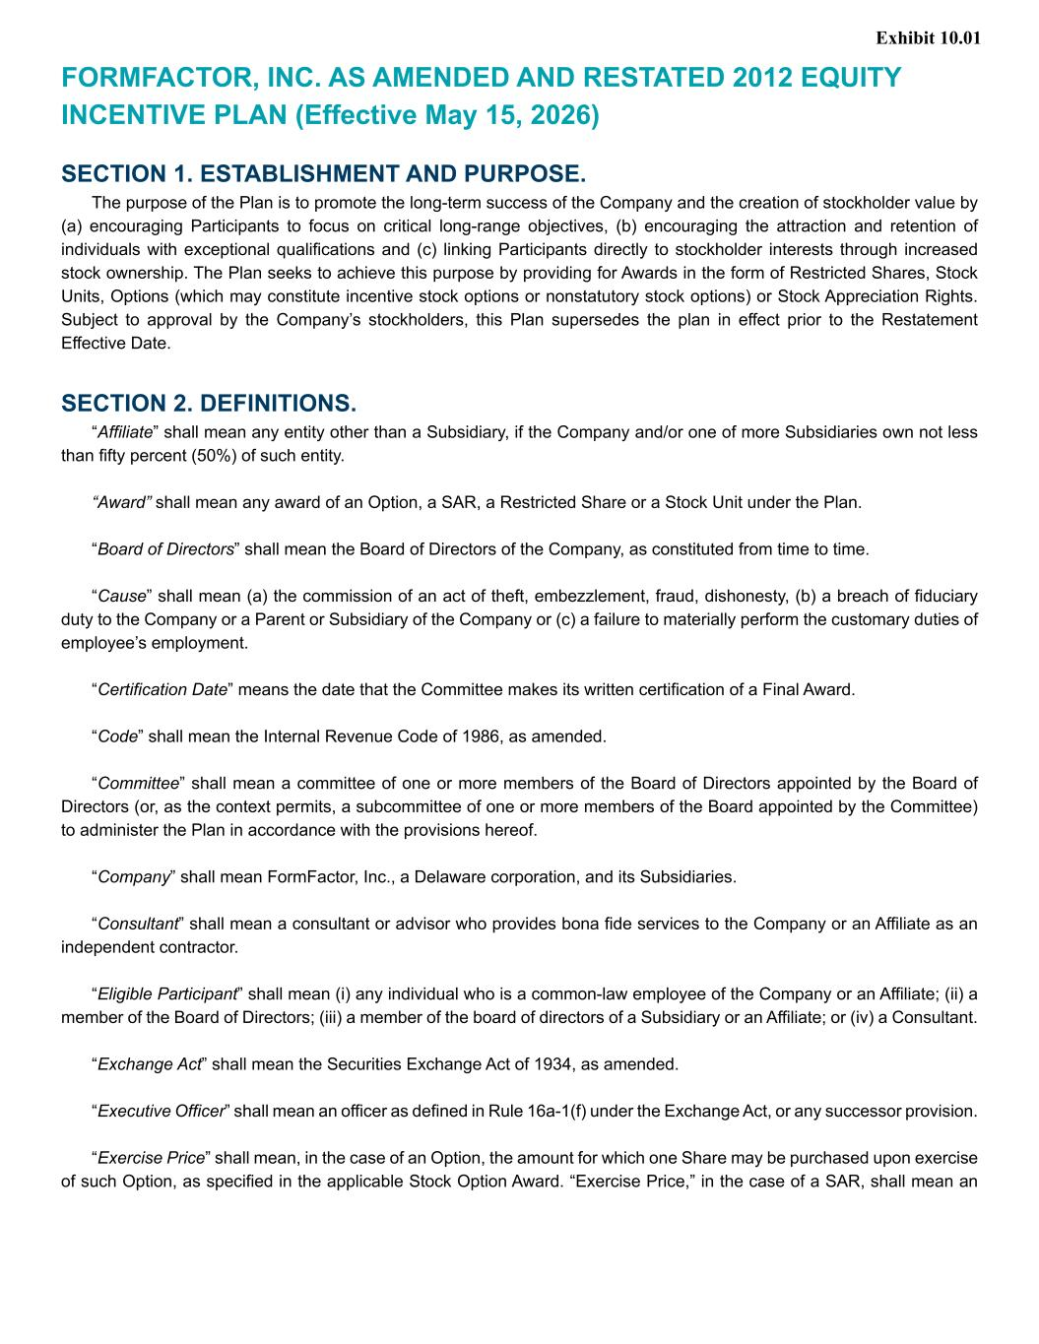
38
FORMFACTOR, INC. AS AMENDED AND RESTATED 2012 EQUITY INCENTIVE PLAN (Effective May 15, 2026) SECTION 1. ESTABLISHMENT AND PURPOSE. The purpose of the Plan is to promote the long-term success of the Company and the creation of stockholder value by (a) encouraging Participants to focus on critical long-range objectives, (b) encouraging the attraction and retention of individuals with exceptional qualifications and (c) linking Participants directly to stockholder interests through increased stock ownership. The Plan seeks to achieve this purpose by providing for Awards in the form of Restricted Shares, Stock Units, Options (which may constitute incentive stock options or nonstatutory stock options) or Stock Appreciation Rights. Subject to approval by the Company’s stockholders, this Plan supersedes the plan in effect prior to the Restatement Effective Date. SECTION 2. DEFINITIONS. “Affiliate” shall mean any entity other than a Subsidiary, if the Company and/or one of more Subsidiaries own not less than fifty percent (50%) of such entity. “Award” shall mean any award of an Option, a SAR, a Restricted Share or a Stock Unit under the Plan. “Board of Directors” shall mean the Board of Directors of the Company, as constituted from time to time. “Cause” shall mean (a) the commission of an act of theft, embezzlement, fraud, dishonesty, (b) a breach of fiduciary duty to the Company or a Parent or Subsidiary of the Company or (c) a failure to materially perform the customary duties of employee’s employment. “Certification Date” means the date that the Committee makes its written certification of a Final Award. “Code” shall mean the Internal Revenue Code of 1986, as amended. “Committee” shall mean a committee of one or more members of the Board of Directors appointed by the Board of Directors (or, as the context permits, a subcommittee of one or more members of the Board appointed by the Committee) to administer the Plan in accordance with the provisions hereof. “Company” shall mean FormFactor, Inc., a Delaware corporation, and its Subsidiaries. “Consultant” shall mean a consultant or advisor who provides bona fide services to the Company or an Affiliate as an independent contractor. “Eligible Participant” shall mean (i) any individual who is a common-law employee of the Company or an Affiliate; (ii) a member of the Board of Directors; (iii) a member of the board of directors of a Subsidiary or an Affiliate; or (iv) a Consultant. “Exchange Act” shall mean the Securities Exchange Act of 1934, as amended. “Executive Officer” shall mean an officer as defined in Rule 16a-1(f) under the Exchange Act, or any successor provision. “Exercise Price” shall mean, in the case of an Option, the amount for which one Share may be purchased upon exercise of such Option, as specified in the applicable Stock Option Award. “Exercise Price,” in the case of a SAR, shall mean an Exhibit 10.01

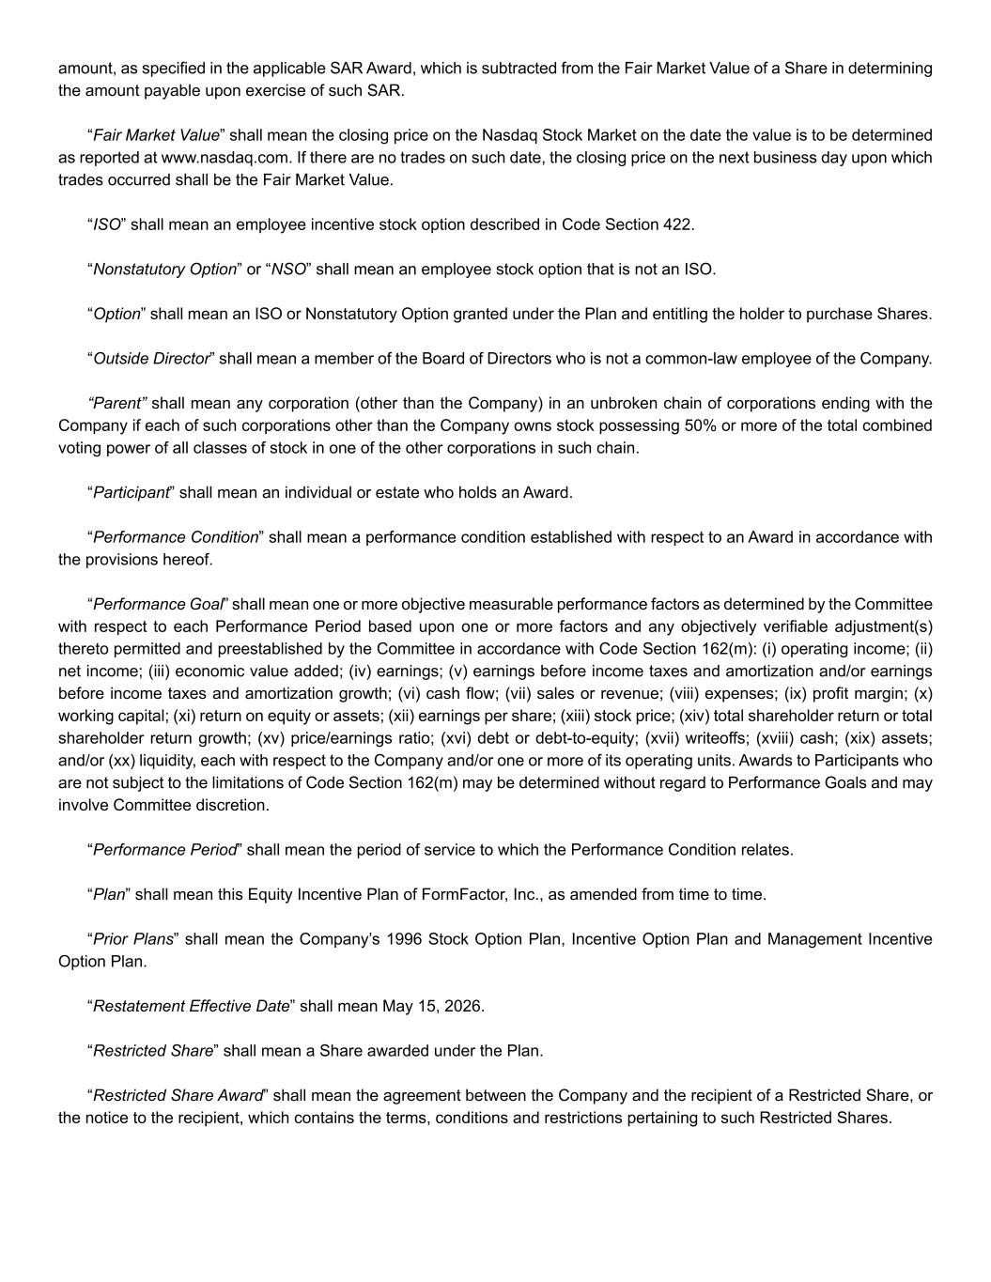
amount, as specified in the applicable SAR Award, which is subtracted from the Fair Market Value of a Share in determining the amount payable upon exercise of such SAR. “Fair Market Value” shall mean the closing price on the Nasdaq Stock Market on the date the value is to be determined as reported at www.nasdaq.com. If there are no trades on such date, the closing price on the next business day upon which trades occurred shall be the Fair Market Value. “ISO” shall mean an employee incentive stock option described in Code Section 422. “Nonstatutory Option” or “NSO” shall mean an employee stock option that is not an ISO. “Option” shall mean an ISO or Nonstatutory Option granted under the Plan and entitling the holder to purchase Shares. “Outside Director” shall mean a member of the Board of Directors who is not a common-law employee of the Company. “Parent” shall mean any corporation (other than the Company) in an unbroken chain of corporations ending with the Company if each of such corporations other than the Company owns stock possessing 50% or more of the total combined voting power of all classes of stock in one of the other corporations in such chain. “Participant” shall mean an individual or estate who holds an Award. “Performance Condition” shall mean a performance condition established with respect to an Award in accordance with the provisions hereof. “Performance Goal” shall mean one or more objective measurable performance factors as determined by the Committee with respect to each Performance Period based upon one or more factors and any objectively verifiable adjustment(s) thereto permitted and preestablished by the Committee in accordance with Code Section 162(m): (i) operating income; (ii) net income; (iii) economic value added; (iv) earnings; (v) earnings before income taxes and amortization and/or earnings before income taxes and amortization growth; (vi) cash flow; (vii) sales or revenue; (viii) expenses; (ix) profit margin; (x) working capital; (xi) return on equity or assets; (xii) earnings per share; (xiii) stock price; (xiv) total shareholder return or total shareholder return growth; (xv) price/earnings ratio; (xvi) debt or debt-to-equity; (xvii) writeoffs; (xviii) cash; (xix) assets; and/or (xx) liquidity, each with respect to the Company and/or one or more of its operating units. Awards to Participants who are not subject to the limitations of Code Section 162(m) may be determined without regard to Performance Goals and may involve Committee discretion. “Performance Period” shall mean the period of service to which the Performance Condition relates. “Plan” shall mean this Equity Incentive Plan of FormFactor, Inc., as amended from time to time. “Prior Plans” shall mean the Company’s 1996 Stock Option Plan, Incentive Option Plan and Management Incentive Option Plan. “Restatement Effective Date” shall mean May 15, 2026. “Restricted Share” shall mean a Share awarded under the Plan. “Restricted Share Award” shall mean the agreement between the Company and the recipient of a Restricted Share, or the notice to the recipient, which contains the terms, conditions and restrictions pertaining to such Restricted Shares.

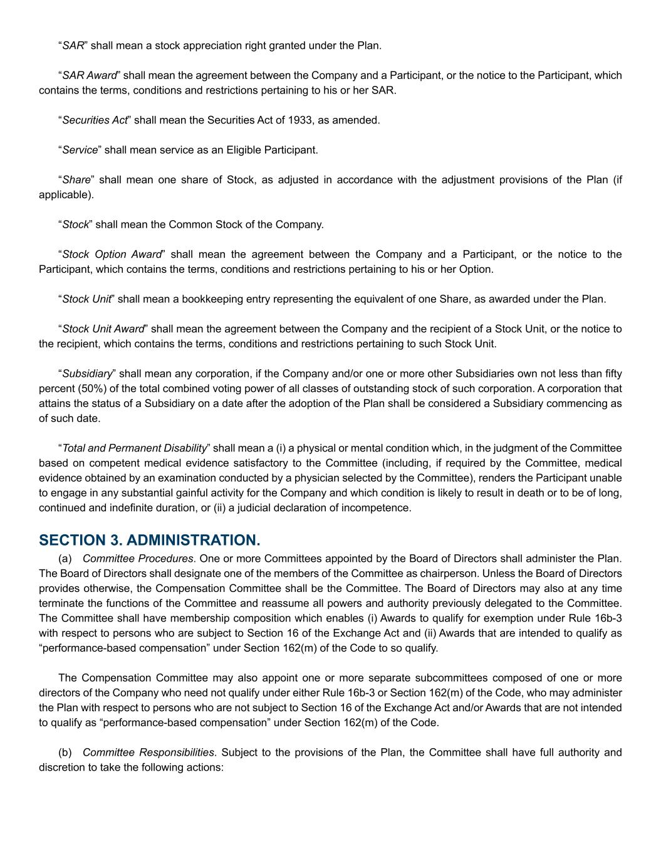
“SAR” shall mean a stock appreciation right granted under the Plan. “SAR Award” shall mean the agreement between the Company and a Participant, or the notice to the Participant, which contains the terms, conditions and restrictions pertaining to his or her SAR. “Securities Act” shall mean the Securities Act of 1933, as amended. “Service” shall mean service as an Eligible Participant. “Share” shall mean one share of Stock, as adjusted in accordance with the adjustment provisions of the Plan (if applicable). “Stock” shall mean the Common Stock of the Company. “Stock Option Award” shall mean the agreement between the Company and a Participant, or the notice to the Participant, which contains the terms, conditions and restrictions pertaining to his or her Option. “Stock Unit” shall mean a bookkeeping entry representing the equivalent of one Share, as awarded under the Plan. “Stock Unit Award” shall mean the agreement between the Company and the recipient of a Stock Unit, or the notice to the recipient, which contains the terms, conditions and restrictions pertaining to such Stock Unit. “Subsidiary” shall mean any corporation, if the Company and/or one or more other Subsidiaries own not less than fifty percent (50%) of the total combined voting power of all classes of outstanding stock of such corporation. A corporation that attains the status of a Subsidiary on a date after the adoption of the Plan shall be considered a Subsidiary commencing as of such date. “Total and Permanent Disability” shall mean a (i) a physical or mental condition which, in the judgment of the Committee based on competent medical evidence satisfactory to the Committee (including, if required by the Committee, medical evidence obtained by an examination conducted by a physician selected by the Committee), renders the Participant unable to engage in any substantial gainful activity for the Company and which condition is likely to result in death or to be of long, continued and indefinite duration, or (ii) a judicial declaration of incompetence. SECTION 3. ADMINISTRATION. (a) Committee Procedures. One or more Committees appointed by the Board of Directors shall administer the Plan. The Board of Directors shall designate one of the members of the Committee as chairperson. Unless the Board of Directors provides otherwise, the Compensation Committee shall be the Committee. The Board of Directors may also at any time terminate the functions of the Committee and reassume all powers and authority previously delegated to the Committee. The Committee shall have membership composition which enables (i) Awards to qualify for exemption under Rule 16b-3 with respect to persons who are subject to Section 16 of the Exchange Act and (ii) Awards that are intended to qualify as “performance-based compensation” under Section 162(m) of the Code to so qualify. The Compensation Committee may also appoint one or more separate subcommittees composed of one or more directors of the Company who need not qualify under either Rule 16b-3 or Section 162(m) of the Code, who may administer the Plan with respect to persons who are not subject to Section 16 of the Exchange Act and/or Awards that are not intended to qualify as “performance-based compensation” under Section 162(m) of the Code. (b) Committee Responsibilities. Subject to the provisions of the Plan, the Committee shall have full authority and discretion to take the following actions:

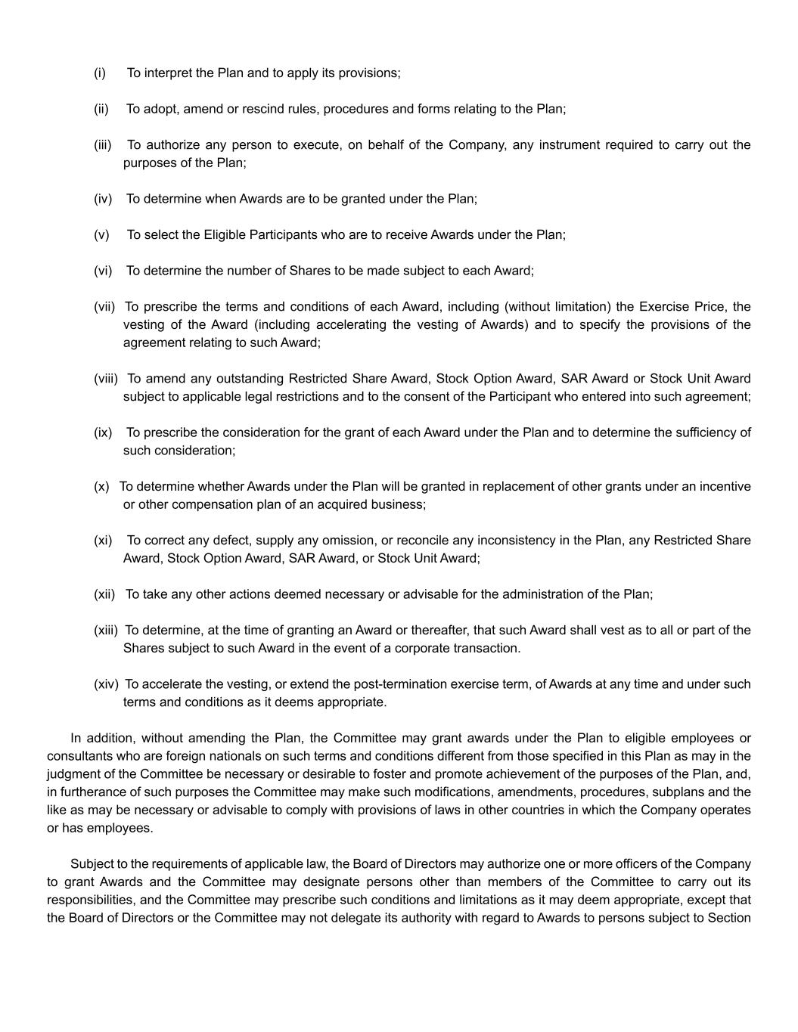
(i) To interpret the Plan and to apply its provisions; (ii) To adopt, amend or rescind rules, procedures and forms relating to the Plan; (iii) To authorize any person to execute, on behalf of the Company, any instrument required to carry out the purposes of the Plan; (iv) To determine when Awards are to be granted under the Plan; (v) To select the Eligible Participants who are to receive Awards under the Plan; (vi) To determine the number of Shares to be made subject to each Award; (vii) To prescribe the terms and conditions of each Award, including (without limitation) the Exercise Price, the vesting of the Award (including accelerating the vesting of Awards) and to specify the provisions of the agreement relating to such Award; (viii) To amend any outstanding Restricted Share Award, Stock Option Award, SAR Award or Stock Unit Award subject to applicable legal restrictions and to the consent of the Participant who entered into such agreement; (ix) To prescribe the consideration for the grant of each Award under the Plan and to determine the sufficiency of such consideration; (x) To determine whether Awards under the Plan will be granted in replacement of other grants under an incentive or other compensation plan of an acquired business; (xi) To correct any defect, supply any omission, or reconcile any inconsistency in the Plan, any Restricted Share Award, Stock Option Award, SAR Award, or Stock Unit Award; (xii) To take any other actions deemed necessary or advisable for the administration of the Plan; (xiii) To determine, at the time of granting an Award or thereafter, that such Award shall vest as to all or part of the Shares subject to such Award in the event of a corporate transaction. (xiv) To accelerate the vesting, or extend the post-termination exercise term, of Awards at any time and under such terms and conditions as it deems appropriate. In addition, without amending the Plan, the Committee may grant awards under the Plan to eligible employees or consultants who are foreign nationals on such terms and conditions different from those specified in this Plan as may in the judgment of the Committee be necessary or desirable to foster and promote achievement of the purposes of the Plan, and, in furtherance of such purposes the Committee may make such modifications, amendments, procedures, subplans and the like as may be necessary or advisable to comply with provisions of laws in other countries in which the Company operates or has employees. Subject to the requirements of applicable law, the Board of Directors may authorize one or more officers of the Company to grant Awards and the Committee may designate persons other than members of the Committee to carry out its responsibilities, and the Committee may prescribe such conditions and limitations as it may deem appropriate, except that the Board of Directors or the Committee may not delegate its authority with regard to Awards to persons subject to Section

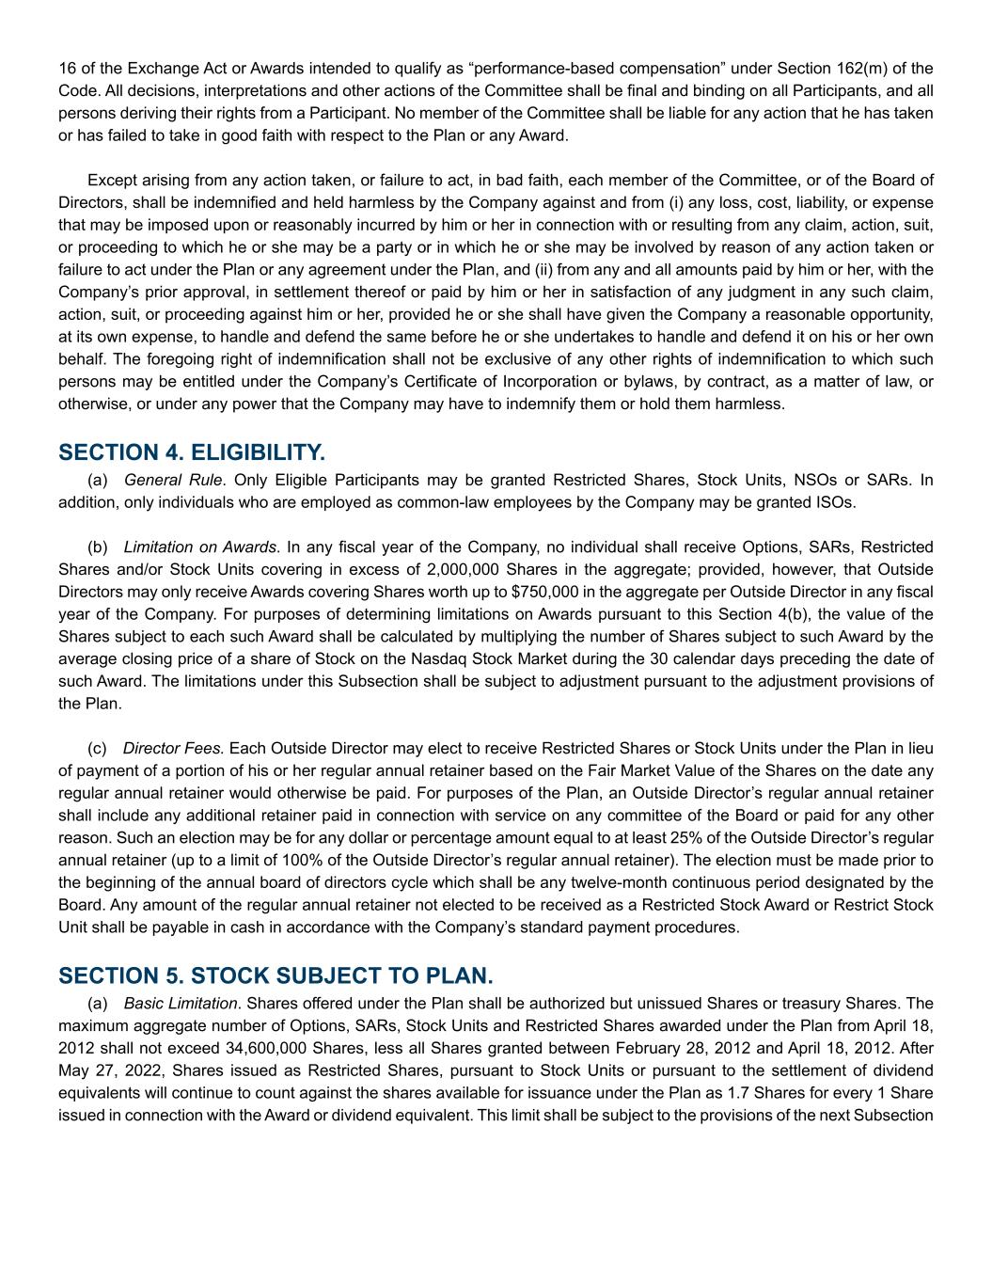
16 of the Exchange Act or Awards intended to qualify as “performance-based compensation” under Section 162(m) of the Code. All decisions, interpretations and other actions of the Committee shall be final and binding on all Participants, and all persons deriving their rights from a Participant. No member of the Committee shall be liable for any action that he has taken or has failed to take in good faith with respect to the Plan or any Award. Except arising from any action taken, or failure to act, in bad faith, each member of the Committee, or of the Board of Directors, shall be indemnified and held harmless by the Company against and from (i) any loss, cost, liability, or expense that may be imposed upon or reasonably incurred by him or her in connection with or resulting from any claim, action, suit, or proceeding to which he or she may be a party or in which he or she may be involved by reason of any action taken or failure to act under the Plan or any agreement under the Plan, and (ii) from any and all amounts paid by him or her, with the Company’s prior approval, in settlement thereof or paid by him or her in satisfaction of any judgment in any such claim, action, suit, or proceeding against him or her, provided he or she shall have given the Company a reasonable opportunity, at its own expense, to handle and defend the same before he or she undertakes to handle and defend it on his or her own behalf. The foregoing right of indemnification shall not be exclusive of any other rights of indemnification to which such persons may be entitled under the Company’s Certificate of Incorporation or bylaws, by contract, as a matter of law, or otherwise, or under any power that the Company may have to indemnify them or hold them harmless. SECTION 4. ELIGIBILITY. (a) General Rule. Only Eligible Participants may be granted Restricted Shares, Stock Units, NSOs or SARs. In addition, only individuals who are employed as common-law employees by the Company may be granted ISOs. (b) Limitation on Awards. In any fiscal year of the Company, no individual shall receive Options, SARs, Restricted Shares and/or Stock Units covering in excess of 2,000,000 Shares in the aggregate; provided, however, that Outside Directors may only receive Awards covering Shares worth up to $750,000 in the aggregate per Outside Director in any fiscal year of the Company. For purposes of determining limitations on Awards pursuant to this Section 4(b), the value of the Shares subject to each such Award shall be calculated by multiplying the number of Shares subject to such Award by the average closing price of a share of Stock on the Nasdaq Stock Market during the 30 calendar days preceding the date of such Award. The limitations under this Subsection shall be subject to adjustment pursuant to the adjustment provisions of the Plan. (c) Director Fees. Each Outside Director may elect to receive Restricted Shares or Stock Units under the Plan in lieu of payment of a portion of his or her regular annual retainer based on the Fair Market Value of the Shares on the date any regular annual retainer would otherwise be paid. For purposes of the Plan, an Outside Director’s regular annual retainer shall include any additional retainer paid in connection with service on any committee of the Board or paid for any other reason. Such an election may be for any dollar or percentage amount equal to at least 25% of the Outside Director’s regular annual retainer (up to a limit of 100% of the Outside Director’s regular annual retainer). The election must be made prior to the beginning of the annual board of directors cycle which shall be any twelve-month continuous period designated by the Board. Any amount of the regular annual retainer not elected to be received as a Restricted Stock Award or Restrict Stock Unit shall be payable in cash in accordance with the Company’s standard payment procedures. SECTION 5. STOCK SUBJECT TO PLAN. (a) Basic Limitation. Shares offered under the Plan shall be authorized but unissued Shares or treasury Shares. The maximum aggregate number of Options, SARs, Stock Units and Restricted Shares awarded under the Plan from April 18, 2012 shall not exceed 34,600,000 Shares, less all Shares granted between February 28, 2012 and April 18, 2012. After May 27, 2022, Shares issued as Restricted Shares, pursuant to Stock Units or pursuant to the settlement of dividend equivalents will continue to count against the shares available for issuance under the Plan as 1.7 Shares for every 1 Share issued in connection with the Award or dividend equivalent. This limit shall be subject to the provisions of the next Subsection

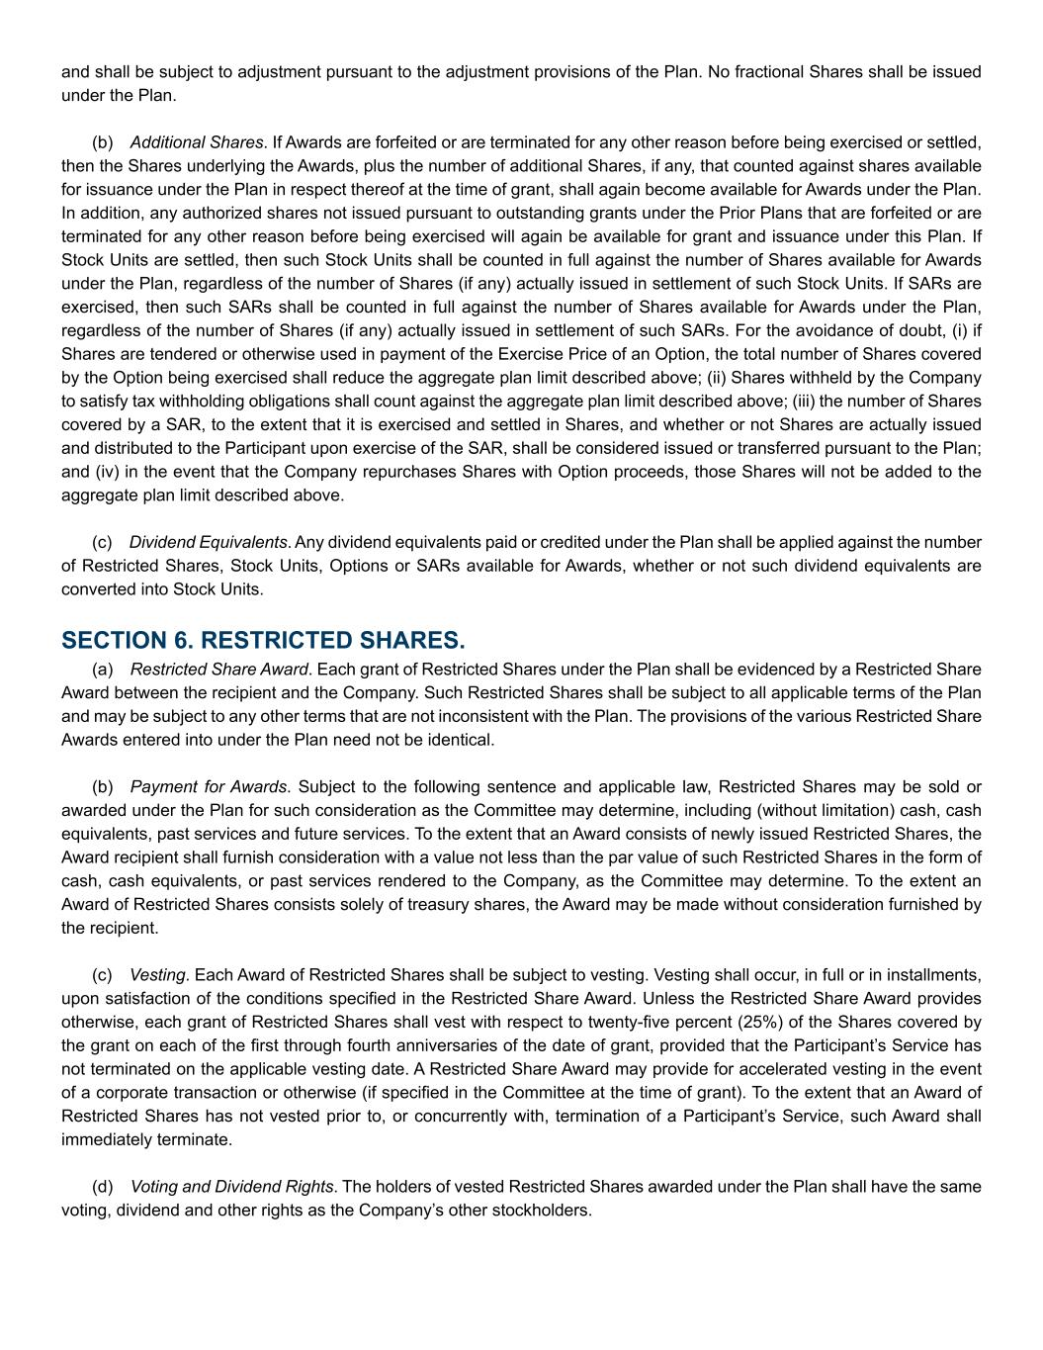
and shall be subject to adjustment pursuant to the adjustment provisions of the Plan. No fractional Shares shall be issued under the Plan. (b) Additional Shares. If Awards are forfeited or are terminated for any other reason before being exercised or settled, then the Shares underlying the Awards, plus the number of additional Shares, if any, that counted against shares available for issuance under the Plan in respect thereof at the time of grant, shall again become available for Awards under the Plan. In addition, any authorized shares not issued pursuant to outstanding grants under the Prior Plans that are forfeited or are terminated for any other reason before being exercised will again be available for grant and issuance under this Plan. If Stock Units are settled, then such Stock Units shall be counted in full against the number of Shares available for Awards under the Plan, regardless of the number of Shares (if any) actually issued in settlement of such Stock Units. If SARs are exercised, then such SARs shall be counted in full against the number of Shares available for Awards under the Plan, regardless of the number of Shares (if any) actually issued in settlement of such SARs. For the avoidance of doubt, (i) if Shares are tendered or otherwise used in payment of the Exercise Price of an Option, the total number of Shares covered by the Option being exercised shall reduce the aggregate plan limit described above; (ii) Shares withheld by the Company to satisfy tax withholding obligations shall count against the aggregate plan limit described above; (iii) the number of Shares covered by a SAR, to the extent that it is exercised and settled in Shares, and whether or not Shares are actually issued and distributed to the Participant upon exercise of the SAR, shall be considered issued or transferred pursuant to the Plan; and (iv) in the event that the Company repurchases Shares with Option proceeds, those Shares will not be added to the aggregate plan limit described above. (c) Dividend Equivalents. Any dividend equivalents paid or credited under the Plan shall be applied against the number of Restricted Shares, Stock Units, Options or SARs available for Awards, whether or not such dividend equivalents are converted into Stock Units. SECTION 6. RESTRICTED SHARES. (a) Restricted Share Award. Each grant of Restricted Shares under the Plan shall be evidenced by a Restricted Share Award between the recipient and the Company. Such Restricted Shares shall be subject to all applicable terms of the Plan and may be subject to any other terms that are not inconsistent with the Plan. The provisions of the various Restricted Share Awards entered into under the Plan need not be identical. (b) Payment for Awards. Subject to the following sentence and applicable law, Restricted Shares may be sold or awarded under the Plan for such consideration as the Committee may determine, including (without limitation) cash, cash equivalents, past services and future services. To the extent that an Award consists of newly issued Restricted Shares, the Award recipient shall furnish consideration with a value not less than the par value of such Restricted Shares in the form of cash, cash equivalents, or past services rendered to the Company, as the Committee may determine. To the extent an Award of Restricted Shares consists solely of treasury shares, the Award may be made without consideration furnished by the recipient. (c) Vesting. Each Award of Restricted Shares shall be subject to vesting. Vesting shall occur, in full or in installments, upon satisfaction of the conditions specified in the Restricted Share Award. Unless the Restricted Share Award provides otherwise, each grant of Restricted Shares shall vest with respect to twenty-five percent (25%) of the Shares covered by the grant on each of the first through fourth anniversaries of the date of grant, provided that the Participant’s Service has not terminated on the applicable vesting date. A Restricted Share Award may provide for accelerated vesting in the event of a corporate transaction or otherwise (if specified in the Committee at the time of grant). To the extent that an Award of Restricted Shares has not vested prior to, or concurrently with, termination of a Participant’s Service, such Award shall immediately terminate. (d) Voting and Dividend Rights. The holders of vested Restricted Shares awarded under the Plan shall have the same voting, dividend and other rights as the Company’s other stockholders.

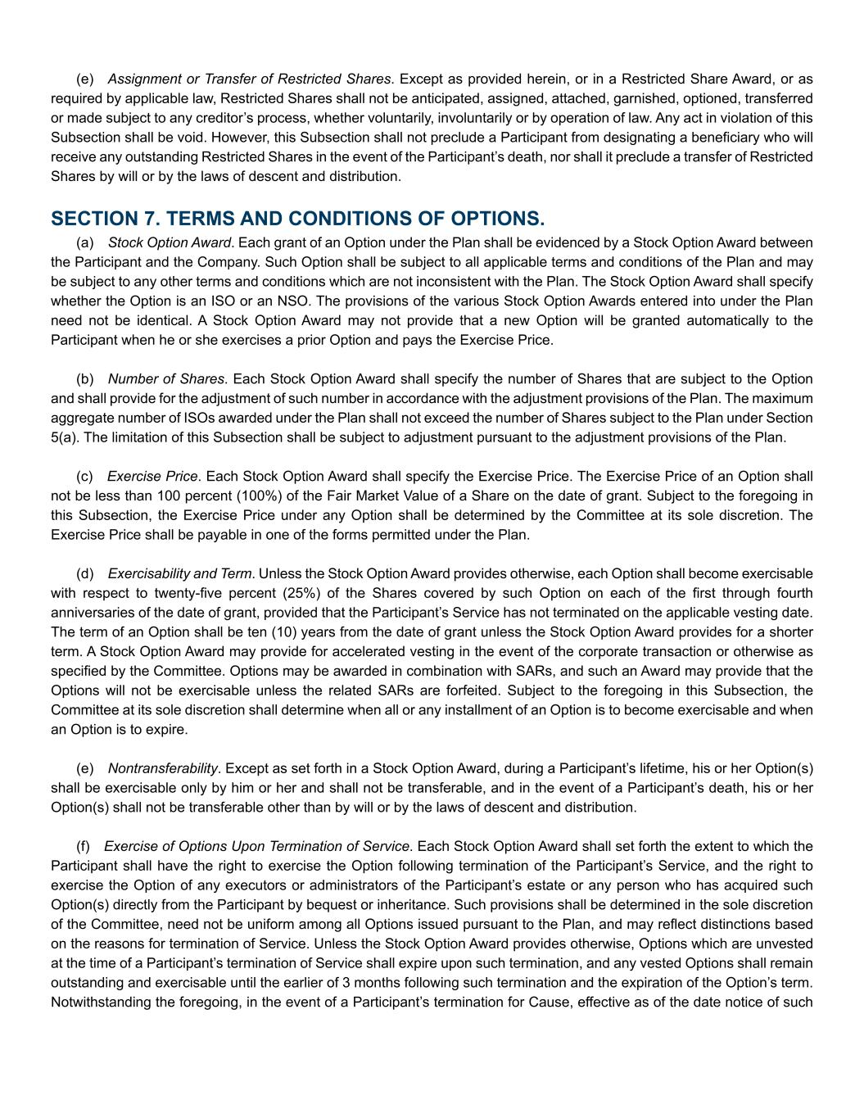
(e) Assignment or Transfer of Restricted Shares. Except as provided herein, or in a Restricted Share Award, or as required by applicable law, Restricted Shares shall not be anticipated, assigned, attached, garnished, optioned, transferred or made subject to any creditor’s process, whether voluntarily, involuntarily or by operation of law. Any act in violation of this Subsection shall be void. However, this Subsection shall not preclude a Participant from designating a beneficiary who will receive any outstanding Restricted Shares in the event of the Participant’s death, nor shall it preclude a transfer of Restricted Shares by will or by the laws of descent and distribution. SECTION 7. TERMS AND CONDITIONS OF OPTIONS. (a) Stock Option Award. Each grant of an Option under the Plan shall be evidenced by a Stock Option Award between the Participant and the Company. Such Option shall be subject to all applicable terms and conditions of the Plan and may be subject to any other terms and conditions which are not inconsistent with the Plan. The Stock Option Award shall specify whether the Option is an ISO or an NSO. The provisions of the various Stock Option Awards entered into under the Plan need not be identical. A Stock Option Award may not provide that a new Option will be granted automatically to the Participant when he or she exercises a prior Option and pays the Exercise Price. (b) Number of Shares. Each Stock Option Award shall specify the number of Shares that are subject to the Option and shall provide for the adjustment of such number in accordance with the adjustment provisions of the Plan. The maximum aggregate number of ISOs awarded under the Plan shall not exceed the number of Shares subject to the Plan under Section 5(a). The limitation of this Subsection shall be subject to adjustment pursuant to the adjustment provisions of the Plan. (c) Exercise Price. Each Stock Option Award shall specify the Exercise Price. The Exercise Price of an Option shall not be less than 100 percent (100%) of the Fair Market Value of a Share on the date of grant. Subject to the foregoing in this Subsection, the Exercise Price under any Option shall be determined by the Committee at its sole discretion. The Exercise Price shall be payable in one of the forms permitted under the Plan. (d) Exercisability and Term. Unless the Stock Option Award provides otherwise, each Option shall become exercisable with respect to twenty-five percent (25%) of the Shares covered by such Option on each of the first through fourth anniversaries of the date of grant, provided that the Participant’s Service has not terminated on the applicable vesting date. The term of an Option shall be ten (10) years from the date of grant unless the Stock Option Award provides for a shorter term. A Stock Option Award may provide for accelerated vesting in the event of the corporate transaction or otherwise as specified by the Committee. Options may be awarded in combination with SARs, and such an Award may provide that the Options will not be exercisable unless the related SARs are forfeited. Subject to the foregoing in this Subsection, the Committee at its sole discretion shall determine when all or any installment of an Option is to become exercisable and when an Option is to expire. (e) Nontransferability. Except as set forth in a Stock Option Award, during a Participant’s lifetime, his or her Option(s) shall be exercisable only by him or her and shall not be transferable, and in the event of a Participant’s death, his or her Option(s) shall not be transferable other than by will or by the laws of descent and distribution. (f) Exercise of Options Upon Termination of Service. Each Stock Option Award shall set forth the extent to which the Participant shall have the right to exercise the Option following termination of the Participant’s Service, and the right to exercise the Option of any executors or administrators of the Participant’s estate or any person who has acquired such Option(s) directly from the Participant by bequest or inheritance. Such provisions shall be determined in the sole discretion of the Committee, need not be uniform among all Options issued pursuant to the Plan, and may reflect distinctions based on the reasons for termination of Service. Unless the Stock Option Award provides otherwise, Options which are unvested at the time of a Participant’s termination of Service shall expire upon such termination, and any vested Options shall remain outstanding and exercisable until the earlier of 3 months following such termination and the expiration of the Option’s term. Notwithstanding the foregoing, in the event of a Participant’s termination for Cause, effective as of the date notice of such

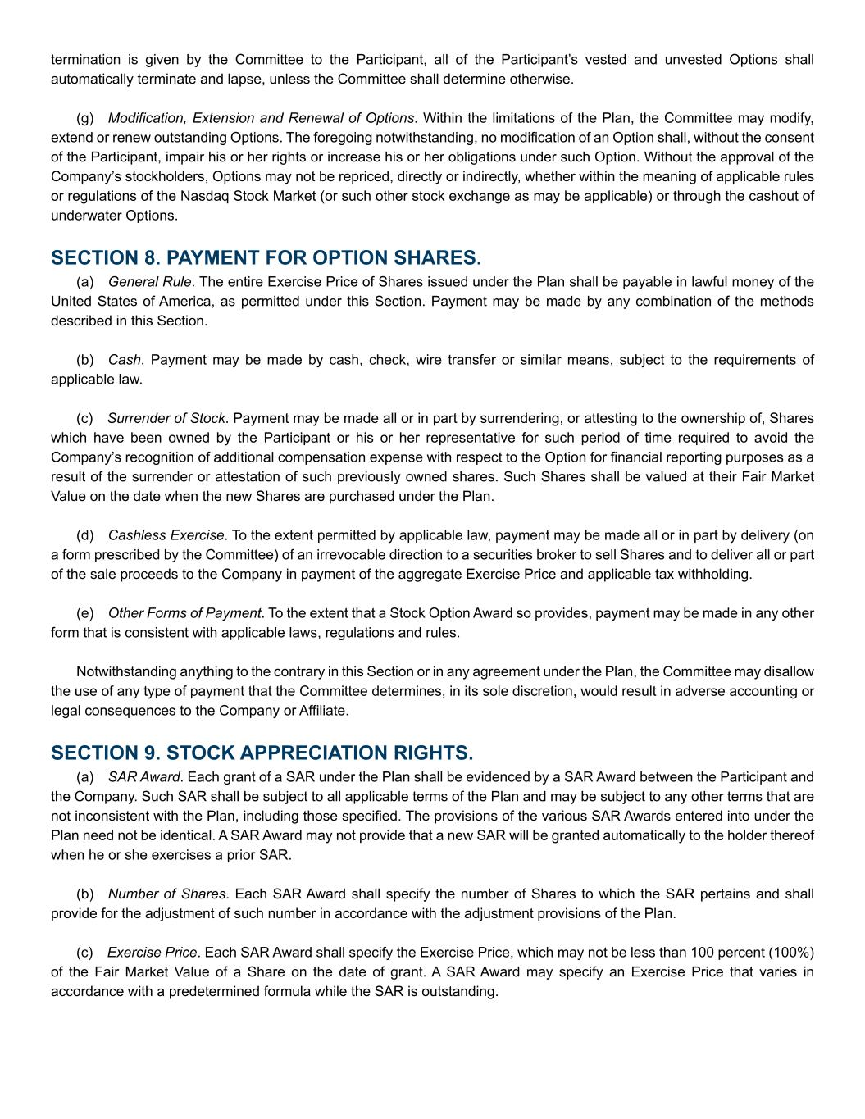
termination is given by the Committee to the Participant, all of the Participant’s vested and unvested Options shall automatically terminate and lapse, unless the Committee shall determine otherwise. (g) Modification, Extension and Renewal of Options. Within the limitations of the Plan, the Committee may modify, extend or renew outstanding Options. The foregoing notwithstanding, no modification of an Option shall, without the consent of the Participant, impair his or her rights or increase his or her obligations under such Option. Without the approval of the Company’s stockholders, Options may not be repriced, directly or indirectly, whether within the meaning of applicable rules or regulations of the Nasdaq Stock Market (or such other stock exchange as may be applicable) or through the cashout of underwater Options. SECTION 8. PAYMENT FOR OPTION SHARES. (a) General Rule. The entire Exercise Price of Shares issued under the Plan shall be payable in lawful money of the United States of America, as permitted under this Section. Payment may be made by any combination of the methods described in this Section. (b) Cash. Payment may be made by cash, check, wire transfer or similar means, subject to the requirements of applicable law. (c) Surrender of Stock. Payment may be made all or in part by surrendering, or attesting to the ownership of, Shares which have been owned by the Participant or his or her representative for such period of time required to avoid the Company’s recognition of additional compensation expense with respect to the Option for financial reporting purposes as a result of the surrender or attestation of such previously owned shares. Such Shares shall be valued at their Fair Market Value on the date when the new Shares are purchased under the Plan. (d) Cashless Exercise. To the extent permitted by applicable law, payment may be made all or in part by delivery (on a form prescribed by the Committee) of an irrevocable direction to a securities broker to sell Shares and to deliver all or part of the sale proceeds to the Company in payment of the aggregate Exercise Price and applicable tax withholding. (e) Other Forms of Payment. To the extent that a Stock Option Award so provides, payment may be made in any other form that is consistent with applicable laws, regulations and rules. Notwithstanding anything to the contrary in this Section or in any agreement under the Plan, the Committee may disallow the use of any type of payment that the Committee determines, in its sole discretion, would result in adverse accounting or legal consequences to the Company or Affiliate. SECTION 9. STOCK APPRECIATION RIGHTS. (a) SAR Award. Each grant of a SAR under the Plan shall be evidenced by a SAR Award between the Participant and the Company. Such SAR shall be subject to all applicable terms of the Plan and may be subject to any other terms that are not inconsistent with the Plan, including those specified. The provisions of the various SAR Awards entered into under the Plan need not be identical. A SAR Award may not provide that a new SAR will be granted automatically to the holder thereof when he or she exercises a prior SAR. (b) Number of Shares. Each SAR Award shall specify the number of Shares to which the SAR pertains and shall provide for the adjustment of such number in accordance with the adjustment provisions of the Plan. (c) Exercise Price. Each SAR Award shall specify the Exercise Price, which may not be less than 100 percent (100%) of the Fair Market Value of a Share on the date of grant. A SAR Award may specify an Exercise Price that varies in accordance with a predetermined formula while the SAR is outstanding.

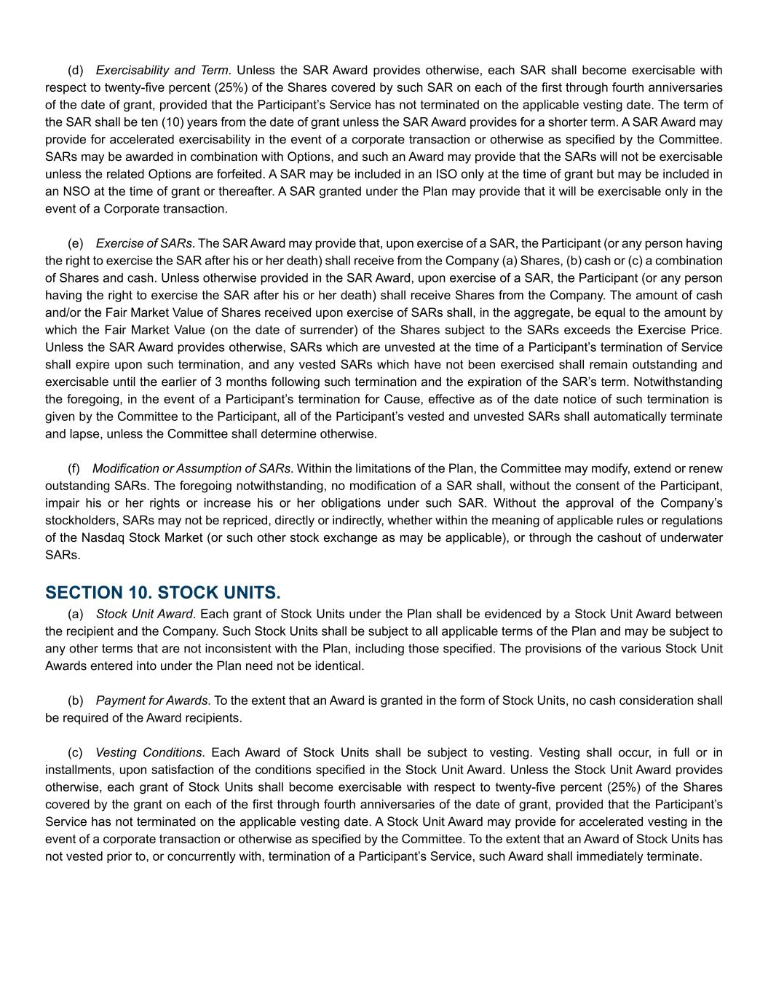
(d) Exercisability and Term. Unless the SAR Award provides otherwise, each SAR shall become exercisable with respect to twenty-five percent (25%) of the Shares covered by such SAR on each of the first through fourth anniversaries of the date of grant, provided that the Participant’s Service has not terminated on the applicable vesting date. The term of the SAR shall be ten (10) years from the date of grant unless the SAR Award provides for a shorter term. A SAR Award may provide for accelerated exercisability in the event of a corporate transaction or otherwise as specified by the Committee. SARs may be awarded in combination with Options, and such an Award may provide that the SARs will not be exercisable unless the related Options are forfeited. A SAR may be included in an ISO only at the time of grant but may be included in an NSO at the time of grant or thereafter. A SAR granted under the Plan may provide that it will be exercisable only in the event of a Corporate transaction. (e) Exercise of SARs. The SAR Award may provide that, upon exercise of a SAR, the Participant (or any person having the right to exercise the SAR after his or her death) shall receive from the Company (a) Shares, (b) cash or (c) a combination of Shares and cash. Unless otherwise provided in the SAR Award, upon exercise of a SAR, the Participant (or any person having the right to exercise the SAR after his or her death) shall receive Shares from the Company. The amount of cash and/or the Fair Market Value of Shares received upon exercise of SARs shall, in the aggregate, be equal to the amount by which the Fair Market Value (on the date of surrender) of the Shares subject to the SARs exceeds the Exercise Price. Unless the SAR Award provides otherwise, SARs which are unvested at the time of a Participant’s termination of Service shall expire upon such termination, and any vested SARs which have not been exercised shall remain outstanding and exercisable until the earlier of 3 months following such termination and the expiration of the SAR’s term. Notwithstanding the foregoing, in the event of a Participant’s termination for Cause, effective as of the date notice of such termination is given by the Committee to the Participant, all of the Participant’s vested and unvested SARs shall automatically terminate and lapse, unless the Committee shall determine otherwise. (f) Modification or Assumption of SARs. Within the limitations of the Plan, the Committee may modify, extend or renew outstanding SARs. The foregoing notwithstanding, no modification of a SAR shall, without the consent of the Participant, impair his or her rights or increase his or her obligations under such SAR. Without the approval of the Company’s stockholders, SARs may not be repriced, directly or indirectly, whether within the meaning of applicable rules or regulations of the Nasdaq Stock Market (or such other stock exchange as may be applicable), or through the cashout of underwater SARs. SECTION 10. STOCK UNITS. (a) Stock Unit Award. Each grant of Stock Units under the Plan shall be evidenced by a Stock Unit Award between the recipient and the Company. Such Stock Units shall be subject to all applicable terms of the Plan and may be subject to any other terms that are not inconsistent with the Plan, including those specified. The provisions of the various Stock Unit Awards entered into under the Plan need not be identical. (b) Payment for Awards. To the extent that an Award is granted in the form of Stock Units, no cash consideration shall be required of the Award recipients. (c) Vesting Conditions. Each Award of Stock Units shall be subject to vesting. Vesting shall occur, in full or in installments, upon satisfaction of the conditions specified in the Stock Unit Award. Unless the Stock Unit Award provides otherwise, each grant of Stock Units shall become exercisable with respect to twenty-five percent (25%) of the Shares covered by the grant on each of the first through fourth anniversaries of the date of grant, provided that the Participant’s Service has not terminated on the applicable vesting date. A Stock Unit Award may provide for accelerated vesting in the event of a corporate transaction or otherwise as specified by the Committee. To the extent that an Award of Stock Units has not vested prior to, or concurrently with, termination of a Participant’s Service, such Award shall immediately terminate.

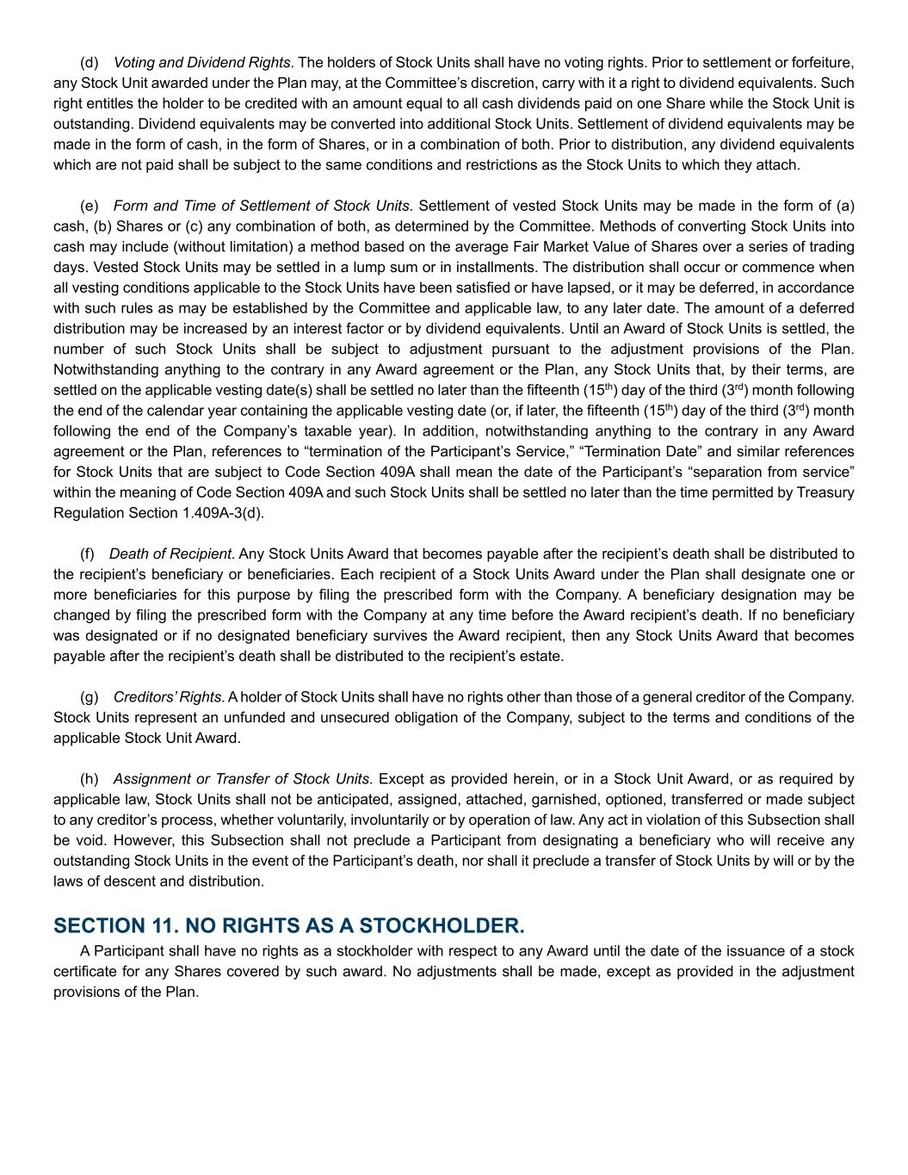
(d) Voting and Dividend Rights. The holders of Stock Units shall have no voting rights. Prior to settlement or forfeiture, any Stock Unit awarded under the Plan may, at the Committee’s discretion, carry with it a right to dividend equivalents. Such right entitles the holder to be credited with an amount equal to all cash dividends paid on one Share while the Stock Unit is outstanding. Dividend equivalents may be converted into additional Stock Units. Settlement of dividend equivalents may be made in the form of cash, in the form of Shares, or in a combination of both. Prior to distribution, any dividend equivalents which are not paid shall be subject to the same conditions and restrictions as the Stock Units to which they attach. (e) Form and Time of Settlement of Stock Units. Settlement of vested Stock Units may be made in the form of (a) cash, (b) Shares or (c) any combination of both, as determined by the Committee. Methods of converting Stock Units into cash may include (without limitation) a method based on the average Fair Market Value of Shares over a series of trading days. Vested Stock Units may be settled in a lump sum or in installments. The distribution shall occur or commence when all vesting conditions applicable to the Stock Units have been satisfied or have lapsed, or it may be deferred, in accordance with such rules as may be established by the Committee and applicable law, to any later date. The amount of a deferred distribution may be increased by an interest factor or by dividend equivalents. Until an Award of Stock Units is settled, the number of such Stock Units shall be subject to adjustment pursuant to the adjustment provisions of the Plan. Notwithstanding anything to the contrary in any Award agreement or the Plan, any Stock Units that, by their terms, are settled on the applicable vesting date(s) shall be settled no later than the fifteenth (15th) day of the third (3rd) month following the end of the calendar year containing the applicable vesting date (or, if later, the fifteenth (15th) day of the third (3rd) month following the end of the Company’s taxable year). In addition, notwithstanding anything to the contrary in any Award agreement or the Plan, references to “termination of the Participant’s Service,” “Termination Date” and similar references for Stock Units that are subject to Code Section 409A shall mean the date of the Participant’s “separation from service” within the meaning of Code Section 409A and such Stock Units shall be settled no later than the time permitted by Treasury Regulation Section 1.409A-3(d). (f) Death of Recipient. Any Stock Units Award that becomes payable after the recipient’s death shall be distributed to the recipient’s beneficiary or beneficiaries. Each recipient of a Stock Units Award under the Plan shall designate one or more beneficiaries for this purpose by filing the prescribed form with the Company. A beneficiary designation may be changed by filing the prescribed form with the Company at any time before the Award recipient’s death. If no beneficiary was designated or if no designated beneficiary survives the Award recipient, then any Stock Units Award that becomes payable after the recipient’s death shall be distributed to the recipient’s estate. (g) Creditors’ Rights. A holder of Stock Units shall have no rights other than those of a general creditor of the Company. Stock Units represent an unfunded and unsecured obligation of the Company, subject to the terms and conditions of the applicable Stock Unit Award. (h) Assignment or Transfer of Stock Units. Except as provided herein, or in a Stock Unit Award, or as required by applicable law, Stock Units shall not be anticipated, assigned, attached, garnished, optioned, transferred or made subject to any creditor’s process, whether voluntarily, involuntarily or by operation of law. Any act in violation of this Subsection shall be void. However, this Subsection shall not preclude a Participant from designating a beneficiary who will receive any outstanding Stock Units in the event of the Participant’s death, nor shall it preclude a transfer of Stock Units by will or by the laws of descent and distribution. SECTION 11. NO RIGHTS AS A STOCKHOLDER. A Participant shall have no rights as a stockholder with respect to any Award until the date of the issuance of a stock certificate for any Shares covered by such award. No adjustments shall be made, except as provided in the adjustment provisions of the Plan.

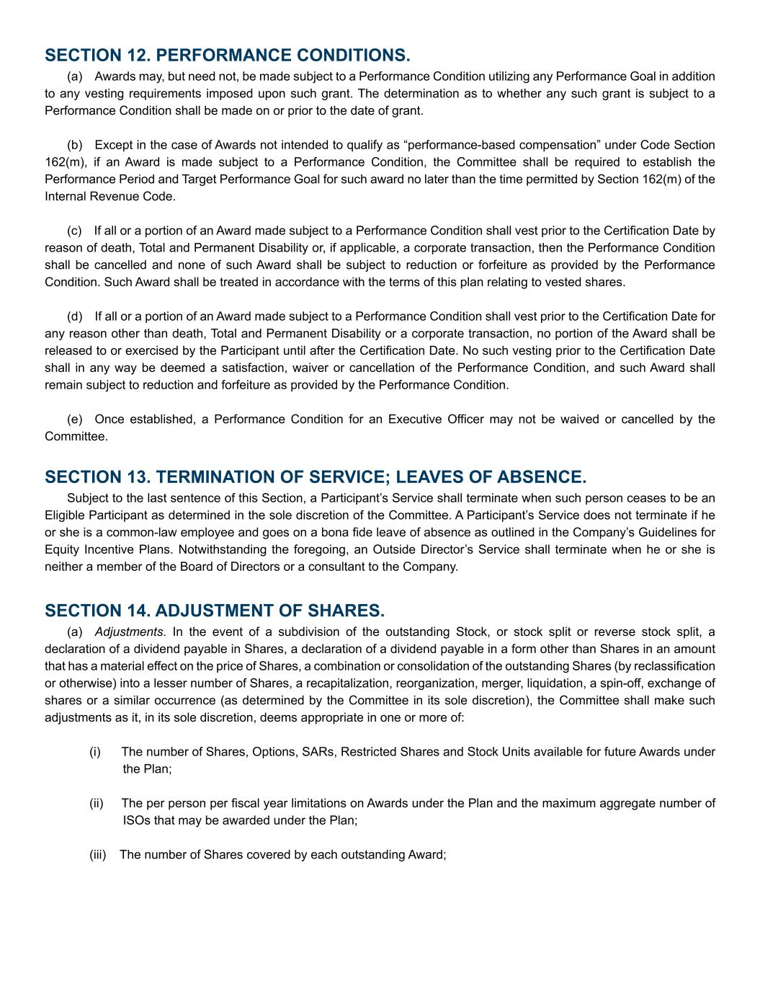
SECTION 12. PERFORMANCE CONDITIONS. (a) Awards may, but need not, be made subject to a Performance Condition utilizing any Performance Goal in addition to any vesting requirements imposed upon such grant. The determination as to whether any such grant is subject to a Performance Condition shall be made on or prior to the date of grant. (b) Except in the case of Awards not intended to qualify as “performance-based compensation” under Code Section 162(m), if an Award is made subject to a Performance Condition, the Committee shall be required to establish the Performance Period and Target Performance Goal for such award no later than the time permitted by Section 162(m) of the Internal Revenue Code. (c) If all or a portion of an Award made subject to a Performance Condition shall vest prior to the Certification Date by reason of death, Total and Permanent Disability or, if applicable, a corporate transaction, then the Performance Condition shall be cancelled and none of such Award shall be subject to reduction or forfeiture as provided by the Performance Condition. Such Award shall be treated in accordance with the terms of this plan relating to vested shares. (d) If all or a portion of an Award made subject to a Performance Condition shall vest prior to the Certification Date for any reason other than death, Total and Permanent Disability or a corporate transaction, no portion of the Award shall be released to or exercised by the Participant until after the Certification Date. No such vesting prior to the Certification Date shall in any way be deemed a satisfaction, waiver or cancellation of the Performance Condition, and such Award shall remain subject to reduction and forfeiture as provided by the Performance Condition. (e) Once established, a Performance Condition for an Executive Officer may not be waived or cancelled by the Committee. SECTION 13. TERMINATION OF SERVICE; LEAVES OF ABSENCE. Subject to the last sentence of this Section, a Participant’s Service shall terminate when such person ceases to be an Eligible Participant as determined in the sole discretion of the Committee. A Participant’s Service does not terminate if he or she is a common-law employee and goes on a bona fide leave of absence as outlined in the Company’s Guidelines for Equity Incentive Plans. Notwithstanding the foregoing, an Outside Director’s Service shall terminate when he or she is neither a member of the Board of Directors or a consultant to the Company. SECTION 14. ADJUSTMENT OF SHARES. (a) Adjustments. In the event of a subdivision of the outstanding Stock, or stock split or reverse stock split, a declaration of a dividend payable in Shares, a declaration of a dividend payable in a form other than Shares in an amount that has a material effect on the price of Shares, a combination or consolidation of the outstanding Shares (by reclassification or otherwise) into a lesser number of Shares, a recapitalization, reorganization, merger, liquidation, a spin-off, exchange of shares or a similar occurrence (as determined by the Committee in its sole discretion), the Committee shall make such adjustments as it, in its sole discretion, deems appropriate in one or more of: (i) The number of Shares, Options, SARs, Restricted Shares and Stock Units available for future Awards under the Plan; (ii) The per person per fiscal year limitations on Awards under the Plan and the maximum aggregate number of ISOs that may be awarded under the Plan; (iii) The number of Shares covered by each outstanding Award;

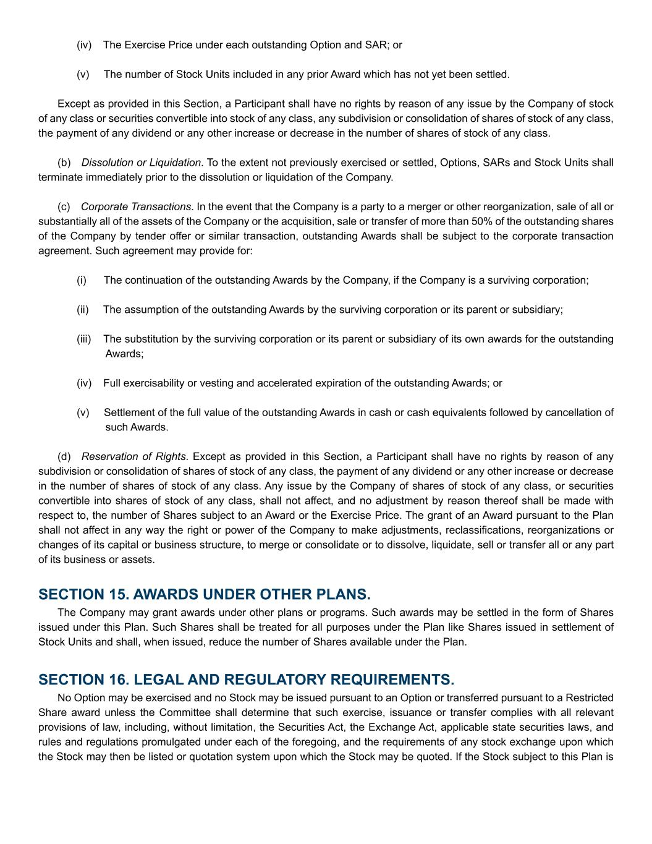
(iv) The Exercise Price under each outstanding Option and SAR; or (v) The number of Stock Units included in any prior Award which has not yet been settled. Except as provided in this Section, a Participant shall have no rights by reason of any issue by the Company of stock of any class or securities convertible into stock of any class, any subdivision or consolidation of shares of stock of any class, the payment of any dividend or any other increase or decrease in the number of shares of stock of any class. (b) Dissolution or Liquidation. To the extent not previously exercised or settled, Options, SARs and Stock Units shall terminate immediately prior to the dissolution or liquidation of the Company. (c) Corporate Transactions. In the event that the Company is a party to a merger or other reorganization, sale of all or substantially all of the assets of the Company or the acquisition, sale or transfer of more than 50% of the outstanding shares of the Company by tender offer or similar transaction, outstanding Awards shall be subject to the corporate transaction agreement. Such agreement may provide for: (i) The continuation of the outstanding Awards by the Company, if the Company is a surviving corporation; (ii) The assumption of the outstanding Awards by the surviving corporation or its parent or subsidiary; (iii) The substitution by the surviving corporation or its parent or subsidiary of its own awards for the outstanding Awards; (iv) Full exercisability or vesting and accelerated expiration of the outstanding Awards; or (v) Settlement of the full value of the outstanding Awards in cash or cash equivalents followed by cancellation of such Awards. (d) Reservation of Rights. Except as provided in this Section, a Participant shall have no rights by reason of any subdivision or consolidation of shares of stock of any class, the payment of any dividend or any other increase or decrease in the number of shares of stock of any class. Any issue by the Company of shares of stock of any class, or securities convertible into shares of stock of any class, shall not affect, and no adjustment by reason thereof shall be made with respect to, the number of Shares subject to an Award or the Exercise Price. The grant of an Award pursuant to the Plan shall not affect in any way the right or power of the Company to make adjustments, reclassifications, reorganizations or changes of its capital or business structure, to merge or consolidate or to dissolve, liquidate, sell or transfer all or any part of its business or assets. SECTION 15. AWARDS UNDER OTHER PLANS. The Company may grant awards under other plans or programs. Such awards may be settled in the form of Shares issued under this Plan. Such Shares shall be treated for all purposes under the Plan like Shares issued in settlement of Stock Units and shall, when issued, reduce the number of Shares available under the Plan. SECTION 16. LEGAL AND REGULATORY REQUIREMENTS. No Option may be exercised and no Stock may be issued pursuant to an Option or transferred pursuant to a Restricted Share award unless the Committee shall determine that such exercise, issuance or transfer complies with all relevant provisions of law, including, without limitation, the Securities Act, the Exchange Act, applicable state securities laws, and rules and regulations promulgated under each of the foregoing, and the requirements of any stock exchange upon which the Stock may then be listed or quotation system upon which the Stock may be quoted. If the Stock subject to this Plan is

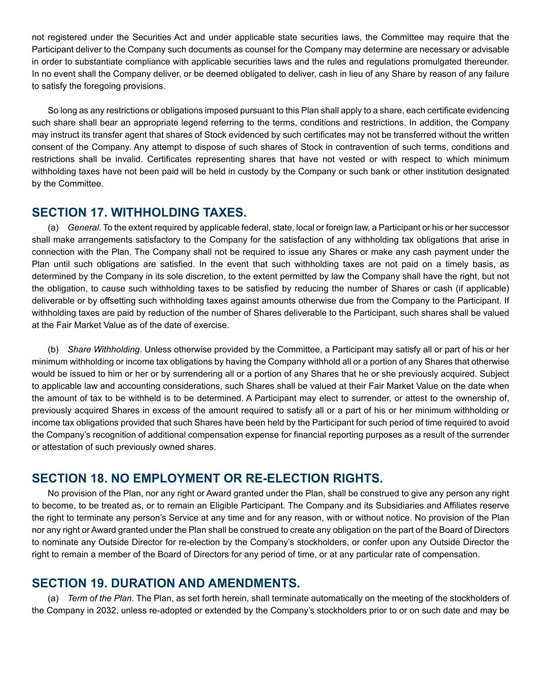
not registered under the Securities Act and under applicable state securities laws, the Committee may require that the Participant deliver to the Company such documents as counsel for the Company may determine are necessary or advisable in order to substantiate compliance with applicable securities laws and the rules and regulations promulgated thereunder. In no event shall the Company deliver, or be deemed obligated to deliver, cash in lieu of any Share by reason of any failure to satisfy the foregoing provisions. So long as any restrictions or obligations imposed pursuant to this Plan shall apply to a share, each certificate evidencing such share shall bear an appropriate legend referring to the terms, conditions and restrictions. In addition, the Company may instruct its transfer agent that shares of Stock evidenced by such certificates may not be transferred without the written consent of the Company. Any attempt to dispose of such shares of Stock in contravention of such terms, conditions and restrictions shall be invalid. Certificates representing shares that have not vested or with respect to which minimum withholding taxes have not been paid will be held in custody by the Company or such bank or other institution designated by the Committee. SECTION 17. WITHHOLDING TAXES. (a) General. To the extent required by applicable federal, state, local or foreign law, a Participant or his or her successor shall make arrangements satisfactory to the Company for the satisfaction of any withholding tax obligations that arise in connection with the Plan. The Company shall not be required to issue any Shares or make any cash payment under the Plan until such obligations are satisfied. In the event that such withholding taxes are not paid on a timely basis, as determined by the Company in its sole discretion, to the extent permitted by law the Company shall have the right, but not the obligation, to cause such withholding taxes to be satisfied by reducing the number of Shares or cash (if applicable) deliverable or by offsetting such withholding taxes against amounts otherwise due from the Company to the Participant. If withholding taxes are paid by reduction of the number of Shares deliverable to the Participant, such shares shall be valued at the Fair Market Value as of the date of exercise. (b) Share Withholding. Unless otherwise provided by the Committee, a Participant may satisfy all or part of his or her minimum withholding or income tax obligations by having the Company withhold all or a portion of any Shares that otherwise would be issued to him or her or by surrendering all or a portion of any Shares that he or she previously acquired. Subject to applicable law and accounting considerations, such Shares shall be valued at their Fair Market Value on the date when the amount of tax to be withheld is to be determined. A Participant may elect to surrender, or attest to the ownership of, previously acquired Shares in excess of the amount required to satisfy all or a part of his or her minimum withholding or income tax obligations provided that such Shares have been held by the Participant for such period of time required to avoid the Company’s recognition of additional compensation expense for financial reporting purposes as a result of the surrender or attestation of such previously owned shares. SECTION 18. NO EMPLOYMENT OR RE-ELECTION RIGHTS. No provision of the Plan, nor any right or Award granted under the Plan, shall be construed to give any person any right to become, to be treated as, or to remain an Eligible Participant. The Company and its Subsidiaries and Affiliates reserve the right to terminate any person’s Service at any time and for any reason, with or without notice. No provision of the Plan nor any right or Award granted under the Plan shall be construed to create any obligation on the part of the Board of Directors to nominate any Outside Director for re-election by the Company’s stockholders, or confer upon any Outside Director the right to remain a member of the Board of Directors for any period of time, or at any particular rate of compensation. SECTION 19. DURATION AND AMENDMENTS. (a) Term of the Plan. The Plan, as set forth herein, shall terminate automatically on the meeting of the stockholders of the Company in 2032, unless re-adopted or extended by the Company’s stockholders prior to or on such date and may be

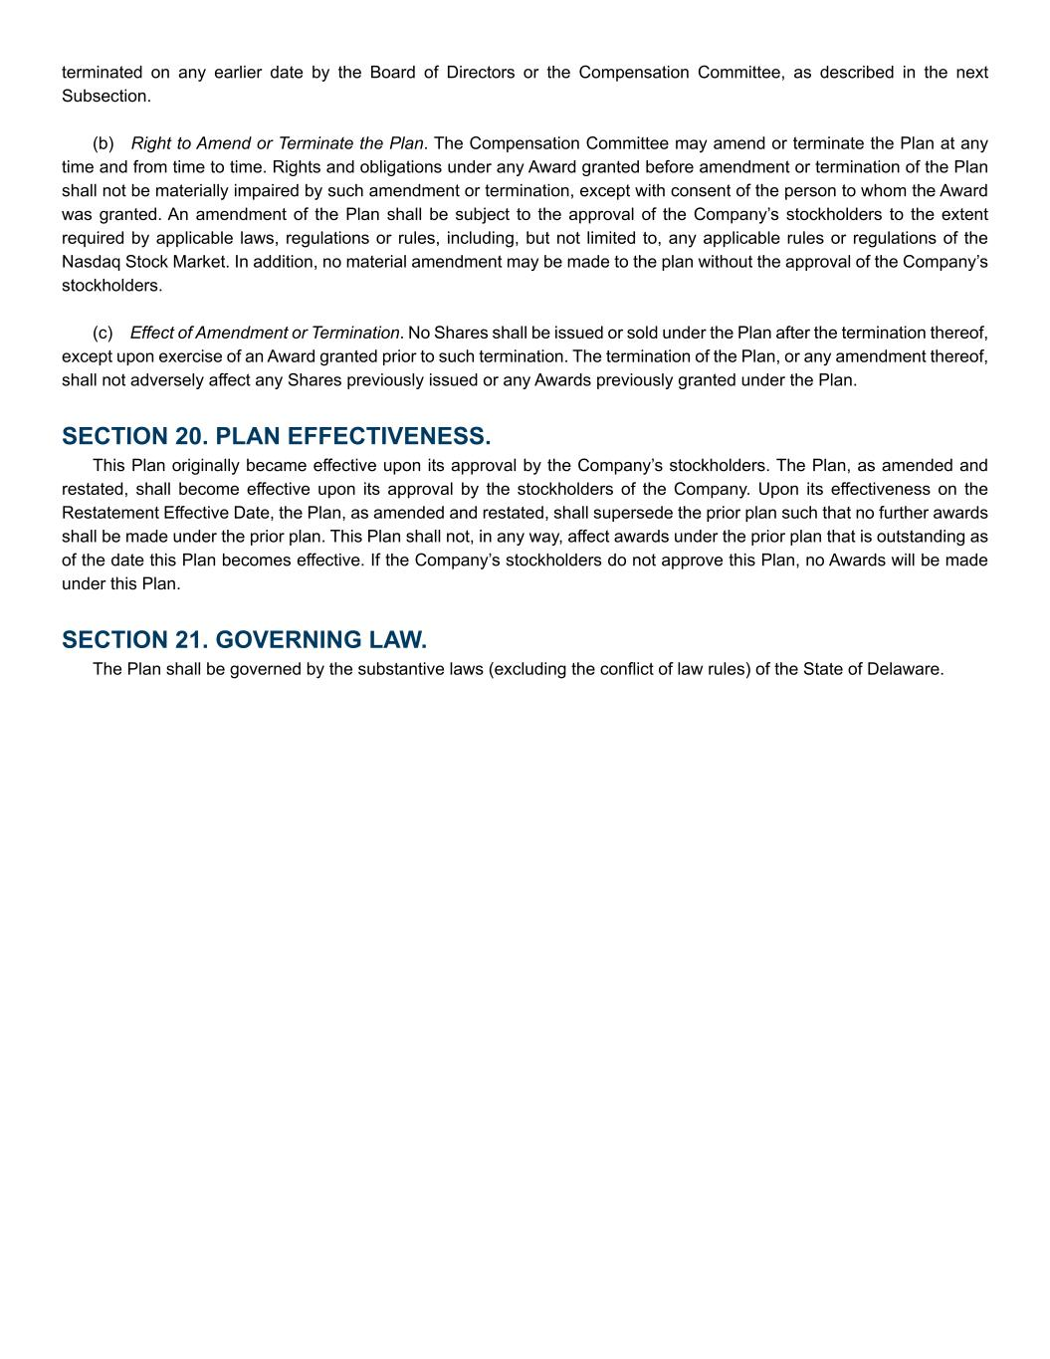
terminated on any earlier date by the Board of Directors or the Compensation Committee, as described in the next Subsection. (b) Right to Amend or Terminate the Plan. The Compensation Committee may amend or terminate the Plan at any time and from time to time. Rights and obligations under any Award granted before amendment or termination of the Plan shall not be materially impaired by such amendment or termination, except with consent of the person to whom the Award was granted. An amendment of the Plan shall be subject to the approval of the Company’s stockholders to the extent required by applicable laws, regulations or rules, including, but not limited to, any applicable rules or regulations of the Nasdaq Stock Market. In addition, no material amendment may be made to the plan without the approval of the Company’s stockholders. (c) Effect of Amendment or Termination. No Shares shall be issued or sold under the Plan after the termination thereof, except upon exercise of an Award granted prior to such termination. The termination of the Plan, or any amendment thereof, shall not adversely affect any Shares previously issued or any Awards previously granted under the Plan. SECTION 20. PLAN EFFECTIVENESS. This Plan originally became effective upon its approval by the Company’s stockholders. The Plan, as amended and restated, shall become effective upon its approval by the stockholders of the Company. Upon its effectiveness on the Restatement Effective Date, the Plan, as amended and restated, shall supersede the prior plan such that no further awards shall be made under the prior plan. This Plan shall not, in any way, affect awards under the prior plan that is outstanding as of the date this Plan becomes effective. If the Company’s stockholders do not approve this Plan, no Awards will be made under this Plan. SECTION 21. GOVERNING LAW. The Plan shall be governed by the substantive laws (excluding the conflict of law rules) of the State of Delaware.

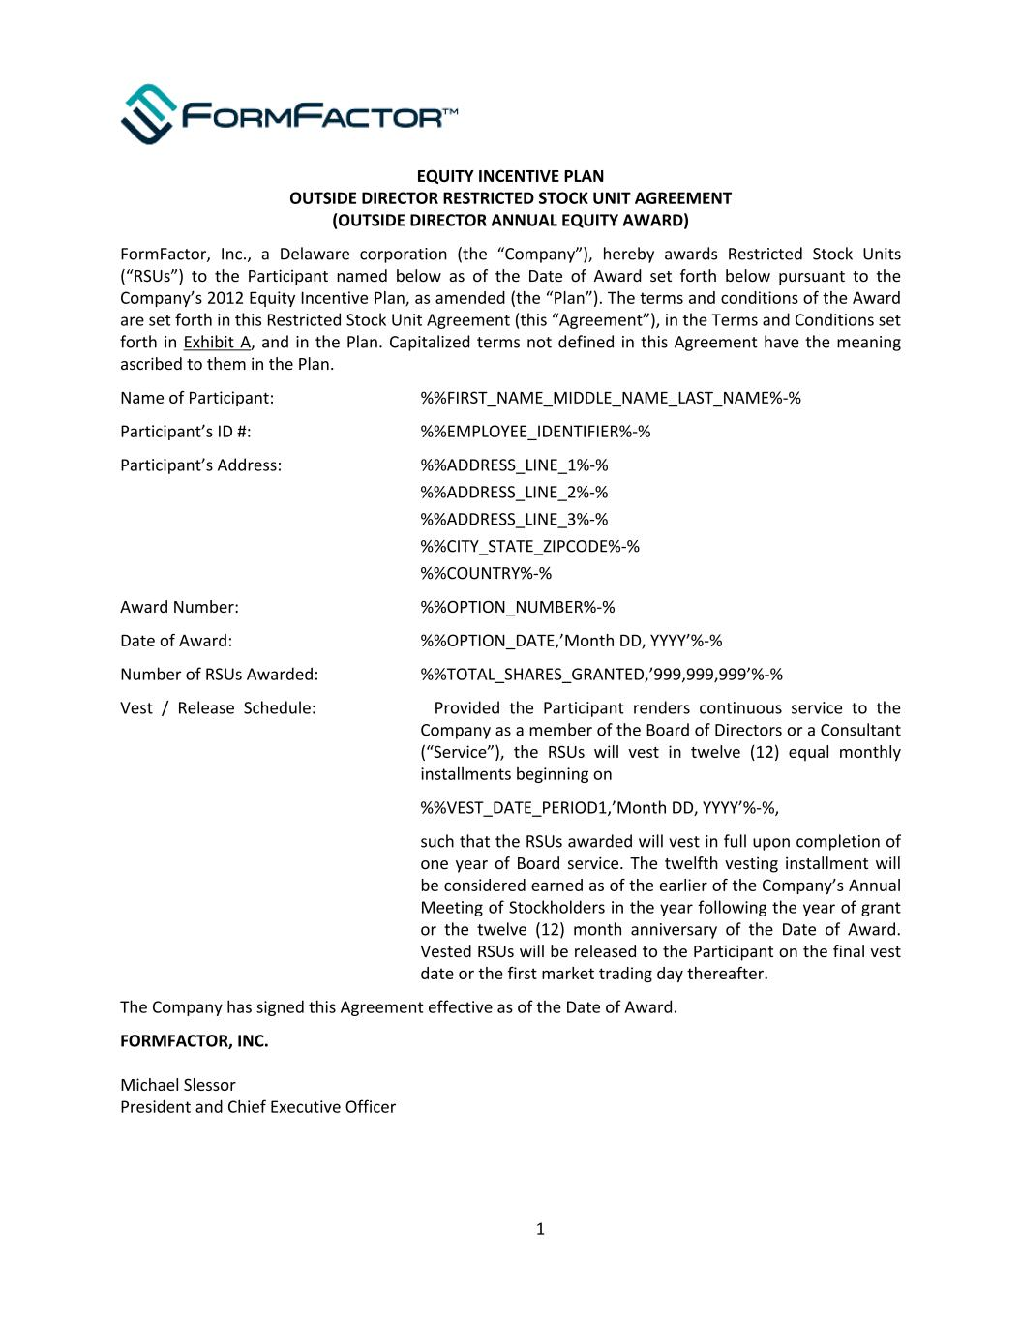
EQUITY INCENTIVE PLAN OUTSIDE DIRECTOR RESTRICTED STOCK UNIT AGREEMENT (OUTSIDE DIRECTOR ANNUAL EQUITY AWARD) FormFactor, Inc., a Delaware corporation (the “Company”), hereby awards Restricted Stock Units (“RSUs”) to the Participant named below as of the Date of Award set forth below pursuant to the Company’s 2012 Equity Incentive Plan, as amended (the “Plan”). The terms and conditions of the Award are set forth in this Restricted Stock Unit Agreement (this “Agreement”), in the Terms and Conditions set forth in Exhibit A, and in the Plan. Capitalized terms not defined in this Agreement have the meaning ascribed to them in the Plan. Name of Participant: %%FIRST_NAME_MIDDLE_NAME_LAST_NAME%-% Participant’s ID #: %%EMPLOYEE_IDENTIFIER%-% Participant’s Address: %%ADDRESS_LINE_1%-% %%ADDRESS_LINE_2%-% %%ADDRESS_LINE_3%-% %%CITY_STATE_ZIPCODE%-% %%COUNTRY%-% Award Number: %%OPTION_NUMBER%-% Date of Award: %%OPTION_DATE,’Month DD, YYYY’%-% Number of RSUs Awarded: %%TOTAL_SHARES_GRANTED,’999,999,999’%-% Vest / Release Schedule: Provided the Participant renders continuous service to the Company as a member of the Board of Directors or a Consultant (“Service”), the RSUs will vest in twelve (12) equal monthly installments beginning on %%VEST_DATE_PERIOD1,’Month DD, YYYY’%-%, such that the RSUs awarded will vest in full upon completion of one year of Board service. The twelfth vesting installment will be considered earned as of the earlier of the Company’s Annual Meeting of Stockholders in the year following the year of grant or the twelve (12) month anniversary of the Date of Award. Vested RSUs will be released to the Participant on the final vest date or the first market trading day thereafter. The Company has signed this Agreement effective as of the Date of Award. FORMFACTOR, INC. Michael Slessor President and Chief Executive Officer 1

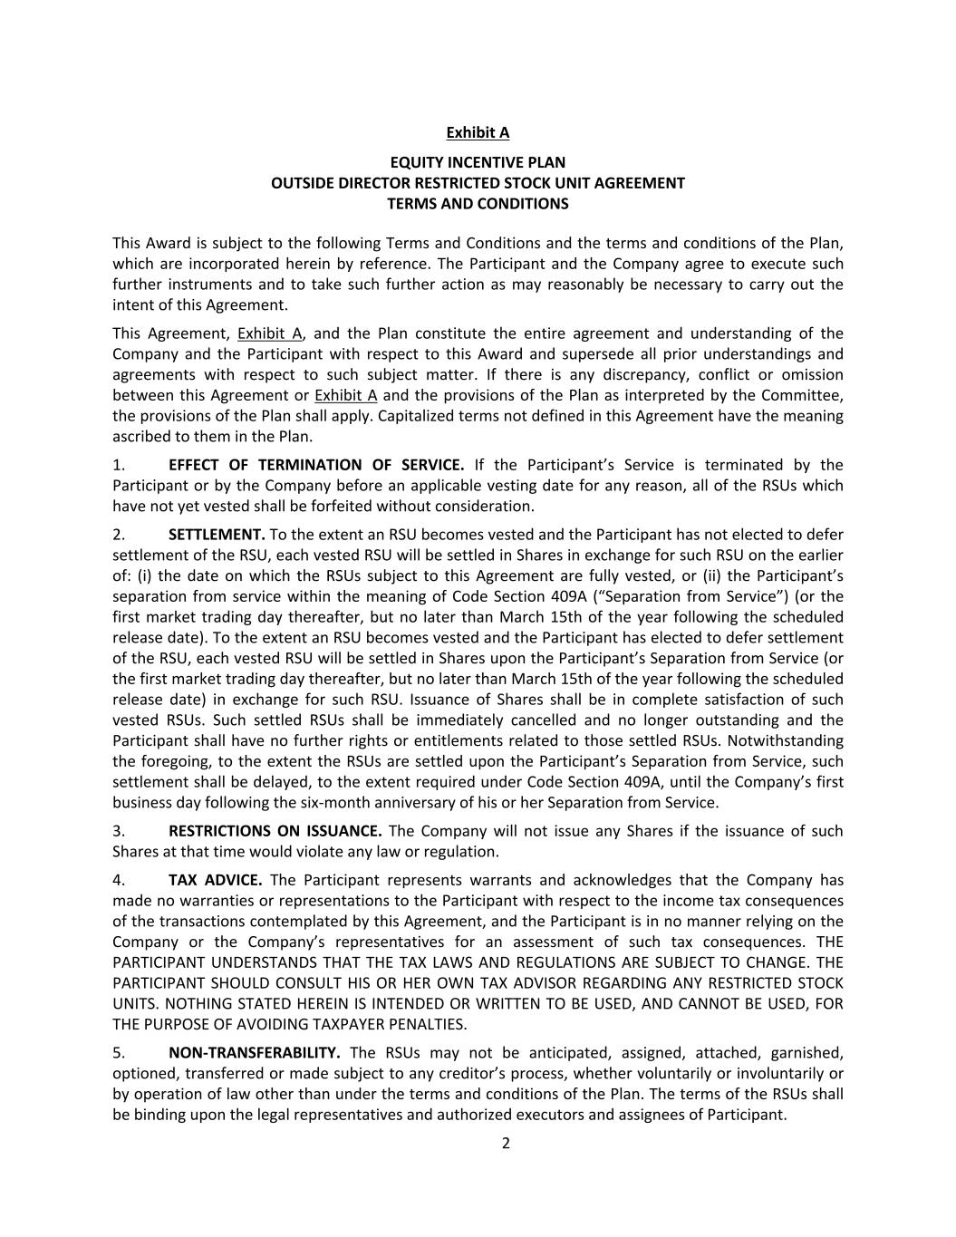
Exhibit A EQUITY INCENTIVE PLAN OUTSIDE DIRECTOR RESTRICTED STOCK UNIT AGREEMENT TERMS AND CONDITIONS This Award is subject to the following Terms and Conditions and the terms and conditions of the Plan, which are incorporated herein by reference. The Participant and the Company agree to execute such further instruments and to take such further action as may reasonably be necessary to carry out the intent of this Agreement. This Agreement, Exhibit A, and the Plan constitute the entire agreement and understanding of the Company and the Participant with respect to this Award and supersede all prior understandings and agreements with respect to such subject matter. If there is any discrepancy, conflict or omission between this Agreement or Exhibit A and the provisions of the Plan as interpreted by the Committee, the provisions of the Plan shall apply. Capitalized terms not defined in this Agreement have the meaning ascribed to them in the Plan. 1. EFFECT OF TERMINATION OF SERVICE. If the Participant’s Service is terminated by the Participant or by the Company before an applicable vesting date for any reason, all of the RSUs which have not yet vested shall be forfeited without consideration. 2. SETTLEMENT. To the extent an RSU becomes vested and the Participant has not elected to defer settlement of the RSU, each vested RSU will be settled in Shares in exchange for such RSU on the earlier of: (i) the date on which the RSUs subject to this Agreement are fully vested, or (ii) the Participant’s separation from service within the meaning of Code Section 409A (“Separation from Service”) (or the first market trading day thereafter, but no later than March 15th of the year following the scheduled release date). To the extent an RSU becomes vested and the Participant has elected to defer settlement of the RSU, each vested RSU will be settled in Shares upon the Participant’s Separation from Service (or the first market trading day thereafter, but no later than March 15th of the year following the scheduled release date) in exchange for such RSU. Issuance of Shares shall be in complete satisfaction of such vested RSUs. Such settled RSUs shall be immediately cancelled and no longer outstanding and the Participant shall have no further rights or entitlements related to those settled RSUs. Notwithstanding the foregoing, to the extent the RSUs are settled upon the Participant’s Separation from Service, such settlement shall be delayed, to the extent required under Code Section 409A, until the Company’s first business day following the six-month anniversary of his or her Separation from Service. 3. RESTRICTIONS ON ISSUANCE. The Company will not issue any Shares if the issuance of such Shares at that time would violate any law or regulation. 4. TAX ADVICE. The Participant represents warrants and acknowledges that the Company has made no warranties or representations to the Participant with respect to the income tax consequences of the transactions contemplated by this Agreement, and the Participant is in no manner relying on the Company or the Company’s representatives for an assessment of such tax consequences. THE PARTICIPANT UNDERSTANDS THAT THE TAX LAWS AND REGULATIONS ARE SUBJECT TO CHANGE. THE PARTICIPANT SHOULD CONSULT HIS OR HER OWN TAX ADVISOR REGARDING ANY RESTRICTED STOCK UNITS. NOTHING STATED HEREIN IS INTENDED OR WRITTEN TO BE USED, AND CANNOT BE USED, FOR THE PURPOSE OF AVOIDING TAXPAYER PENALTIES. 5. NON-TRANSFERABILITY. The RSUs may not be anticipated, assigned, attached, garnished, optioned, transferred or made subject to any creditor’s process, whether voluntarily or involuntarily or by operation of law other than under the terms and conditions of the Plan. The terms of the RSUs shall be binding upon the legal representatives and authorized executors and assignees of Participant. 2

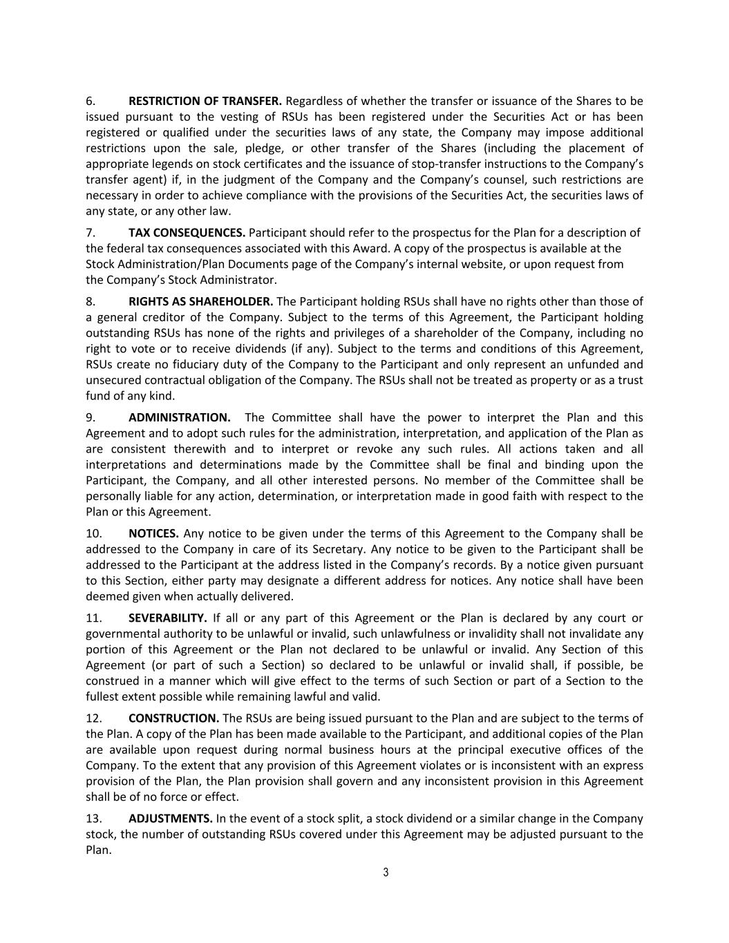
6. RESTRICTION OF TRANSFER. Regardless of whether the transfer or issuance of the Shares to be issued pursuant to the vesting of RSUs has been registered under the Securities Act or has been registered or qualified under the securities laws of any state, the Company may impose additional restrictions upon the sale, pledge, or other transfer of the Shares (including the placement of appropriate legends on stock certificates and the issuance of stop-transfer instructions to the Company’s transfer agent) if, in the judgment of the Company and the Company’s counsel, such restrictions are necessary in order to achieve compliance with the provisions of the Securities Act, the securities laws of any state, or any other law. 7. TAX CONSEQUENCES. Participant should refer to the prospectus for the Plan for a description of the federal tax consequences associated with this Award. A copy of the prospectus is available at the Stock Administration/Plan Documents page of the Company’s internal website, or upon request from the Company’s Stock Administrator. 8. RIGHTS AS SHAREHOLDER. The Participant holding RSUs shall have no rights other than those of a general creditor of the Company. Subject to the terms of this Agreement, the Participant holding outstanding RSUs has none of the rights and privileges of a shareholder of the Company, including no right to vote or to receive dividends (if any). Subject to the terms and conditions of this Agreement, RSUs create no fiduciary duty of the Company to the Participant and only represent an unfunded and unsecured contractual obligation of the Company. The RSUs shall not be treated as property or as a trust fund of any kind. 9. ADMINISTRATION. The Committee shall have the power to interpret the Plan and this Agreement and to adopt such rules for the administration, interpretation, and application of the Plan as are consistent therewith and to interpret or revoke any such rules. All actions taken and all interpretations and determinations made by the Committee shall be final and binding upon the Participant, the Company, and all other interested persons. No member of the Committee shall be personally liable for any action, determination, or interpretation made in good faith with respect to the Plan or this Agreement. 10. NOTICES. Any notice to be given under the terms of this Agreement to the Company shall be addressed to the Company in care of its Secretary. Any notice to be given to the Participant shall be addressed to the Participant at the address listed in the Company’s records. By a notice given pursuant to this Section, either party may designate a different address for notices. Any notice shall have been deemed given when actually delivered. 11. SEVERABILITY. If all or any part of this Agreement or the Plan is declared by any court or governmental authority to be unlawful or invalid, such unlawfulness or invalidity shall not invalidate any portion of this Agreement or the Plan not declared to be unlawful or invalid. Any Section of this Agreement (or part of such a Section) so declared to be unlawful or invalid shall, if possible, be construed in a manner which will give effect to the terms of such Section or part of a Section to the fullest extent possible while remaining lawful and valid. 12. CONSTRUCTION. The RSUs are being issued pursuant to the Plan and are subject to the terms of the Plan. A copy of the Plan has been made available to the Participant, and additional copies of the Plan are available upon request during normal business hours at the principal executive offices of the Company. To the extent that any provision of this Agreement violates or is inconsistent with an express provision of the Plan, the Plan provision shall govern and any inconsistent provision in this Agreement shall be of no force or effect. 13. ADJUSTMENTS. In the event of a stock split, a stock dividend or a similar change in the Company stock, the number of outstanding RSUs covered under this Agreement may be adjusted pursuant to the Plan. 3

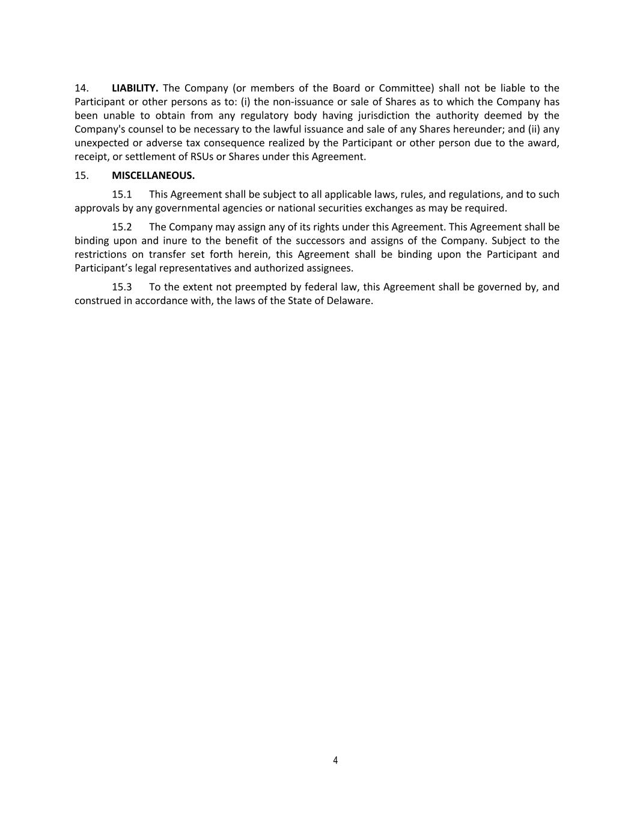
14. LIABILITY. The Company (or members of the Board or Committee) shall not be liable to the Participant or other persons as to: (i) the non-issuance or sale of Shares as to which the Company has been unable to obtain from any regulatory body having jurisdiction the authority deemed by the Company's counsel to be necessary to the lawful issuance and sale of any Shares hereunder; and (ii) any unexpected or adverse tax consequence realized by the Participant or other person due to the award, receipt, or settlement of RSUs or Shares under this Agreement. 15. MISCELLANEOUS. 15.1 This Agreement shall be subject to all applicable laws, rules, and regulations, and to such approvals by any governmental agencies or national securities exchanges as may be required. 15.2 The Company may assign any of its rights under this Agreement. This Agreement shall be binding upon and inure to the benefit of the successors and assigns of the Company. Subject to the restrictions on transfer set forth herein, this Agreement shall be binding upon the Participant and Participant’s legal representatives and authorized assignees. 15.3 To the extent not preempted by federal law, this Agreement shall be governed by, and construed in accordance with, the laws of the State of Delaware. 4

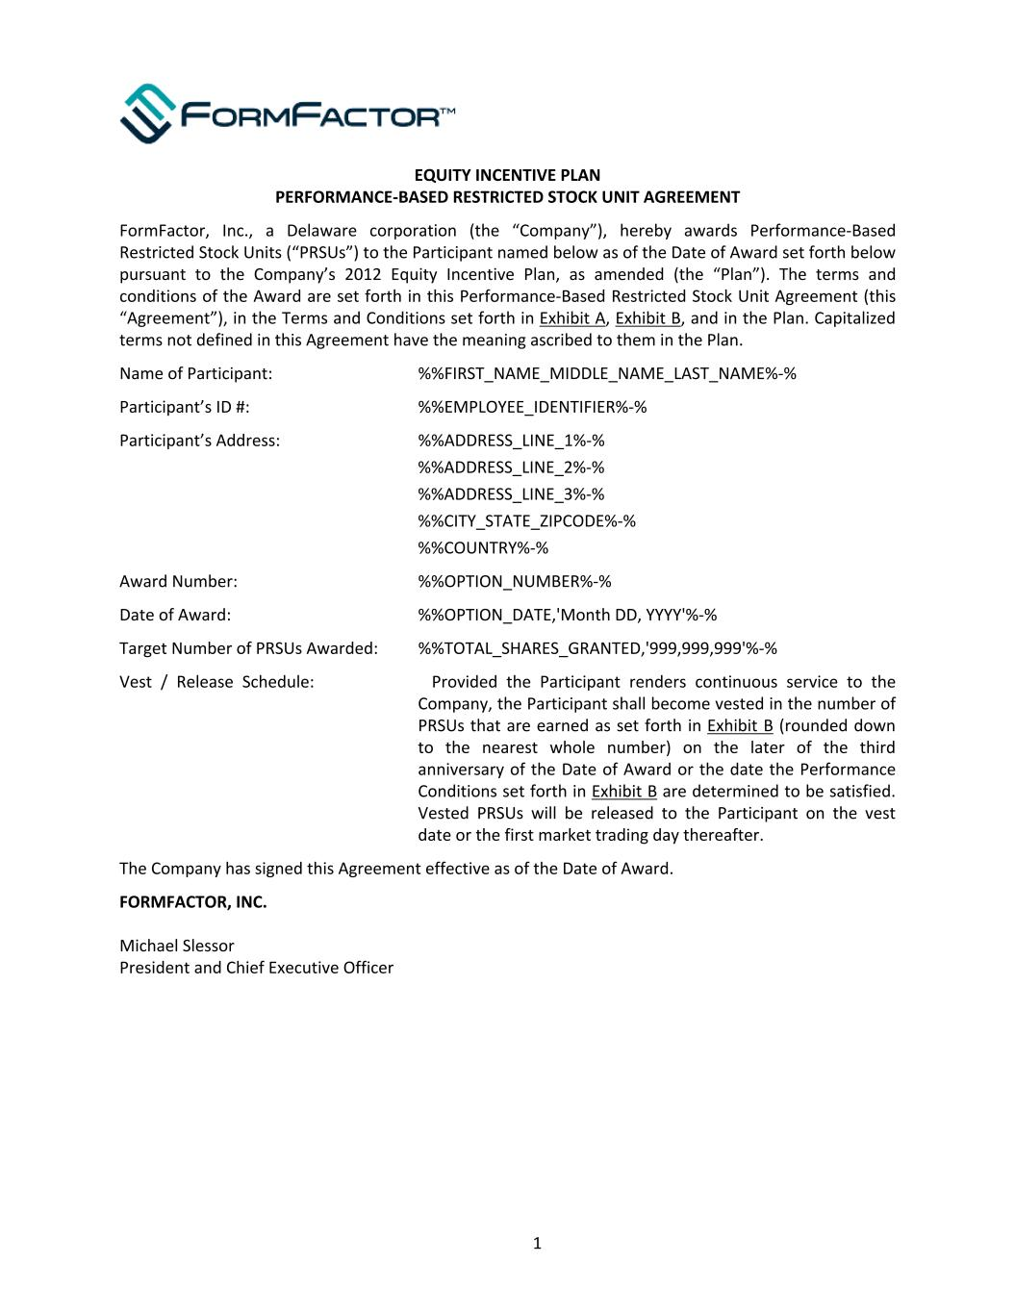
EQUITY INCENTIVE PLAN PERFORMANCE-BASED RESTRICTED STOCK UNIT AGREEMENT FormFactor, Inc., a Delaware corporation (the “Company”), hereby awards Performance-Based Restricted Stock Units (“PRSUs”) to the Participant named below as of the Date of Award set forth below pursuant to the Company’s 2012 Equity Incentive Plan, as amended (the “Plan”). The terms and conditions of the Award are set forth in this Performance-Based Restricted Stock Unit Agreement (this “Agreement”), in the Terms and Conditions set forth in Exhibit A, Exhibit B, and in the Plan. Capitalized terms not defined in this Agreement have the meaning ascribed to them in the Plan. Name of Participant: %%FIRST_NAME_MIDDLE_NAME_LAST_NAME%-% Participant’s ID #: %%EMPLOYEE_IDENTIFIER%-% Participant’s Address: %%ADDRESS_LINE_1%-% %%ADDRESS_LINE_2%-% %%ADDRESS_LINE_3%-% %%CITY_STATE_ZIPCODE%-% %%COUNTRY%-% Award Number: %%OPTION_NUMBER%-% Date of Award: %%OPTION_DATE,'Month DD, YYYY'%-% Target Number of PRSUs Awarded: %%TOTAL_SHARES_GRANTED,'999,999,999'%-% Vest / Release Schedule: Provided the Participant renders continuous service to the Company, the Participant shall become vested in the number of PRSUs that are earned as set forth in Exhibit B (rounded down to the nearest whole number) on the later of the third anniversary of the Date of Award or the date the Performance Conditions set forth in Exhibit B are determined to be satisfied. Vested PRSUs will be released to the Participant on the vest date or the first market trading day thereafter. The Company has signed this Agreement effective as of the Date of Award. FORMFACTOR, INC. Michael Slessor President and Chief Executive Officer 1

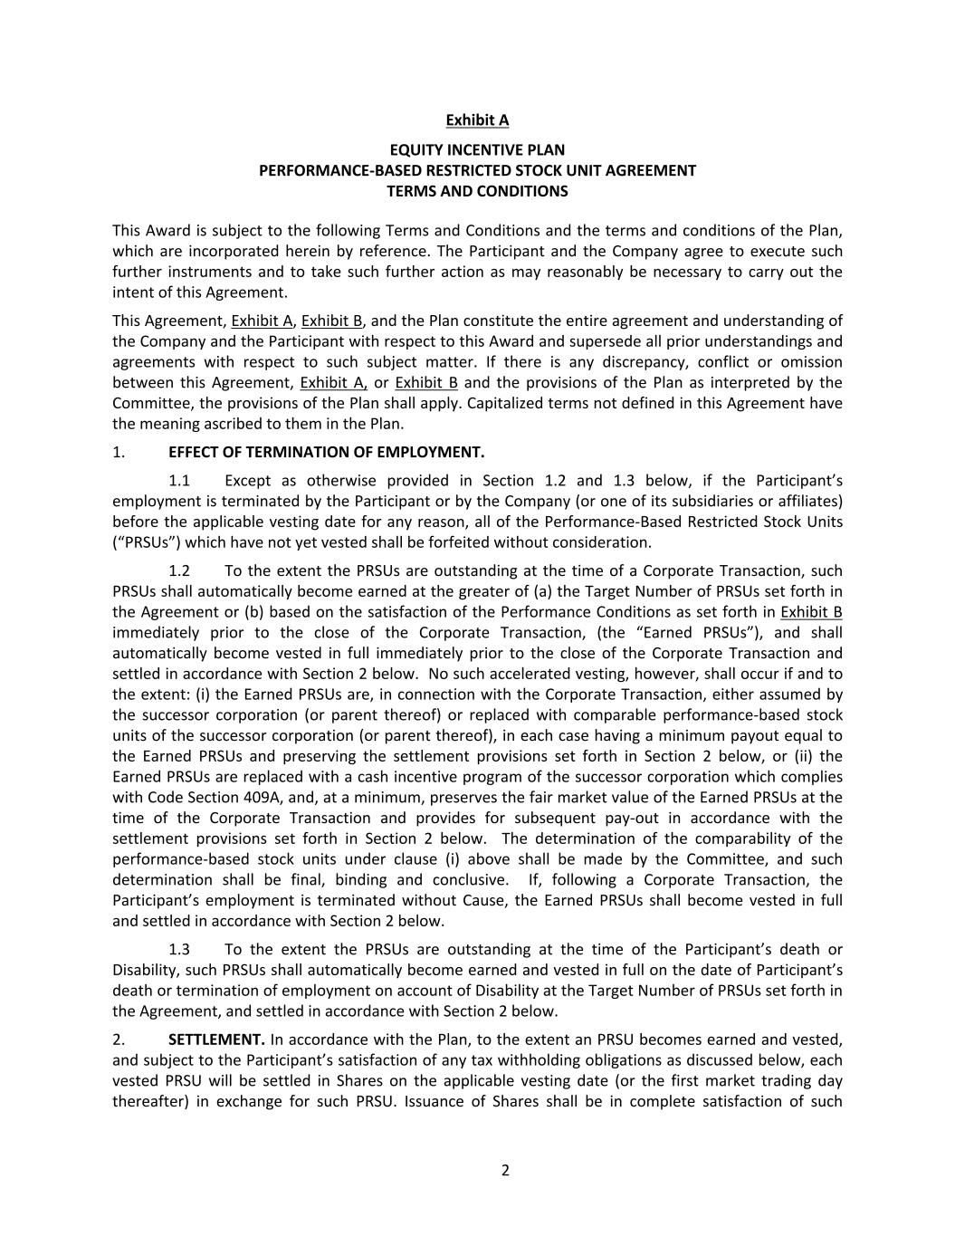
Exhibit A EQUITY INCENTIVE PLAN PERFORMANCE-BASED RESTRICTED STOCK UNIT AGREEMENT TERMS AND CONDITIONS This Award is subject to the following Terms and Conditions and the terms and conditions of the Plan, which are incorporated herein by reference. The Participant and the Company agree to execute such further instruments and to take such further action as may reasonably be necessary to carry out the intent of this Agreement. This Agreement, Exhibit A, Exhibit B, and the Plan constitute the entire agreement and understanding of the Company and the Participant with respect to this Award and supersede all prior understandings and agreements with respect to such subject matter. If there is any discrepancy, conflict or omission between this Agreement, Exhibit A, or Exhibit B and the provisions of the Plan as interpreted by the Committee, the provisions of the Plan shall apply. Capitalized terms not defined in this Agreement have the meaning ascribed to them in the Plan. 1. EFFECT OF TERMINATION OF EMPLOYMENT. 1.1 Except as otherwise provided in Section 1.2 and 1.3 below, if the Participant’s employment is terminated by the Participant or by the Company (or one of its subsidiaries or affiliates) before the applicable vesting date for any reason, all of the Performance-Based Restricted Stock Units (“PRSUs”) which have not yet vested shall be forfeited without consideration. 1.2 To the extent the PRSUs are outstanding at the time of a Corporate Transaction, such PRSUs shall automatically become earned at the greater of (a) the Target Number of PRSUs set forth in the Agreement or (b) based on the satisfaction of the Performance Conditions as set forth in Exhibit B immediately prior to the close of the Corporate Transaction, (the “Earned PRSUs”), and shall automatically become vested in full immediately prior to the close of the Corporate Transaction and settled in accordance with Section 2 below. No such accelerated vesting, however, shall occur if and to the extent: (i) the Earned PRSUs are, in connection with the Corporate Transaction, either assumed by the successor corporation (or parent thereof) or replaced with comparable performance-based stock units of the successor corporation (or parent thereof), in each case having a minimum payout equal to the Earned PRSUs and preserving the settlement provisions set forth in Section 2 below, or (ii) the Earned PRSUs are replaced with a cash incentive program of the successor corporation which complies with Code Section 409A, and, at a minimum, preserves the fair market value of the Earned PRSUs at the time of the Corporate Transaction and provides for subsequent pay-out in accordance with the settlement provisions set forth in Section 2 below. The determination of the comparability of the performance-based stock units under clause (i) above shall be made by the Committee, and such determination shall be final, binding and conclusive. If, following a Corporate Transaction, the Participant’s employment is terminated without Cause, the Earned PRSUs shall become vested in full and settled in accordance with Section 2 below. 1.3 To the extent the PRSUs are outstanding at the time of the Participant’s death or Disability, such PRSUs shall automatically become earned and vested in full on the date of Participant’s death or termination of employment on account of Disability at the Target Number of PRSUs set forth in the Agreement, and settled in accordance with Section 2 below. 2. SETTLEMENT. In accordance with the Plan, to the extent an PRSU becomes earned and vested, and subject to the Participant’s satisfaction of any tax withholding obligations as discussed below, each vested PRSU will be settled in Shares on the applicable vesting date (or the first market trading day thereafter) in exchange for such PRSU. Issuance of Shares shall be in complete satisfaction of such 2

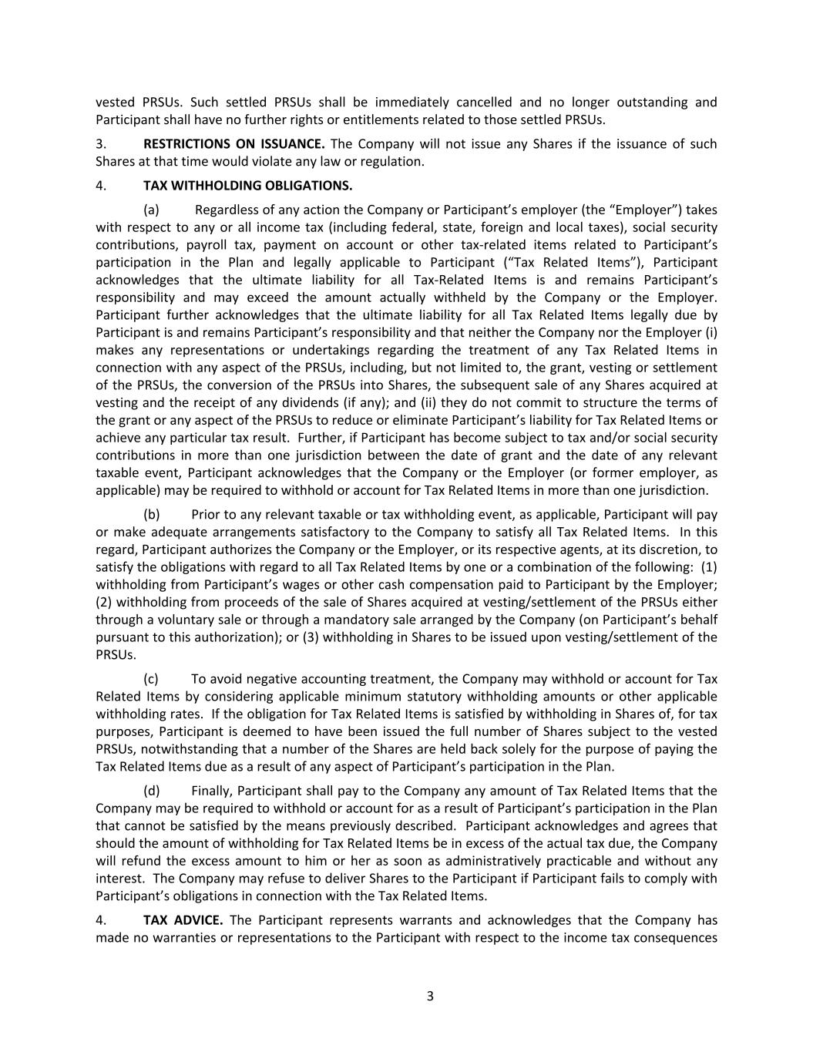
vested PRSUs. Such settled PRSUs shall be immediately cancelled and no longer outstanding and Participant shall have no further rights or entitlements related to those settled PRSUs. 3. RESTRICTIONS ON ISSUANCE. The Company will not issue any Shares if the issuance of such Shares at that time would violate any law or regulation. 4. TAX WITHHOLDING OBLIGATIONS. (a) Regardless of any action the Company or Participant’s employer (the “Employer”) takes with respect to any or all income tax (including federal, state, foreign and local taxes), social security contributions, payroll tax, payment on account or other tax-related items related to Participant’s participation in the Plan and legally applicable to Participant (“Tax Related Items”), Participant acknowledges that the ultimate liability for all Tax-Related Items is and remains Participant’s responsibility and may exceed the amount actually withheld by the Company or the Employer. Participant further acknowledges that the ultimate liability for all Tax Related Items legally due by Participant is and remains Participant’s responsibility and that neither the Company nor the Employer (i) makes any representations or undertakings regarding the treatment of any Tax Related Items in connection with any aspect of the PRSUs, including, but not limited to, the grant, vesting or settlement of the PRSUs, the conversion of the PRSUs into Shares, the subsequent sale of any Shares acquired at vesting and the receipt of any dividends (if any); and (ii) they do not commit to structure the terms of the grant or any aspect of the PRSUs to reduce or eliminate Participant’s liability for Tax Related Items or achieve any particular tax result. Further, if Participant has become subject to tax and/or social security contributions in more than one jurisdiction between the date of grant and the date of any relevant taxable event, Participant acknowledges that the Company or the Employer (or former employer, as applicable) may be required to withhold or account for Tax Related Items in more than one jurisdiction. (b) Prior to any relevant taxable or tax withholding event, as applicable, Participant will pay or make adequate arrangements satisfactory to the Company to satisfy all Tax Related Items. In this regard, Participant authorizes the Company or the Employer, or its respective agents, at its discretion, to satisfy the obligations with regard to all Tax Related Items by one or a combination of the following: (1) withholding from Participant’s wages or other cash compensation paid to Participant by the Employer; (2) withholding from proceeds of the sale of Shares acquired at vesting/settlement of the PRSUs either through a voluntary sale or through a mandatory sale arranged by the Company (on Participant’s behalf pursuant to this authorization); or (3) withholding in Shares to be issued upon vesting/settlement of the PRSUs. (c) To avoid negative accounting treatment, the Company may withhold or account for Tax Related Items by considering applicable minimum statutory withholding amounts or other applicable withholding rates. If the obligation for Tax Related Items is satisfied by withholding in Shares of, for tax purposes, Participant is deemed to have been issued the full number of Shares subject to the vested PRSUs, notwithstanding that a number of the Shares are held back solely for the purpose of paying the Tax Related Items due as a result of any aspect of Participant’s participation in the Plan. (d) Finally, Participant shall pay to the Company any amount of Tax Related Items that the Company may be required to withhold or account for as a result of Participant’s participation in the Plan that cannot be satisfied by the means previously described. Participant acknowledges and agrees that should the amount of withholding for Tax Related Items be in excess of the actual tax due, the Company will refund the excess amount to him or her as soon as administratively practicable and without any interest. The Company may refuse to deliver Shares to the Participant if Participant fails to comply with Participant’s obligations in connection with the Tax Related Items. 4. TAX ADVICE. The Participant represents warrants and acknowledges that the Company has made no warranties or representations to the Participant with respect to the income tax consequences 3

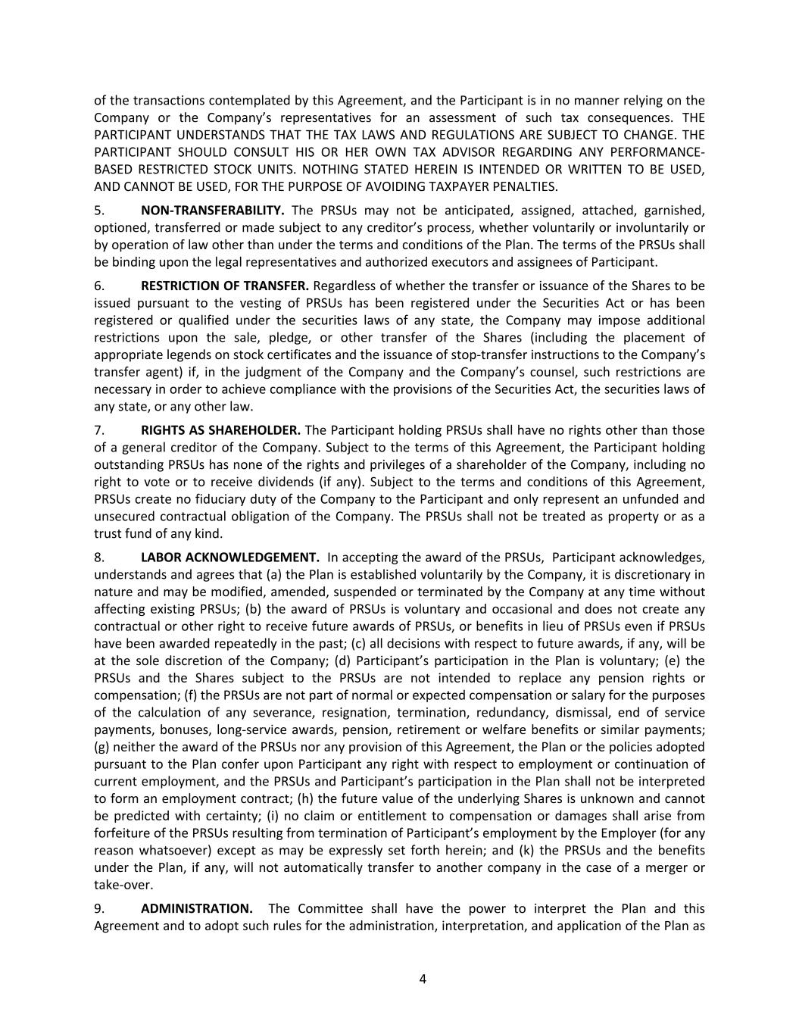
of the transactions contemplated by this Agreement, and the Participant is in no manner relying on the Company or the Company’s representatives for an assessment of such tax consequences. THE PARTICIPANT UNDERSTANDS THAT THE TAX LAWS AND REGULATIONS ARE SUBJECT TO CHANGE. THE PARTICIPANT SHOULD CONSULT HIS OR HER OWN TAX ADVISOR REGARDING ANY PERFORMANCE- BASED RESTRICTED STOCK UNITS. NOTHING STATED HEREIN IS INTENDED OR WRITTEN TO BE USED, AND CANNOT BE USED, FOR THE PURPOSE OF AVOIDING TAXPAYER PENALTIES. 5. NON-TRANSFERABILITY. The PRSUs may not be anticipated, assigned, attached, garnished, optioned, transferred or made subject to any creditor’s process, whether voluntarily or involuntarily or by operation of law other than under the terms and conditions of the Plan. The terms of the PRSUs shall be binding upon the legal representatives and authorized executors and assignees of Participant. 6. RESTRICTION OF TRANSFER. Regardless of whether the transfer or issuance of the Shares to be issued pursuant to the vesting of PRSUs has been registered under the Securities Act or has been registered or qualified under the securities laws of any state, the Company may impose additional restrictions upon the sale, pledge, or other transfer of the Shares (including the placement of appropriate legends on stock certificates and the issuance of stop-transfer instructions to the Company’s transfer agent) if, in the judgment of the Company and the Company’s counsel, such restrictions are necessary in order to achieve compliance with the provisions of the Securities Act, the securities laws of any state, or any other law. 7. RIGHTS AS SHAREHOLDER. The Participant holding PRSUs shall have no rights other than those of a general creditor of the Company. Subject to the terms of this Agreement, the Participant holding outstanding PRSUs has none of the rights and privileges of a shareholder of the Company, including no right to vote or to receive dividends (if any). Subject to the terms and conditions of this Agreement, PRSUs create no fiduciary duty of the Company to the Participant and only represent an unfunded and unsecured contractual obligation of the Company. The PRSUs shall not be treated as property or as a trust fund of any kind. 8. LABOR ACKNOWLEDGEMENT. In accepting the award of the PRSUs, Participant acknowledges, understands and agrees that (a) the Plan is established voluntarily by the Company, it is discretionary in nature and may be modified, amended, suspended or terminated by the Company at any time without affecting existing PRSUs; (b) the award of PRSUs is voluntary and occasional and does not create any contractual or other right to receive future awards of PRSUs, or benefits in lieu of PRSUs even if PRSUs have been awarded repeatedly in the past; (c) all decisions with respect to future awards, if any, will be at the sole discretion of the Company; (d) Participant’s participation in the Plan is voluntary; (e) the PRSUs and the Shares subject to the PRSUs are not intended to replace any pension rights or compensation; (f) the PRSUs are not part of normal or expected compensation or salary for the purposes of the calculation of any severance, resignation, termination, redundancy, dismissal, end of service payments, bonuses, long-service awards, pension, retirement or welfare benefits or similar payments; (g) neither the award of the PRSUs nor any provision of this Agreement, the Plan or the policies adopted pursuant to the Plan confer upon Participant any right with respect to employment or continuation of current employment, and the PRSUs and Participant’s participation in the Plan shall not be interpreted to form an employment contract; (h) the future value of the underlying Shares is unknown and cannot be predicted with certainty; (i) no claim or entitlement to compensation or damages shall arise from forfeiture of the PRSUs resulting from termination of Participant’s employment by the Employer (for any reason whatsoever) except as may be expressly set forth herein; and (k) the PRSUs and the benefits under the Plan, if any, will not automatically transfer to another company in the case of a merger or take-over. 9. ADMINISTRATION. The Committee shall have the power to interpret the Plan and this Agreement and to adopt such rules for the administration, interpretation, and application of the Plan as 4

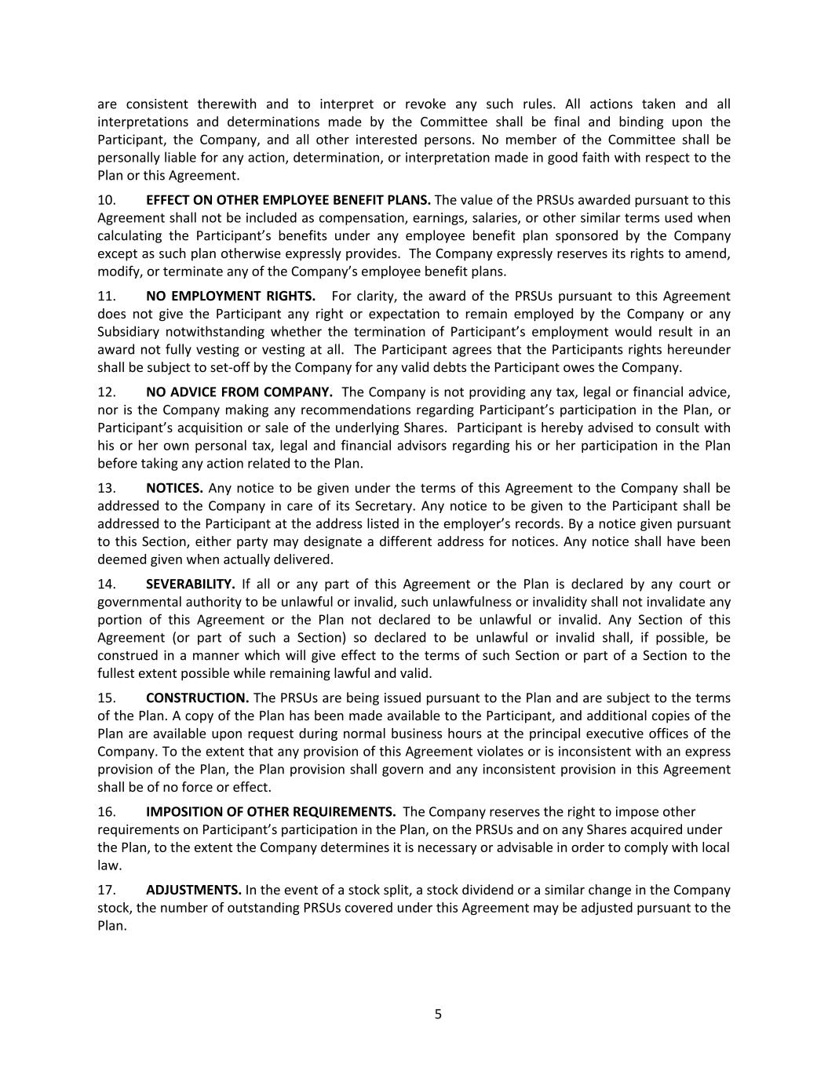
are consistent therewith and to interpret or revoke any such rules. All actions taken and all interpretations and determinations made by the Committee shall be final and binding upon the Participant, the Company, and all other interested persons. No member of the Committee shall be personally liable for any action, determination, or interpretation made in good faith with respect to the Plan or this Agreement. 10. EFFECT ON OTHER EMPLOYEE BENEFIT PLANS. The value of the PRSUs awarded pursuant to this Agreement shall not be included as compensation, earnings, salaries, or other similar terms used when calculating the Participant’s benefits under any employee benefit plan sponsored by the Company except as such plan otherwise expressly provides. The Company expressly reserves its rights to amend, modify, or terminate any of the Company’s employee benefit plans. 11. NO EMPLOYMENT RIGHTS. For clarity, the award of the PRSUs pursuant to this Agreement does not give the Participant any right or expectation to remain employed by the Company or any Subsidiary notwithstanding whether the termination of Participant’s employment would result in an award not fully vesting or vesting at all. The Participant agrees that the Participants rights hereunder shall be subject to set-off by the Company for any valid debts the Participant owes the Company. 12. NO ADVICE FROM COMPANY. The Company is not providing any tax, legal or financial advice, nor is the Company making any recommendations regarding Participant’s participation in the Plan, or Participant’s acquisition or sale of the underlying Shares. Participant is hereby advised to consult with his or her own personal tax, legal and financial advisors regarding his or her participation in the Plan before taking any action related to the Plan. 13. NOTICES. Any notice to be given under the terms of this Agreement to the Company shall be addressed to the Company in care of its Secretary. Any notice to be given to the Participant shall be addressed to the Participant at the address listed in the employer’s records. By a notice given pursuant to this Section, either party may designate a different address for notices. Any notice shall have been deemed given when actually delivered. 14. SEVERABILITY. If all or any part of this Agreement or the Plan is declared by any court or governmental authority to be unlawful or invalid, such unlawfulness or invalidity shall not invalidate any portion of this Agreement or the Plan not declared to be unlawful or invalid. Any Section of this Agreement (or part of such a Section) so declared to be unlawful or invalid shall, if possible, be construed in a manner which will give effect to the terms of such Section or part of a Section to the fullest extent possible while remaining lawful and valid. 15. CONSTRUCTION. The PRSUs are being issued pursuant to the Plan and are subject to the terms of the Plan. A copy of the Plan has been made available to the Participant, and additional copies of the Plan are available upon request during normal business hours at the principal executive offices of the Company. To the extent that any provision of this Agreement violates or is inconsistent with an express provision of the Plan, the Plan provision shall govern and any inconsistent provision in this Agreement shall be of no force or effect. 16. IMPOSITION OF OTHER REQUIREMENTS. The Company reserves the right to impose other requirements on Participant’s participation in the Plan, on the PRSUs and on any Shares acquired under the Plan, to the extent the Company determines it is necessary or advisable in order to comply with local law. 17. ADJUSTMENTS. In the event of a stock split, a stock dividend or a similar change in the Company stock, the number of outstanding PRSUs covered under this Agreement may be adjusted pursuant to the Plan. 5

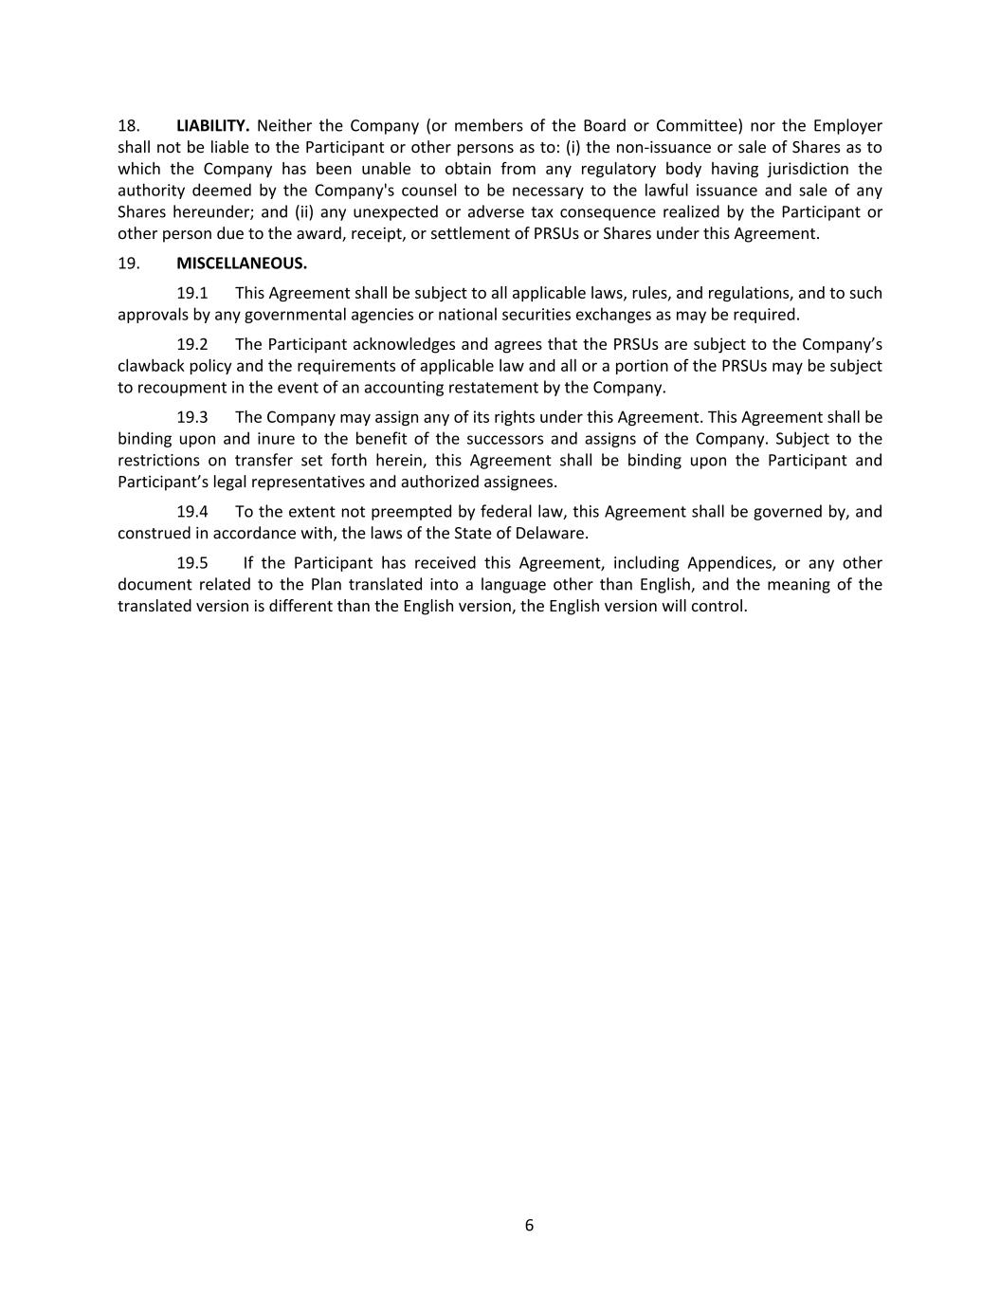
18. LIABILITY. Neither the Company (or members of the Board or Committee) nor the Employer shall not be liable to the Participant or other persons as to: (i) the non-issuance or sale of Shares as to which the Company has been unable to obtain from any regulatory body having jurisdiction the authority deemed by the Company's counsel to be necessary to the lawful issuance and sale of any Shares hereunder; and (ii) any unexpected or adverse tax consequence realized by the Participant or other person due to the award, receipt, or settlement of PRSUs or Shares under this Agreement. 19. MISCELLANEOUS. 19.1 This Agreement shall be subject to all applicable laws, rules, and regulations, and to such approvals by any governmental agencies or national securities exchanges as may be required. 19.2 The Participant acknowledges and agrees that the PRSUs are subject to the Company’s clawback policy and the requirements of applicable law and all or a portion of the PRSUs may be subject to recoupment in the event of an accounting restatement by the Company. 19.3 The Company may assign any of its rights under this Agreement. This Agreement shall be binding upon and inure to the benefit of the successors and assigns of the Company. Subject to the restrictions on transfer set forth herein, this Agreement shall be binding upon the Participant and Participant’s legal representatives and authorized assignees. 19.4 To the extent not preempted by federal law, this Agreement shall be governed by, and construed in accordance with, the laws of the State of Delaware. 19.5 If the Participant has received this Agreement, including Appendices, or any other document related to the Plan translated into a language other than English, and the meaning of the translated version is different than the English version, the English version will control. 6

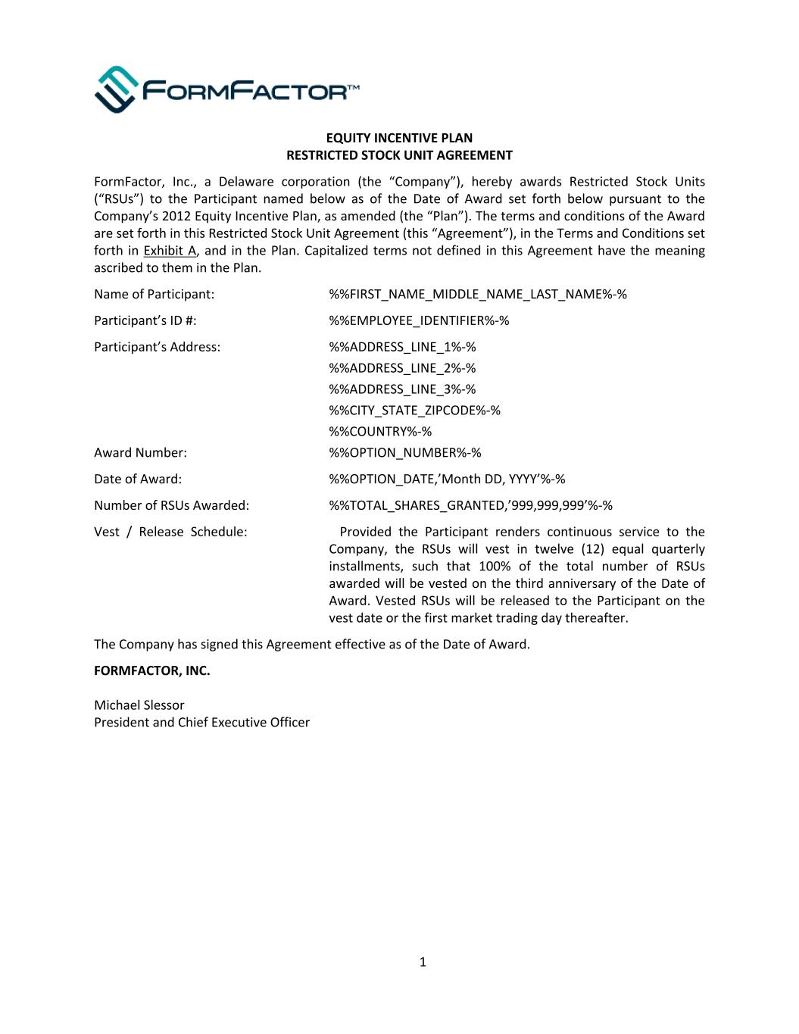
EQUITY INCENTIVE PLAN RESTRICTED STOCK UNIT AGREEMENT FormFactor, Inc., a Delaware corporation (the “Company”), hereby awards Restricted Stock Units (“RSUs”) to the Participant named below as of the Date of Award set forth below pursuant to the Company’s 2012 Equity Incentive Plan, as amended (the “Plan”). The terms and conditions of the Award are set forth in this Restricted Stock Unit Agreement (this “Agreement”), in the Terms and Conditions set forth in Exhibit A, and in the Plan. Capitalized terms not defined in this Agreement have the meaning ascribed to them in the Plan. Name of Participant: %%FIRST_NAME_MIDDLE_NAME_LAST_NAME%-% Participant’s ID #: %%EMPLOYEE_IDENTIFIER%-% Participant’s Address: %%ADDRESS_LINE_1%-% %%ADDRESS_LINE_2%-% %%ADDRESS_LINE_3%-% %%CITY_STATE_ZIPCODE%-% %%COUNTRY%-% Award Number: %%OPTION_NUMBER%-% Date of Award: %%OPTION_DATE,’Month DD, YYYY’%-% Number of RSUs Awarded: %%TOTAL_SHARES_GRANTED,’999,999,999’%-% Vest / Release Schedule: Provided the Participant renders continuous service to the Company, the RSUs will vest in twelve (12) equal quarterly installments, such that 100% of the total number of RSUs awarded will be vested on the third anniversary of the Date of Award. Vested RSUs will be released to the Participant on the vest date or the first market trading day thereafter. The Company has signed this Agreement effective as of the Date of Award. FORMFACTOR, INC. Michael Slessor President and Chief Executive Officer 1

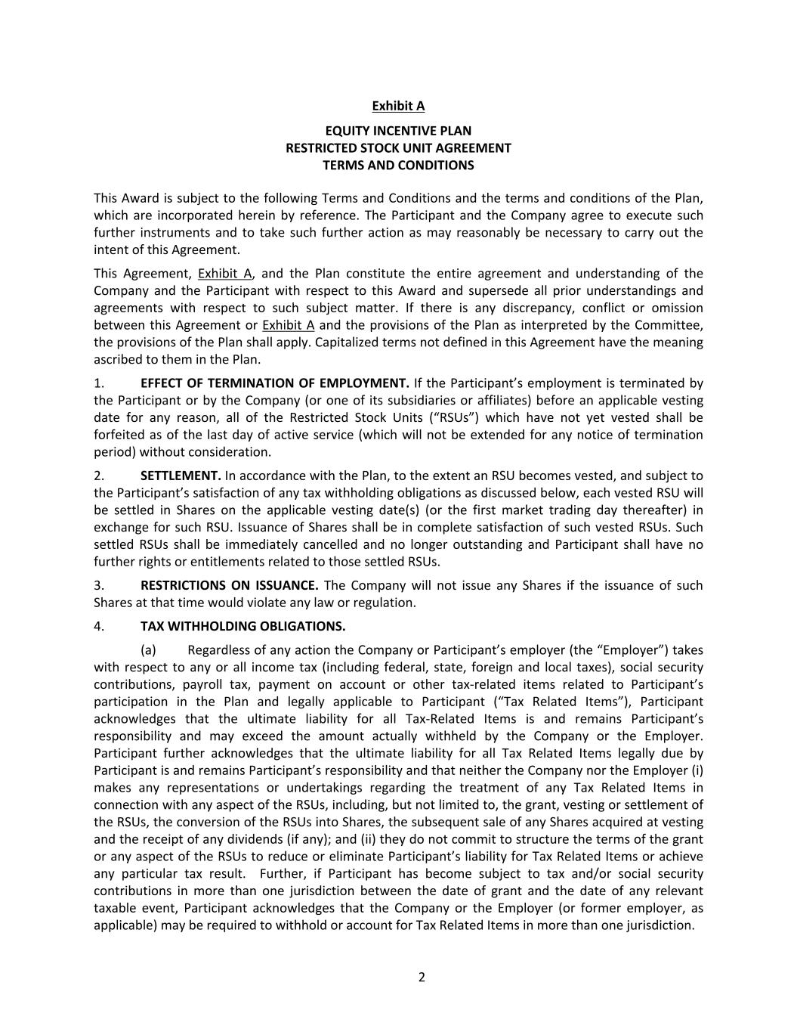
Exhibit A EQUITY INCENTIVE PLAN RESTRICTED STOCK UNIT AGREEMENT TERMS AND CONDITIONS This Award is subject to the following Terms and Conditions and the terms and conditions of the Plan, which are incorporated herein by reference. The Participant and the Company agree to execute such further instruments and to take such further action as may reasonably be necessary to carry out the intent of this Agreement. This Agreement, Exhibit A, and the Plan constitute the entire agreement and understanding of the Company and the Participant with respect to this Award and supersede all prior understandings and agreements with respect to such subject matter. If there is any discrepancy, conflict or omission between this Agreement or Exhibit A and the provisions of the Plan as interpreted by the Committee, the provisions of the Plan shall apply. Capitalized terms not defined in this Agreement have the meaning ascribed to them in the Plan. 1. EFFECT OF TERMINATION OF EMPLOYMENT. If the Participant’s employment is terminated by the Participant or by the Company (or one of its subsidiaries or affiliates) before an applicable vesting date for any reason, all of the Restricted Stock Units (“RSUs”) which have not yet vested shall be forfeited as of the last day of active service (which will not be extended for any notice of termination period) without consideration. 2. SETTLEMENT. In accordance with the Plan, to the extent an RSU becomes vested, and subject to the Participant’s satisfaction of any tax withholding obligations as discussed below, each vested RSU will be settled in Shares on the applicable vesting date(s) (or the first market trading day thereafter) in exchange for such RSU. Issuance of Shares shall be in complete satisfaction of such vested RSUs. Such settled RSUs shall be immediately cancelled and no longer outstanding and Participant shall have no further rights or entitlements related to those settled RSUs. 3. RESTRICTIONS ON ISSUANCE. The Company will not issue any Shares if the issuance of such Shares at that time would violate any law or regulation. 4. TAX WITHHOLDING OBLIGATIONS. (a) Regardless of any action the Company or Participant’s employer (the “Employer”) takes with respect to any or all income tax (including federal, state, foreign and local taxes), social security contributions, payroll tax, payment on account or other tax-related items related to Participant’s participation in the Plan and legally applicable to Participant (“Tax Related Items”), Participant acknowledges that the ultimate liability for all Tax-Related Items is and remains Participant’s responsibility and may exceed the amount actually withheld by the Company or the Employer. Participant further acknowledges that the ultimate liability for all Tax Related Items legally due by Participant is and remains Participant’s responsibility and that neither the Company nor the Employer (i) makes any representations or undertakings regarding the treatment of any Tax Related Items in connection with any aspect of the RSUs, including, but not limited to, the grant, vesting or settlement of the RSUs, the conversion of the RSUs into Shares, the subsequent sale of any Shares acquired at vesting and the receipt of any dividends (if any); and (ii) they do not commit to structure the terms of the grant or any aspect of the RSUs to reduce or eliminate Participant’s liability for Tax Related Items or achieve any particular tax result. Further, if Participant has become subject to tax and/or social security contributions in more than one jurisdiction between the date of grant and the date of any relevant taxable event, Participant acknowledges that the Company or the Employer (or former employer, as applicable) may be required to withhold or account for Tax Related Items in more than one jurisdiction. 2

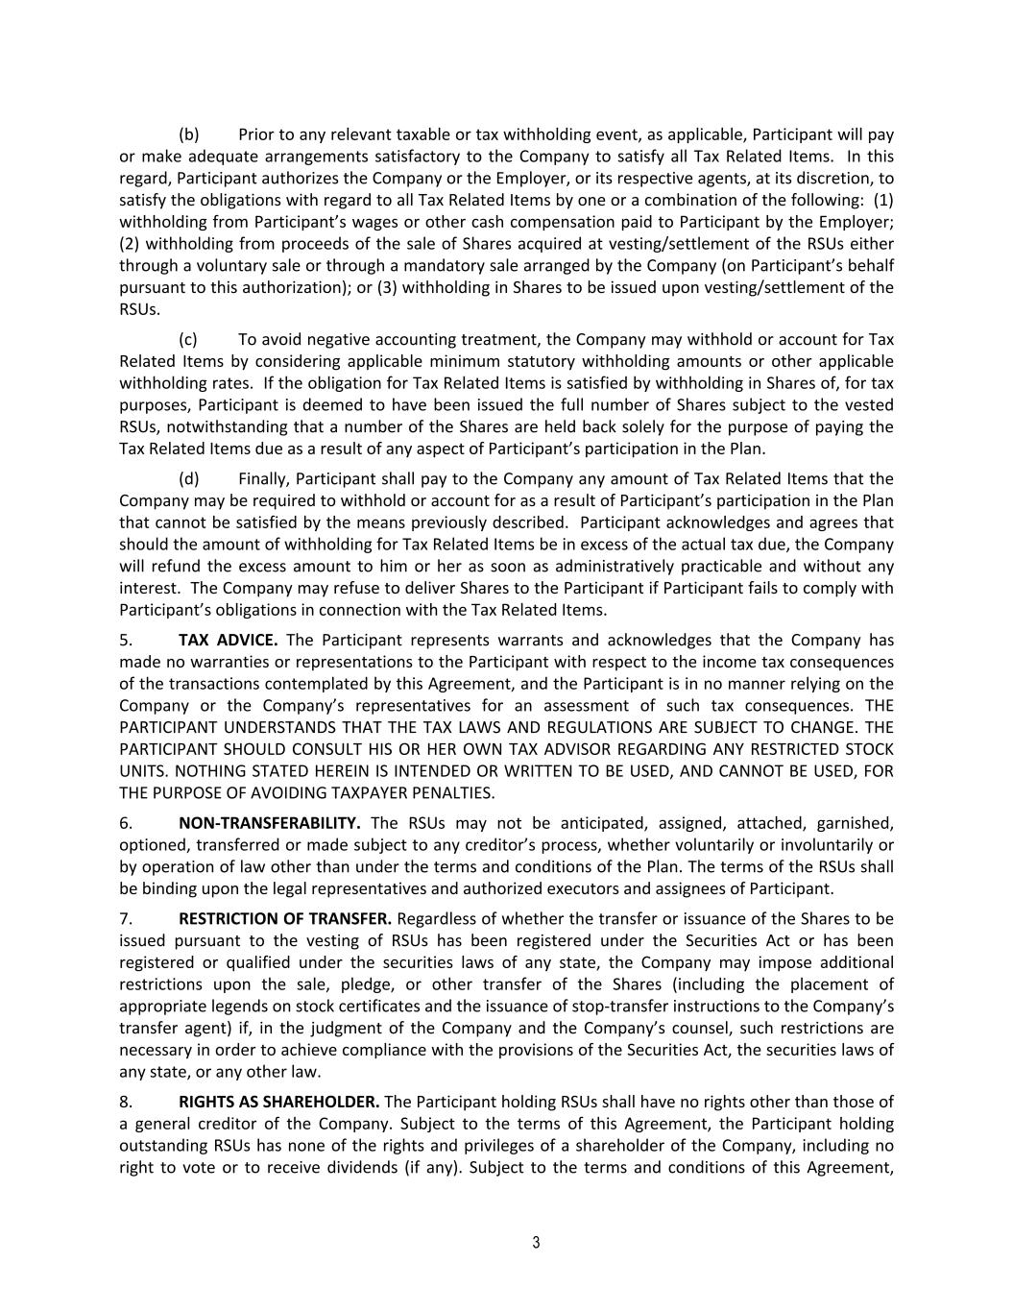
(b) Prior to any relevant taxable or tax withholding event, as applicable, Participant will pay or make adequate arrangements satisfactory to the Company to satisfy all Tax Related Items. In this regard, Participant authorizes the Company or the Employer, or its respective agents, at its discretion, to satisfy the obligations with regard to all Tax Related Items by one or a combination of the following: (1) withholding from Participant’s wages or other cash compensation paid to Participant by the Employer; (2) withholding from proceeds of the sale of Shares acquired at vesting/settlement of the RSUs either through a voluntary sale or through a mandatory sale arranged by the Company (on Participant’s behalf pursuant to this authorization); or (3) withholding in Shares to be issued upon vesting/settlement of the RSUs. (c) To avoid negative accounting treatment, the Company may withhold or account for Tax Related Items by considering applicable minimum statutory withholding amounts or other applicable withholding rates. If the obligation for Tax Related Items is satisfied by withholding in Shares of, for tax purposes, Participant is deemed to have been issued the full number of Shares subject to the vested RSUs, notwithstanding that a number of the Shares are held back solely for the purpose of paying the Tax Related Items due as a result of any aspect of Participant’s participation in the Plan. (d) Finally, Participant shall pay to the Company any amount of Tax Related Items that the Company may be required to withhold or account for as a result of Participant’s participation in the Plan that cannot be satisfied by the means previously described. Participant acknowledges and agrees that should the amount of withholding for Tax Related Items be in excess of the actual tax due, the Company will refund the excess amount to him or her as soon as administratively practicable and without any interest. The Company may refuse to deliver Shares to the Participant if Participant fails to comply with Participant’s obligations in connection with the Tax Related Items. 5. TAX ADVICE. The Participant represents warrants and acknowledges that the Company has made no warranties or representations to the Participant with respect to the income tax consequences of the transactions contemplated by this Agreement, and the Participant is in no manner relying on the Company or the Company’s representatives for an assessment of such tax consequences. THE PARTICIPANT UNDERSTANDS THAT THE TAX LAWS AND REGULATIONS ARE SUBJECT TO CHANGE. THE PARTICIPANT SHOULD CONSULT HIS OR HER OWN TAX ADVISOR REGARDING ANY RESTRICTED STOCK UNITS. NOTHING STATED HEREIN IS INTENDED OR WRITTEN TO BE USED, AND CANNOT BE USED, FOR THE PURPOSE OF AVOIDING TAXPAYER PENALTIES. 6. NON-TRANSFERABILITY. The RSUs may not be anticipated, assigned, attached, garnished, optioned, transferred or made subject to any creditor’s process, whether voluntarily or involuntarily or by operation of law other than under the terms and conditions of the Plan. The terms of the RSUs shall be binding upon the legal representatives and authorized executors and assignees of Participant. 7. RESTRICTION OF TRANSFER. Regardless of whether the transfer or issuance of the Shares to be issued pursuant to the vesting of RSUs has been registered under the Securities Act or has been registered or qualified under the securities laws of any state, the Company may impose additional restrictions upon the sale, pledge, or other transfer of the Shares (including the placement of appropriate legends on stock certificates and the issuance of stop-transfer instructions to the Company’s transfer agent) if, in the judgment of the Company and the Company’s counsel, such restrictions are necessary in order to achieve compliance with the provisions of the Securities Act, the securities laws of any state, or any other law. 8. RIGHTS AS SHAREHOLDER. The Participant holding RSUs shall have no rights other than those of a general creditor of the Company. Subject to the terms of this Agreement, the Participant holding outstanding RSUs has none of the rights and privileges of a shareholder of the Company, including no right to vote or to receive dividends (if any). Subject to the terms and conditions of this Agreement, 3

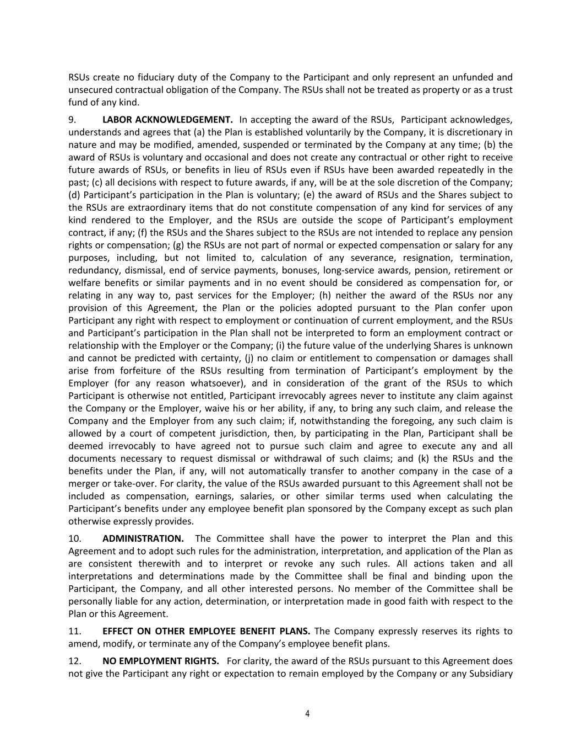
RSUs create no fiduciary duty of the Company to the Participant and only represent an unfunded and unsecured contractual obligation of the Company. The RSUs shall not be treated as property or as a trust fund of any kind. 9. LABOR ACKNOWLEDGEMENT. In accepting the award of the RSUs, Participant acknowledges, understands and agrees that (a) the Plan is established voluntarily by the Company, it is discretionary in nature and may be modified, amended, suspended or terminated by the Company at any time; (b) the award of RSUs is voluntary and occasional and does not create any contractual or other right to receive future awards of RSUs, or benefits in lieu of RSUs even if RSUs have been awarded repeatedly in the past; (c) all decisions with respect to future awards, if any, will be at the sole discretion of the Company; (d) Participant’s participation in the Plan is voluntary; (e) the award of RSUs and the Shares subject to the RSUs are extraordinary items that do not constitute compensation of any kind for services of any kind rendered to the Employer, and the RSUs are outside the scope of Participant’s employment contract, if any; (f) the RSUs and the Shares subject to the RSUs are not intended to replace any pension rights or compensation; (g) the RSUs are not part of normal or expected compensation or salary for any purposes, including, but not limited to, calculation of any severance, resignation, termination, redundancy, dismissal, end of service payments, bonuses, long-service awards, pension, retirement or welfare benefits or similar payments and in no event should be considered as compensation for, or relating in any way to, past services for the Employer; (h) neither the award of the RSUs nor any provision of this Agreement, the Plan or the policies adopted pursuant to the Plan confer upon Participant any right with respect to employment or continuation of current employment, and the RSUs and Participant’s participation in the Plan shall not be interpreted to form an employment contract or relationship with the Employer or the Company; (i) the future value of the underlying Shares is unknown and cannot be predicted with certainty, (j) no claim or entitlement to compensation or damages shall arise from forfeiture of the RSUs resulting from termination of Participant’s employment by the Employer (for any reason whatsoever), and in consideration of the grant of the RSUs to which Participant is otherwise not entitled, Participant irrevocably agrees never to institute any claim against the Company or the Employer, waive his or her ability, if any, to bring any such claim, and release the Company and the Employer from any such claim; if, notwithstanding the foregoing, any such claim is allowed by a court of competent jurisdiction, then, by participating in the Plan, Participant shall be deemed irrevocably to have agreed not to pursue such claim and agree to execute any and all documents necessary to request dismissal or withdrawal of such claims; and (k) the RSUs and the benefits under the Plan, if any, will not automatically transfer to another company in the case of a merger or take-over. For clarity, the value of the RSUs awarded pursuant to this Agreement shall not be included as compensation, earnings, salaries, or other similar terms used when calculating the Participant’s benefits under any employee benefit plan sponsored by the Company except as such plan otherwise expressly provides. 10. ADMINISTRATION. The Committee shall have the power to interpret the Plan and this Agreement and to adopt such rules for the administration, interpretation, and application of the Plan as are consistent therewith and to interpret or revoke any such rules. All actions taken and all interpretations and determinations made by the Committee shall be final and binding upon the Participant, the Company, and all other interested persons. No member of the Committee shall be personally liable for any action, determination, or interpretation made in good faith with respect to the Plan or this Agreement. 11. EFFECT ON OTHER EMPLOYEE BENEFIT PLANS. The Company expressly reserves its rights to amend, modify, or terminate any of the Company’s employee benefit plans. 12. NO EMPLOYMENT RIGHTS. For clarity, the award of the RSUs pursuant to this Agreement does not give the Participant any right or expectation to remain employed by the Company or any Subsidiary 4

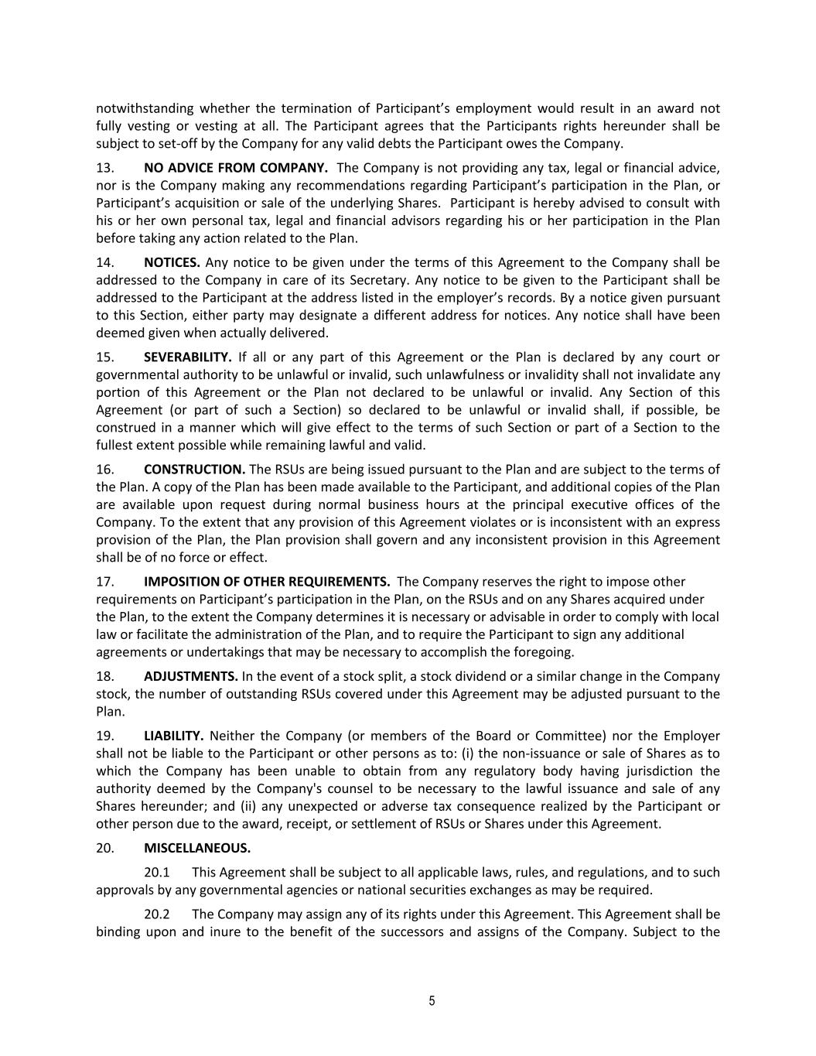
notwithstanding whether the termination of Participant’s employment would result in an award not fully vesting or vesting at all. The Participant agrees that the Participants rights hereunder shall be subject to set-off by the Company for any valid debts the Participant owes the Company. 13. NO ADVICE FROM COMPANY. The Company is not providing any tax, legal or financial advice, nor is the Company making any recommendations regarding Participant’s participation in the Plan, or Participant’s acquisition or sale of the underlying Shares. Participant is hereby advised to consult with his or her own personal tax, legal and financial advisors regarding his or her participation in the Plan before taking any action related to the Plan. 14. NOTICES. Any notice to be given under the terms of this Agreement to the Company shall be addressed to the Company in care of its Secretary. Any notice to be given to the Participant shall be addressed to the Participant at the address listed in the employer’s records. By a notice given pursuant to this Section, either party may designate a different address for notices. Any notice shall have been deemed given when actually delivered. 15. SEVERABILITY. If all or any part of this Agreement or the Plan is declared by any court or governmental authority to be unlawful or invalid, such unlawfulness or invalidity shall not invalidate any portion of this Agreement or the Plan not declared to be unlawful or invalid. Any Section of this Agreement (or part of such a Section) so declared to be unlawful or invalid shall, if possible, be construed in a manner which will give effect to the terms of such Section or part of a Section to the fullest extent possible while remaining lawful and valid. 16. CONSTRUCTION. The RSUs are being issued pursuant to the Plan and are subject to the terms of the Plan. A copy of the Plan has been made available to the Participant, and additional copies of the Plan are available upon request during normal business hours at the principal executive offices of the Company. To the extent that any provision of this Agreement violates or is inconsistent with an express provision of the Plan, the Plan provision shall govern and any inconsistent provision in this Agreement shall be of no force or effect. 17. IMPOSITION OF OTHER REQUIREMENTS. The Company reserves the right to impose other requirements on Participant’s participation in the Plan, on the RSUs and on any Shares acquired under the Plan, to the extent the Company determines it is necessary or advisable in order to comply with local law or facilitate the administration of the Plan, and to require the Participant to sign any additional agreements or undertakings that may be necessary to accomplish the foregoing. 18. ADJUSTMENTS. In the event of a stock split, a stock dividend or a similar change in the Company stock, the number of outstanding RSUs covered under this Agreement may be adjusted pursuant to the Plan. 19. LIABILITY. Neither the Company (or members of the Board or Committee) nor the Employer shall not be liable to the Participant or other persons as to: (i) the non-issuance or sale of Shares as to which the Company has been unable to obtain from any regulatory body having jurisdiction the authority deemed by the Company's counsel to be necessary to the lawful issuance and sale of any Shares hereunder; and (ii) any unexpected or adverse tax consequence realized by the Participant or other person due to the award, receipt, or settlement of RSUs or Shares under this Agreement. 20. MISCELLANEOUS. 20.1 This Agreement shall be subject to all applicable laws, rules, and regulations, and to such approvals by any governmental agencies or national securities exchanges as may be required. 20.2 The Company may assign any of its rights under this Agreement. This Agreement shall be binding upon and inure to the benefit of the successors and assigns of the Company. Subject to the 5


restrictions on transfer set forth herein, this Agreement shall be binding upon the Participant and Participant’s legal representatives and authorized assignees. 20.3 To the extent not preempted by federal law, this Agreement shall be governed by, and construed in accordance with, the laws of the State of Delaware. 20.4 If the Participant has received this Agreement, including Appendices, or any other document related to the Plan translated into a language other than English, and the meaning of the translated version is different than the English version, the English version will control. 6

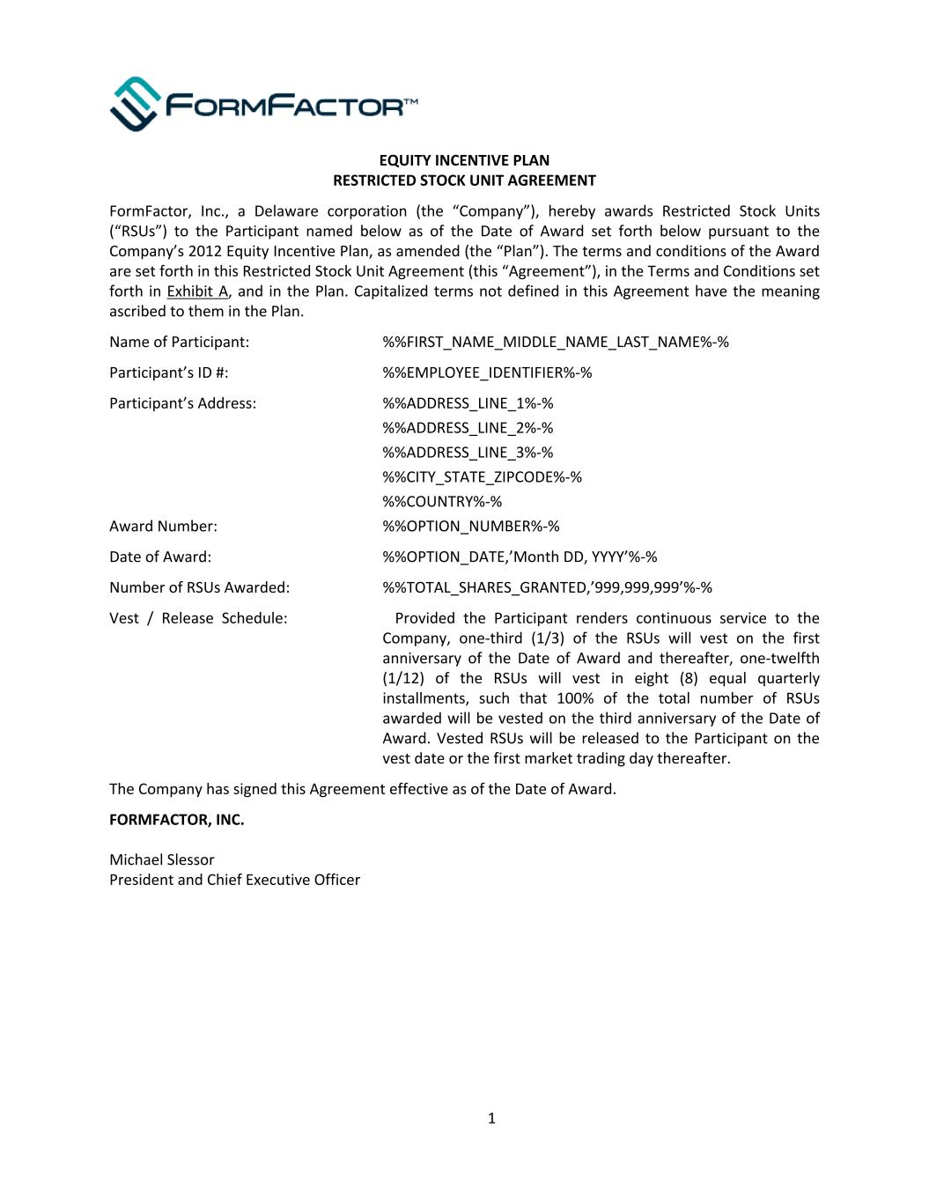
EQUITY INCENTIVE PLAN RESTRICTED STOCK UNIT AGREEMENT FormFactor, Inc., a Delaware corporation (the “Company”), hereby awards Restricted Stock Units (“RSUs”) to the Participant named below as of the Date of Award set forth below pursuant to the Company’s 2012 Equity Incentive Plan, as amended (the “Plan”). The terms and conditions of the Award are set forth in this Restricted Stock Unit Agreement (this “Agreement”), in the Terms and Conditions set forth in Exhibit A, and in the Plan. Capitalized terms not defined in this Agreement have the meaning ascribed to them in the Plan. Name of Participant: %%FIRST_NAME_MIDDLE_NAME_LAST_NAME%-% Participant’s ID #: %%EMPLOYEE_IDENTIFIER%-% Participant’s Address: %%ADDRESS_LINE_1%-% %%ADDRESS_LINE_2%-% %%ADDRESS_LINE_3%-% %%CITY_STATE_ZIPCODE%-% %%COUNTRY%-% Award Number: %%OPTION_NUMBER%-% Date of Award: %%OPTION_DATE,’Month DD, YYYY’%-% Number of RSUs Awarded: %%TOTAL_SHARES_GRANTED,’999,999,999’%-% Vest / Release Schedule: Provided the Participant renders continuous service to the Company, one-third (1/3) of the RSUs will vest on the first anniversary of the Date of Award and thereafter, one-twelfth (1/12) of the RSUs will vest in eight (8) equal quarterly installments, such that 100% of the total number of RSUs awarded will be vested on the third anniversary of the Date of Award. Vested RSUs will be released to the Participant on the vest date or the first market trading day thereafter. The Company has signed this Agreement effective as of the Date of Award. FORMFACTOR, INC. Michael Slessor President and Chief Executive Officer 1

Exhibit A EQUITY INCENTIVE PLAN RESTRICTED STOCK UNIT AGREEMENT TERMS AND CONDITIONS This Award is subject to the following Terms and Conditions and the terms and conditions of the Plan, which are incorporated herein by reference. The Participant and the Company agree to execute such further instruments and to take such further action as may reasonably be necessary to carry out the intent of this Agreement. This Agreement, Exhibit A, and the Plan constitute the entire agreement and understanding of the Company and the Participant with respect to this Award and supersede all prior understandings and agreements with respect to such subject matter. If there is any discrepancy, conflict or omission between this Agreement or Exhibit A and the provisions of the Plan as interpreted by the Committee, the provisions of the Plan shall apply. Capitalized terms not defined in this Agreement have the meaning ascribed to them in the Plan. 1. EFFECT OF TERMINATION OF EMPLOYMENT. If the Participant’s employment is terminated by the Participant or by the Company (or one of its subsidiaries or affiliates) before an applicable vesting date for any reason, all of the Restricted Stock Units (“RSUs”) which have not yet vested shall be forfeited as of the last day of active service (which will not be extended for any notice of termination period) without consideration. 2. SETTLEMENT. In accordance with the Plan, to the extent an RSU becomes vested, and subject to the Participant’s satisfaction of any tax withholding obligations as discussed below, each vested RSU will be settled in Shares on the applicable vesting date(s) (or the first market trading day thereafter) in exchange for such RSU. Issuance of Shares shall be in complete satisfaction of such vested RSUs. Such settled RSUs shall be immediately cancelled and no longer outstanding and Participant shall have no further rights or entitlements related to those settled RSUs. 3. RESTRICTIONS ON ISSUANCE. The Company will not issue any Shares if the issuance of such Shares at that time would violate any law or regulation. 4. TAX WITHHOLDING OBLIGATIONS. (a) Regardless of any action the Company or Participant’s employer (the “Employer”) takes with respect to any or all income tax (including federal, state, foreign and local taxes), social security contributions, payroll tax, payment on account or other tax-related items related to Participant’s participation in the Plan and legally applicable to Participant (“Tax Related Items”), Participant acknowledges that the ultimate liability for all Tax-Related Items is and remains Participant’s responsibility and may exceed the amount actually withheld by the Company or the Employer. Participant further acknowledges that the ultimate liability for all Tax Related Items legally due by Participant is and remains Participant’s responsibility and that neither the Company nor the Employer (i) makes any representations or undertakings regarding the treatment of any Tax Related Items in connection with any aspect of the RSUs, including, but not limited to, the grant, vesting or settlement of the RSUs, the conversion of the RSUs into Shares, the subsequent sale of any Shares acquired at vesting and the receipt of any dividends (if any); and (ii) they do not commit to structure the terms of the grant or any aspect of the RSUs to reduce or eliminate Participant’s liability for Tax Related Items or achieve any particular tax result. Further, if Participant has become subject to tax and/or social security contributions in more than one jurisdiction between the date of grant and the date of any relevant taxable event, Participant acknowledges that the Company or the Employer (or former employer, as applicable) may be required to withhold or account for Tax Related Items in more than one jurisdiction. 2

(b) Prior to any relevant taxable or tax withholding event, as applicable, Participant will pay or make adequate arrangements satisfactory to the Company to satisfy all Tax Related Items. In this regard, Participant authorizes the Company or the Employer, or its respective agents, at its discretion, to satisfy the obligations with regard to all Tax Related Items by one or a combination of the following: (1) withholding from Participant’s wages or other cash compensation paid to Participant by the Employer; (2) withholding from proceeds of the sale of Shares acquired at vesting/settlement of the RSUs either through a voluntary sale or through a mandatory sale arranged by the Company (on Participant’s behalf pursuant to this authorization); or (3) withholding in Shares to be issued upon vesting/settlement of the RSUs. (c) To avoid negative accounting treatment, the Company may withhold or account for Tax Related Items by considering applicable minimum statutory withholding amounts or other applicable withholding rates. If the obligation for Tax Related Items is satisfied by withholding in Shares of, for tax purposes, Participant is deemed to have been issued the full number of Shares subject to the vested RSUs, notwithstanding that a number of the Shares are held back solely for the purpose of paying the Tax Related Items due as a result of any aspect of Participant’s participation in the Plan. (d) Finally, Participant shall pay to the Company any amount of Tax Related Items that the Company may be required to withhold or account for as a result of Participant’s participation in the Plan that cannot be satisfied by the means previously described. Participant acknowledges and agrees that should the amount of withholding for Tax Related Items be in excess of the actual tax due, the Company will refund the excess amount to him or her as soon as administratively practicable and without any interest. The Company may refuse to deliver Shares to the Participant if Participant fails to comply with Participant’s obligations in connection with the Tax Related Items. 5. TAX ADVICE. The Participant represents warrants and acknowledges that the Company has made no warranties or representations to the Participant with respect to the income tax consequences of the transactions contemplated by this Agreement, and the Participant is in no manner relying on the Company or the Company’s representatives for an assessment of such tax consequences. THE PARTICIPANT UNDERSTANDS THAT THE TAX LAWS AND REGULATIONS ARE SUBJECT TO CHANGE. THE PARTICIPANT SHOULD CONSULT HIS OR HER OWN TAX ADVISOR REGARDING ANY RESTRICTED STOCK UNITS. NOTHING STATED HEREIN IS INTENDED OR WRITTEN TO BE USED, AND CANNOT BE USED, FOR THE PURPOSE OF AVOIDING TAXPAYER PENALTIES. 6. NON-TRANSFERABILITY. The RSUs may not be anticipated, assigned, attached, garnished, optioned, transferred or made subject to any creditor’s process, whether voluntarily or involuntarily or by operation of law other than under the terms and conditions of the Plan. The terms of the RSUs shall be binding upon the legal representatives and authorized executors and assignees of Participant. 7. RESTRICTION OF TRANSFER. Regardless of whether the transfer or issuance of the Shares to be issued pursuant to the vesting of RSUs has been registered under the Securities Act or has been registered or qualified under the securities laws of any state, the Company may impose additional restrictions upon the sale, pledge, or other transfer of the Shares (including the placement of appropriate legends on stock certificates and the issuance of stop-transfer instructions to the Company’s transfer agent) if, in the judgment of the Company and the Company’s counsel, such restrictions are necessary in order to achieve compliance with the provisions of the Securities Act, the securities laws of any state, or any other law. 8. RIGHTS AS SHAREHOLDER. The Participant holding RSUs shall have no rights other than those of a general creditor of the Company. Subject to the terms of this Agreement, the Participant holding outstanding RSUs has none of the rights and privileges of a shareholder of the Company, including no right to vote or to receive dividends (if any). Subject to the terms and conditions of this Agreement, 3

RSUs create no fiduciary duty of the Company to the Participant and only represent an unfunded and unsecured contractual obligation of the Company. The RSUs shall not be treated as property or as a trust fund of any kind. 9. LABOR ACKNOWLEDGEMENT. In accepting the award of the RSUs, Participant acknowledges, understands and agrees that (a) the Plan is established voluntarily by the Company, it is discretionary in nature and may be modified, amended, suspended or terminated by the Company at any time; (b) the award of RSUs is voluntary and occasional and does not create any contractual or other right to receive future awards of RSUs, or benefits in lieu of RSUs even if RSUs have been awarded repeatedly in the past; (c) all decisions with respect to future awards, if any, will be at the sole discretion of the Company; (d) Participant’s participation in the Plan is voluntary; (e) the award of RSUs and the Shares subject to the RSUs are extraordinary items that do not constitute compensation of any kind for services of any kind rendered to the Employer, and the RSUs are outside the scope of Participant’s employment contract, if any; (f) the RSUs and the Shares subject to the RSUs are not intended to replace any pension rights or compensation; (g) the RSUs are not part of normal or expected compensation or salary for any purposes, including, but not limited to, calculation of any severance, resignation, termination, redundancy, dismissal, end of service payments, bonuses, long-service awards, pension, retirement or welfare benefits or similar payments and in no event should be considered as compensation for, or relating in any way to, past services for the Employer; (h) neither the award of the RSUs nor any provision of this Agreement, the Plan or the policies adopted pursuant to the Plan confer upon Participant any right with respect to employment or continuation of current employment, and the RSUs and Participant’s participation in the Plan shall not be interpreted to form an employment contract or relationship with the Employer or the Company; (i) the future value of the underlying Shares is unknown and cannot be predicted with certainty, (j) no claim or entitlement to compensation or damages shall arise from forfeiture of the RSUs resulting from termination of Participant’s employment by the Employer (for any reason whatsoever), and in consideration of the grant of the RSUs to which Participant is otherwise not entitled, Participant irrevocably agrees never to institute any claim against the Company or the Employer, waive his or her ability, if any, to bring any such claim, and release the Company and the Employer from any such claim; if, notwithstanding the foregoing, any such claim is allowed by a court of competent jurisdiction, then, by participating in the Plan, Participant shall be deemed irrevocably to have agreed not to pursue such claim and agree to execute any and all documents necessary to request dismissal or withdrawal of such claims; and (k) the RSUs and the benefits under the Plan, if any, will not automatically transfer to another company in the case of a merger or take-over. For clarity, the value of the RSUs awarded pursuant to this Agreement shall not be included as compensation, earnings, salaries, or other similar terms used when calculating the Participant’s benefits under any employee benefit plan sponsored by the Company except as such plan otherwise expressly provides. 10. ADMINISTRATION. The Committee shall have the power to interpret the Plan and this Agreement and to adopt such rules for the administration, interpretation, and application of the Plan as are consistent therewith and to interpret or revoke any such rules. All actions taken and all interpretations and determinations made by the Committee shall be final and binding upon the Participant, the Company, and all other interested persons. No member of the Committee shall be personally liable for any action, determination, or interpretation made in good faith with respect to the Plan or this Agreement. 11. EFFECT ON OTHER EMPLOYEE BENEFIT PLANS. The Company expressly reserves its rights to amend, modify, or terminate any of the Company’s employee benefit plans. 12. NO EMPLOYMENT RIGHTS. For clarity, the award of the RSUs pursuant to this Agreement does not give the Participant any right or expectation to remain employed by the Company or any Subsidiary 4

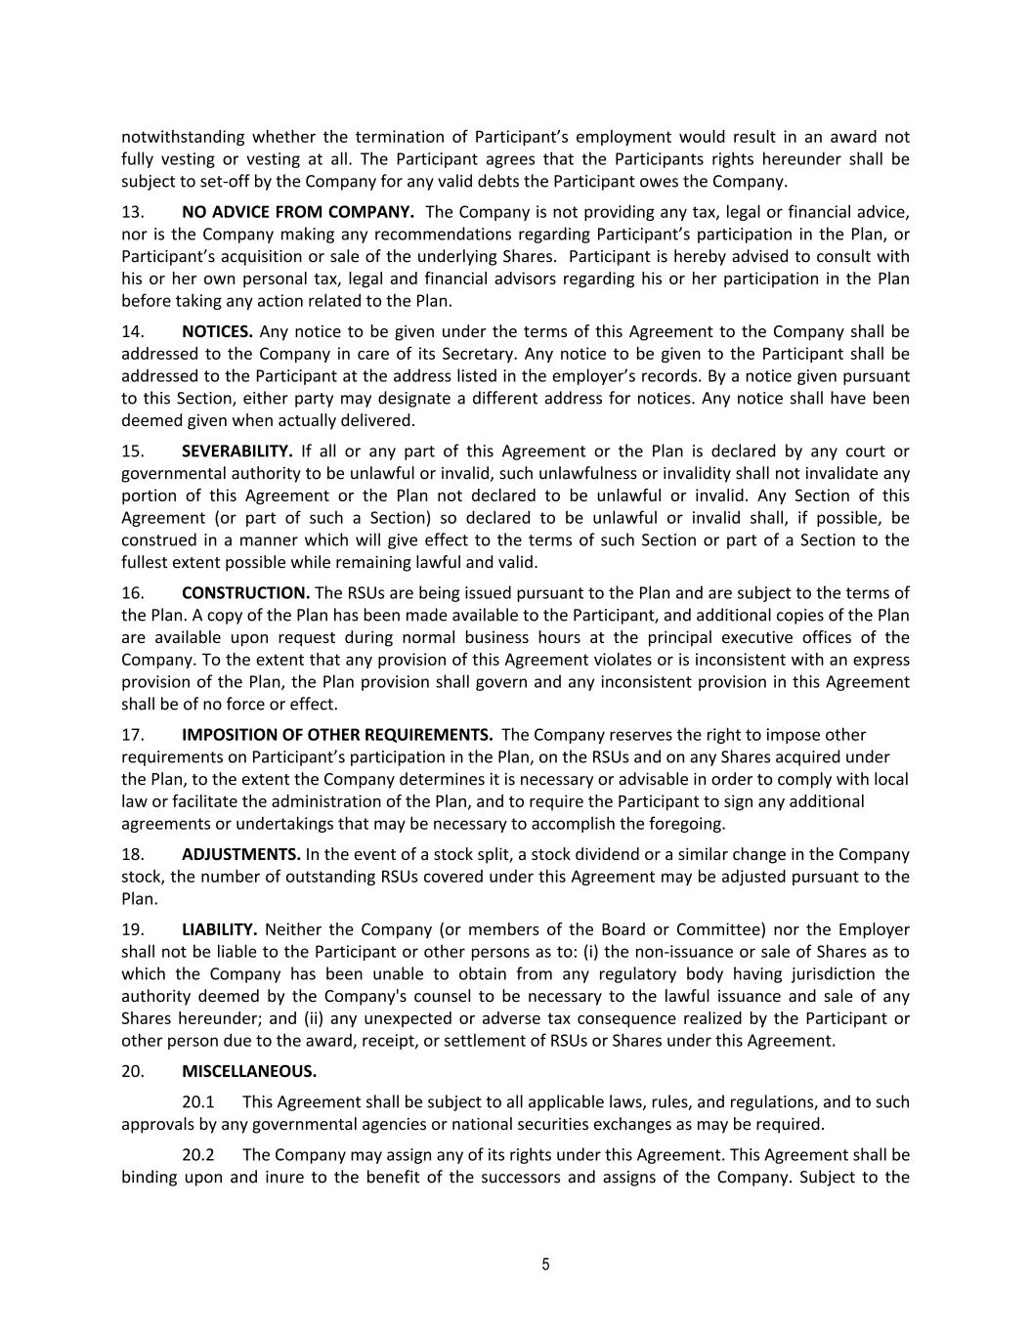
notwithstanding whether the termination of Participant’s employment would result in an award not fully vesting or vesting at all. The Participant agrees that the Participants rights hereunder shall be subject to set-off by the Company for any valid debts the Participant owes the Company. 13. NO ADVICE FROM COMPANY. The Company is not providing any tax, legal or financial advice, nor is the Company making any recommendations regarding Participant’s participation in the Plan, or Participant’s acquisition or sale of the underlying Shares. Participant is hereby advised to consult with his or her own personal tax, legal and financial advisors regarding his or her participation in the Plan before taking any action related to the Plan. 14. NOTICES. Any notice to be given under the terms of this Agreement to the Company shall be addressed to the Company in care of its Secretary. Any notice to be given to the Participant shall be addressed to the Participant at the address listed in the employer’s records. By a notice given pursuant to this Section, either party may designate a different address for notices. Any notice shall have been deemed given when actually delivered. 15. SEVERABILITY. If all or any part of this Agreement or the Plan is declared by any court or governmental authority to be unlawful or invalid, such unlawfulness or invalidity shall not invalidate any portion of this Agreement or the Plan not declared to be unlawful or invalid. Any Section of this Agreement (or part of such a Section) so declared to be unlawful or invalid shall, if possible, be construed in a manner which will give effect to the terms of such Section or part of a Section to the fullest extent possible while remaining lawful and valid. 16. CONSTRUCTION. The RSUs are being issued pursuant to the Plan and are subject to the terms of the Plan. A copy of the Plan has been made available to the Participant, and additional copies of the Plan are available upon request during normal business hours at the principal executive offices of the Company. To the extent that any provision of this Agreement violates or is inconsistent with an express provision of the Plan, the Plan provision shall govern and any inconsistent provision in this Agreement shall be of no force or effect. 17. IMPOSITION OF OTHER REQUIREMENTS. The Company reserves the right to impose other requirements on Participant’s participation in the Plan, on the RSUs and on any Shares acquired under the Plan, to the extent the Company determines it is necessary or advisable in order to comply with local law or facilitate the administration of the Plan, and to require the Participant to sign any additional agreements or undertakings that may be necessary to accomplish the foregoing. 18. ADJUSTMENTS. In the event of a stock split, a stock dividend or a similar change in the Company stock, the number of outstanding RSUs covered under this Agreement may be adjusted pursuant to the Plan. 19. LIABILITY. Neither the Company (or members of the Board or Committee) nor the Employer shall not be liable to the Participant or other persons as to: (i) the non-issuance or sale of Shares as to which the Company has been unable to obtain from any regulatory body having jurisdiction the authority deemed by the Company's counsel to be necessary to the lawful issuance and sale of any Shares hereunder; and (ii) any unexpected or adverse tax consequence realized by the Participant or other person due to the award, receipt, or settlement of RSUs or Shares under this Agreement. 20. MISCELLANEOUS. 20.1 This Agreement shall be subject to all applicable laws, rules, and regulations, and to such approvals by any governmental agencies or national securities exchanges as may be required. 20.2 The Company may assign any of its rights under this Agreement. This Agreement shall be binding upon and inure to the benefit of the successors and assigns of the Company. Subject to the 5

restrictions on transfer set forth herein, this Agreement shall be binding upon the Participant and Participant’s legal representatives and authorized assignees. 20.3 To the extent not preempted by federal law, this Agreement shall be governed by, and construed in accordance with, the laws of the State of Delaware. 20.4 If the Participant has received this Agreement, including Appendices, or any other document related to the Plan translated into a language other than English, and the meaning of the translated version is different than the English version, the English version will control. 6

EXHIBIT 31.01
CERTIFICATION OF CHIEF EXECUTIVE OFFICER
PURSUANT TO 15 U.S.C. SECTION 7241, AS
ADOPTED PURSUANT TO SECTION 302 OF THE SARBANES-OXLEY ACT OF 2002
I, Michael D. Slessor, certify that:
1. I have reviewed the quarterly report on Form 10-Q of FormFactor, Inc.;
2. Based on my knowledge, this report does not contain any untrue statement of a material fact or omit to state a material fact necessary to make the statements made, in light of the circumstances under which such statements were made, not misleading with respect to the period covered by this report;
3. Based on my knowledge, the financial statements, and other financial information included in this report, fairly present in all material respects the financial condition, results of operations and cash flows of the registrant as of, and for, the periods presented in this report;
4. The registrant's other certifying officer and I are responsible for establishing and maintaining disclosure controls and procedures (as defined in Exchange Act Rules 13a-15(e) and 15d-15(e)) and internal control over financial reporting (as defined in Exchange Act Rules 13a-15(f) and 15d-15(f)) for the registrant and have:
a. Designed such disclosure controls and procedures, or caused such disclosure controls and procedures to be designed under our supervision, to ensure that material information relating to the registrant, including its consolidated subsidiaries, is made known to us by others within those entities, particularly during the period in which this report is being prepared;
b. Designed such internal control over financial reporting, or caused such internal control over financial reporting to be designed under our supervision, to provide reasonable assurance regarding the reliability of financial reporting and the preparation of financial statements for external purposes in accordance with generally accepted accounting principles;
c. Evaluated the effectiveness of the registrant's disclosure controls and procedures and presented in this report our conclusions about the effectiveness of the disclosure controls and procedures, as of the end of the period covered by this report based on such evaluation; and
d. Disclosed in this report any change in the registrant's internal control over financial reporting that occurred during the registrant's most recent fiscal quarter that has materially affected, or is reasonably likely to materially affect, the registrant's internal control over financial reporting; and
5. The registrant's other certifying officer and I have disclosed, based on our most recent evaluation of internal control over financial reporting, to the registrant's auditors and the audit committee of the registrant's board of directors (or persons performing the equivalent functions):
a. All significant deficiencies and material weaknesses in the design or operation of internal control over financial reporting which are reasonably likely to adversely affect the registrant's ability to record, process, summarize and report financial information; and
b. Any fraud, whether or not material, that involves management or other employees who have a significant role in the registrant's internal control over financial reporting.
Date: |  |  | August 4, 2026 |  |  | /s/ MICHAEL D. SLESSOR
Michael D. Slessor
Chief Executive Officer
(Principal Executive Officer and Director)

EXHIBIT 31.02
CERTIFICATION OF CHIEF FINANCIAL OFFICER
PURSUANT TO 15 U.S.C. SECTION 7241,
AS ADOPTED PURSUANT TO SECTION 302 OF THE SARBANES-OXLEY ACT OF 2002
I, Aric McKinnis, certify that:
1. I have reviewed the quarterly report on Form 10-Q of FormFactor, Inc.;
2. Based on my knowledge, this report does not contain any untrue statement of a material fact or omit to state a material fact necessary to make the statements made, in light of the circumstances under which such statements were made, not misleading with respect to the period covered by this report;
3. Based on my knowledge, the financial statements, and other financial information included in this report, fairly present in all material respects the financial condition, results of operations and cash flows of the registrant as of, and for, the periods presented in this report;
4. The registrant's other certifying officer and I are responsible for establishing and maintaining disclosure controls and procedures (as defined in Exchange Act Rules 13a-15(e) and 15d-15(e)) and internal control over financial reporting (as defined in Exchange Act Rules 13a-15(f) and 15d-15(f)) for the registrant and have:
a. Designed such disclosure controls and procedures, or caused such disclosure controls and procedures to be designed under our supervision, to ensure that material information relating to the registrant, including its consolidated subsidiaries, is made known to us by others within those entities, particularly during the period in which this report is being prepared;
b. Designed such internal control over financial reporting, or caused such internal control over financial reporting to be designed under our supervision, to provide reasonable assurance regarding the reliability of financial reporting and the preparation of financial statements for external purposes in accordance with generally accepted accounting principles;
c. Evaluated the effectiveness of the registrant's disclosure controls and procedures and presented in this report our conclusions about the effectiveness of the disclosure controls and procedures, as of the end of the period covered by this report based on such evaluation; and
d. Disclosed in this report any change in the registrant's internal control over financial reporting that occurred during the registrant's most recent fiscal quarter that has materially affected, or is reasonably likely to materially affect, the registrant's internal control over financial reporting; and
5. The registrant's other certifying officer and I have disclosed, based on our most recent evaluation of internal control over financial reporting, to the registrant's auditors and the audit committee of the registrant's board of directors (or persons performing the equivalent functions):
a. All significant deficiencies and material weaknesses in the design or operation of internal control over financial reporting which are reasonably likely to adversely affect the registrant's ability to record, process, summarize and report financial information; and
b. Any fraud, whether or not material, that involves management or other employees who have a significant role in the registrant's internal control over financial reporting.
Date: |  |  | August 4, 2026 |  |  | /s/ ARIC MCKINNIS
Aric McKinnis
Chief Financial Officer
(Principal Financial Officer and Principal Accounting Officer)

EXHIBIT 32.01
CERTIFICATION OF
CHIEF EXECUTIVE OFFICER AND CHIEF FINANCIAL OFFICER
PURSUANT TO 18 U.S.C. SECTION 1350,
AS ADOPTED PURSUANT TO SECTION 906 OF THE SARBANES-OXLEY ACT OF 2002
In connection with the quarterly report on Form 10-Q of FormFactor, Inc., a Delaware corporation, for the period ended June 27, 2026, as filed with the Securities and Exchange Commission, each of the undersigned officers of FormFactor, Inc. certifies pursuant to 18 U.S.C. Section 1350, as adopted pursuant to Section 906 of the Sarbanes-Oxley Act of 2002, that, to his respective knowledge:
1. the quarterly report fully complies with the requirements of Section 13(a) or 15(d) of the Securities Exchange Act of 1934, as amended; and
2. the information contained in the quarterly report fairly presents, in all material respects, the financial condition and results of operations of FormFactor, Inc. for the periods presented therein.
Date: |  |  | August 4, 2026 |  |  | /s/ MICHAEL D. SLESSOR
Michael D. Slessor
Chief Executive Officer
(Principal Executive Officer and Director)
Date: |  |  | August 4, 2026 |  |  | /s/ ARIC MCKINNIS
Aric McKinnis
Chief Financial Officer
(Principal Financial Officer and Principal Accounting Officer)

